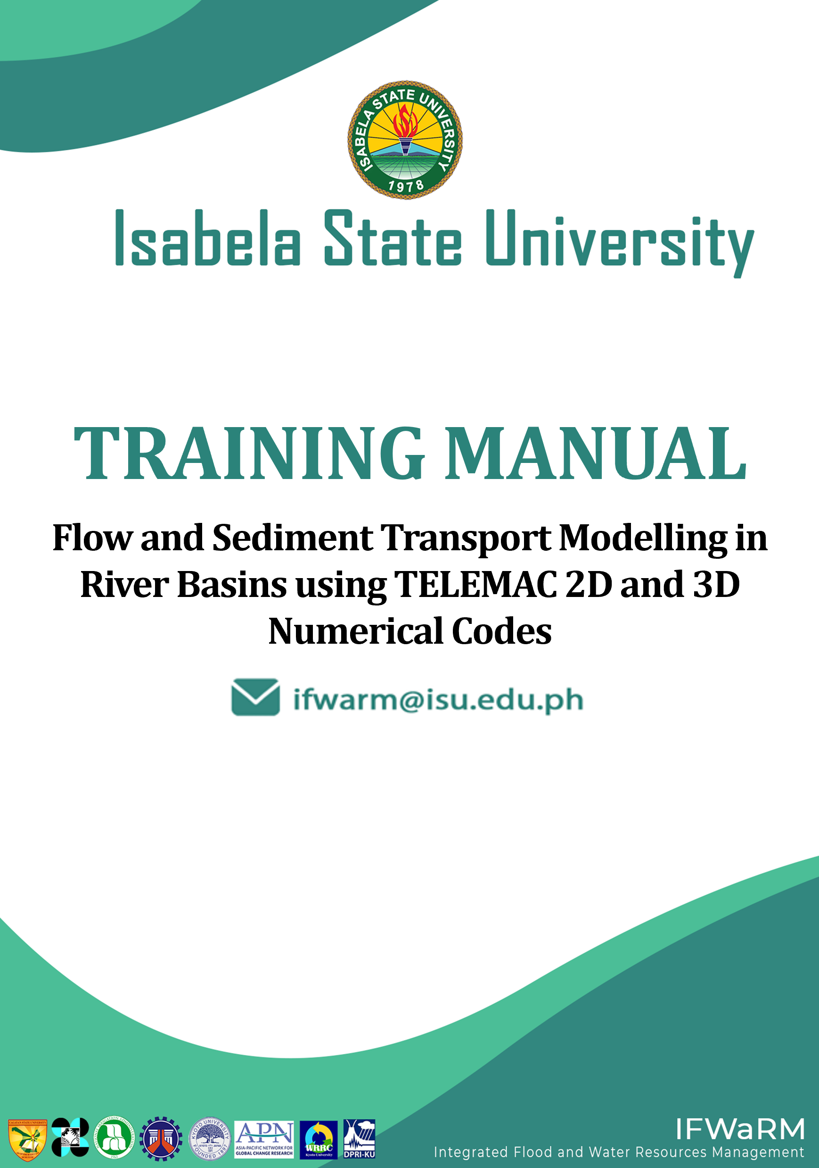

**Training Manual on Flow and Sediment Transport Modelling in River Basins using TELEMAC 2D and 3D Numerical Codes**

Training Manual

Isabela State University

*Water Resources Development Center (WReDC)*

Integrated Flood and Water Resources Management in ASEAN Basins for Integrated Development (IFWaRM)

Cagayan State University

Kyoto University-Disaster Prevention Research Institute (DPRI)

Asia Pacific Network (APN)

Department of Science and Technology

National Irrigation Administration

Contents

List of Figures 5

Rationale 8

Objectives 9

TELEMAC - MASCARET 10

Main Applications 10

Modules 11

i. Pre-requisites 13

ii. Training Guide 13

iii. Software Resources Options 14

Option I – Automatic Installer 14

Option II - Manual Installation of TELEMAC-MASCARET and Prerequisites 14

iv. General Computer Requirements 14

1. The TELEMAC File Structure 15

1.1. Mandatory Files 15

1.1.1. The Geometry File 15

1.1.2. The Boundary Conditions File 15

1.1.3. The Steering File 15

1.2. Optional Files 15

1.2.1. Stage-discharge (or WSE-Q) File (txt - ASCII) 15

1.2.2. Friction Data File (tbl/txt - ASCII) 15

1.2.3. The Results/Restart file (SLF or MED) 15

2. Installation Procedures 16

Note: Enable .NET Framework 3.5 (Includes .NET 2.0 and 3.0) 16

2.1. TELEMAC Installation 16

2.1.1. Example Run Test 25

2.2. Installing Blue Kenue 30

3. Pre-processing utilizing Blue Kenue 33

3.1. Generating Selafin File using Blue Kenue (Geometry File) 33

3.1.1. The Blue Kenue Interface 33

3.1.2. Opening/Importing Data in Blue Kenue 34

3.1.3. Viewing Data in Blue Kenue 37

3.1.3. Mesh Generation 39

3.1.4. Interpolating the DEM into the Created Mesh 47

3.1.5. Saving Files and the Workspace 54

3.2. Generating Boundary Conditions File Using Blue Kenue 56

3.3. Understanding and Creating a Steering File (CAS File) 67

3.3.1. Sample Steering File for a **Purely Hydrodynamic Scenario** in Magat Reservoir (Initial/Uncorrected) 67

3.3.2. Sample Steering File for a Purely Hydrodynamic Scenario in Magat Reservoir (Adjusted/Corrected) 69

3.3.3. Sample Steering File for Modelling a Sediment Transport Scenario using TELEMAC coupled with the GAIA Module (Initial/Uncorrected) 70

3.3.4. Sample Steering File for Modelling a Sediment Transport Scenario by Coupling TELEMAC with the GAIA Module (Adjusted/Corrected) 72

3.3.5. Sample Steering File for Modelling a Sediment Transport Scenario using TELEMAC coupled with GAIA Module and imposing a Hydrograph File (Initial/Uncorrected) 73

3.3.6. Sample Steering File for Modelling a Sediment Transport Scenario using TELEMAC coupled with GAIA Module and imposing a Boundary File (Corrected/Adjusted) 74

3.3.7. Creating a Steering File Using Notepad (or any basic text editing software available) 76

4. Running the Model Setup 78

4.1. Running a Hydrodynamic Simulation on Windows Environment 78

Step 1: Open TELEAMC Command Prompt. 78

Step 2: Change the directory in the **Simulation_Files** folder 78

Step 3: Start the simulation. 78

5. Post-Processing 82

5.1. Post-Processing Using Blue-Kenue 82

5.1.1. Visualizing Velocity in Blue Kenue 84

Appendix I: Enabling .NET Framework 3.5 88

Appendix II: Adding items into the System Variables Path 90

Appendix III: List of Possible Errors 93

Appendix IV: General Summary of Steps in Running a Model 97

Appendix V: Visualized Results Files 98

Scenario 1 – Initial/ Uncorrected Steering File 98

Scenario 1– Adjusted Steering File 98

Scenario 2 – Initial/ Uncorrected Steering File 99

Scenario 2 – Adjusted Steering File 99

Scenario 3 – Initial/ Uncorrected Steering File 100

Scenario 3 – Adjusted Steering File 100

Appendix VI: Downloading the latest release, TELEMAC v8p5 101

Appendix VI: Importing an existing shapefile as an outline. 104

**References** 106

# List of Figures

Figure 1 The open TELEMAC-MASCARET webpage 16

Figure 2 Registration Section Used in Creating and Logging in to Account 17

Figure 3 The Automatic Installer Link 17

Figure 4 The Automatic Installation: Opentelemac-Windows Link 18

Figure 5 The TELEMAC-MASCARET License Agreement 18

Figure 6 Approximate download size of the installer 19

Figure 7 The Open TELEMAC-MASCARET Setup Wizard 19

Figure 8. Selected directory for installation 20

Figure 9 The License Agreement before proceeding to the installation 21

Figure 52 Typing dir to Display Contents 27

Figure 53 The Contents of the Okada Folder after Running the **dir** Command 28

Figure 54 The Command Used to Start the Simulation 28

Figure 55 Correct end of run 29

Figure 56. The National Research Council Webpage 30

Figure 57. The Request Form to be Filled Up 30

Figure 58. The Confirmation of the Installation 31

Figure 59. The Duration of the Installation 32

Figure 60. Finishing the Installation Process 32

Figure 61. The Blue Kenue User Interface 33

Figure 62. Parts of the Blue Kenue User Interface 34

Figure 63. The Extracted Contents of the TELEMAC Training Folder 35

Figure 64. Importing the Bathymetry Data Using the Open Button 35

Figure 65. Toggling All Files (*.*) in Opening/Importing Bathymetry Data 36

Figure 66. Viewing Items in Blue Kenue through a Views Object 37

Figure 67. Other View Options Available in Blue Kenue 37

Figure 68. An Example of a 3D Isometric View 38

Figure 69. Step 1: Creating New Closed Line to Represent the Reservoir Boundaries 39

Figure 70. Naming the Newly Created Outline 40

Figure 71. Query upon Pressing ESC 40

Figure 72. The Current Workspace with the Outline in Dragged into the View Object 40

Figure 73. Current Workspace 41

Figure 74. Opening a New T3 Mesh Generator 41

Figure 75. The New T3 Mesh Properties Window 42

Figure 76. Dragging the Generated Outline into the Generator 43

Figure 77. Running the Mesh Generator 44

Figure 78. Running the Generator 44

Figure 79. The Mesh Generator 44

Figure 80. The Mesh Generator after a Successful Run 45

Figure 81. A Newly Generated Mesh 45

Figure 82. Renaming the Mesh 45

Figure 83. The Newly Created Mesh in 2D View 46

Figure 84. Process of Deactivating an Object in the View Section 46

Figure 85. Creating a New Selafin Object 47

Figure 86. Adding a New Variable to the Selafin Object 47

Figure 87. The Add New SELAFIN Variable Window 48

Figure 88 The new **Variable** has been added 48

Figure 89. Adding a 2D Interpolator 48

Figure 90. Dragging the 2017_DEM Item into the Newly Added 2D Interpolator Tool 49

Figure 91. Selecting the Bottom Item 49

Figure 92. The Map Object Tool 50

Figure 93. Choosing the NewInterpolator2D 50

Figure 94. A Successful Interpolation Finished in 1.000 Seconds 51

Figure 95. Bottom Item in 2D View 51

Figure 96. The Mesh before the Interpolation 52

Figure 97. The Mesh after the Interpolation 52

Figure 98. Highlighting Selafin Item and Saving it into File 53

Figure 99 Saving an entire Workspace in Blue Kenue 54

Figure 100. Entering the File Name and Saving Your Workspace 54

Figure 101. Saving All Unsaved Items 55

Figure 102. Current Workspace 56

Figure 103. Steps in Creating a New Boundary Conditions Item 56

Figure 104. Available t3s Objects 57

Figure 105. The Newly Created Boundary Conditions Item 57

Figure 106. Dragging BOTTOM_BC into 2D View 58

Figure 107. The 2D View after Dragging BOTTOM_BC 58

Figure 108. Zooming in on the Upstream Section of the Reservoir 59

Figure 109. Double-clicking a Node to Start 59

Figure 110. Double-clicking the Other End of the Upstream Section 60

Figure 111. Selecting Add Boundary Segment 60

Figure 112. The Conlim Boundary Segment Editor 61

Figure 113. Boundary Properties for the Upstream Boundary Section 61

Figure 114. Base Map and the Digital Elevation File for Magat Reservoir 62

Figure 115. Zooming in on the Discharge Section 63

Figure 116. Double-clicking up to the End of the Downstream Section 63

Figure 117. Adding Boundary Segment for the Downstream Boundary 64

Figure 118. Boundary Properties for the Downstream Boundary Section 64

Figure 119. Rename the Items 65

Figure 120. Saving the Generated Conlim Item 65

Figure 121. Saving the Boundary Conditions into a File 66

Figure 122. Various Types of Boundary Conditions 66

Figure 123. Using Notepad in the Windows Files and Programs Search Option 76

Figure 124. A Sample Steering File for a Purely Hydrodynamic Scenario 76

Figure 125. Adding .cas File Extension 77

Figure 132. Typing dir in the Next Line 79

Figure 133. The Contents of the Current Directory 79

Figure 134. Starting the Simulation through Line of Code 79

Figure 135. A Snapshot at the Start of the Simulation 80

Figure 136. A Snapshot during the Simulation 80

Figure 137. A Successful End of Run 81

Figure 138. The New File Called Magat_V2.slf 82

Figure 139. The Blue Kenue User Interface 82

Figure 140. Opening Magat_V2.slf 83

Figure 141. A successful Reading and Opening of the Results File 83

Figure 142 Results file content successfully loaded 84

Figure 143. Velocity UV under 2D View 84

Figure 144. Right Clicking on the VELOCITY UV to Display the Result 85

Figure 145. The 2D View with the Animate Playback Option 85

Figure 146. The Animated VELOCITY UV 86

Figure 147. The Display Option Properties 86

Figure 148. The Activation of the Legend Box 87

Figure 149. A Simple Visualization of the VELOCITY Profile Using Blue Kenue 87

Figure 150. Searching for Windows Features 88

Figure 151. The Windows Features window 88

Figure 152. Enabling the .NET Framework 3.5 89

Figure 31 Editing the System Environment Variables 90

Figure 32 The System Properties Window 91

Figure 33 The Environment Variables Window 91

Figure 34 The Edit Environment Variable Window 92

Figure 35 Adding a New Path 93

Figure 153. TELEMAC Automatic Installation Failure 93

Figure 154. pip3 Error 94

Figure 155. The Configparser Error 94

Figure 156. No Module Named Request Error 95

Figure 157. Scenario 1 Velocity Profile Visualized in BlueKenue 98

Figure 158 Scenario 1 Velocity Profile Visualized in BlueKenue 98

Figure 159. Scenario 2 Velocity Profile Visualized in BlueKenue 99

Figure 160. Scenario 2 Sediment Transport Profile Visualized in BlueKenue 99

Figure 161. Scenario 3 Velocity Profile Visualized in BlueKenue 100

Figure 162. Scenario 3 Sediment Transport Profile Visualized in BlueKenue 100

Figure 163. Logging in to your Telemac account 101

Figure 164. The Latest News section of the Telemac website 101

Figure 165. A short release statement regarding the availability of v8p3 version 102

Figure 166. The source code download section 102

Figure 167. Extracting the contents of the downloaded compressed file 103

Figure 168. Importing a shapefile 104

Figure 169. The Magat Reservoir outline loaded as a shapefile 105

# Rationale

Climate change threatens the world with devastating floods and droughts, with Japan, Vietnam, and the Philippines among the worst-affected countries.

Human interventions such as deforestation, dam construction, and irrigation system development have increased the adverse effects of climate change. Furthermore, flood and sediment management in the river basin scale has also become a crucial issue for the Cagayan River Basin in the Philippines.

To help resolve these issues, reliable numerical tools are needed. Not only these numerical models may be used to characterize flood inundation maps, but they can also be used to create mitigation measures and assist in successful land use and emergency planning. In the same light, significant efforts have been made to use remotely sensed data (e.g., Classified Aerial Imagery, Light Detection and Ranging (LiDAR) Terrain Measurements) capable of providing high-resolution Digital Model Terrain (DTM) in 2D or even in 3D space, thereby guiding mesh generation and model parameterization.

TELEMAC’s application range is very wide and comes with a range of modules for two-dimensional (2D) and three-dimensional (3D) modeling of hydro-morphodynamic processes of various water bodies from mountain rivers to coastal deltas under the influence of tides. Multiple sediment transport phenomena can also be modeled, as well as steady and unsteady flow conditions.

Consequently, this training workshop provides an overview of the capabilities, limitations, and challenges related to hydraulic modelling of flow and sediment transport in rivers. As a result, Isabela State University in the Philippines hosted a workshop training course in conjunction with Kyoto University. The details of the training course and other relevant information are given hereafter.

# Objectives

After completing this training, the participants are expected to:

1. Generate a computational mesh from a topographic data set using free pre-processing software Blue Kenue ([www.nrc-cnrc.gc.ca/eng/solutions/advisory/blue_kenue_index.html](http://www.nrc-cnrc.gc.ca/eng/solutions/advisory/blue_kenue_index.html));
2. Create input files to execute TELEMAC2D and TELEMAC3D;
3. Assess the impact of imposed flow on near- and far-field river hydrodynamics; and
4. Analyze and visualize TELEMAC output files using third-party charting and data analysis software.

# TELEMAC - MASCARET

TELEMAC-MASCARET or simply TELEMAC, is an integrated suite of solvers for use in the field of free-surface flow, waves, water quality, and sediment transport (Galland, Goutal, & Hervouet, 1991). Having been used in the context of many studies throughout the world, TELEMAC has become a major standard in its field. It was made “open source” in 2010 to be freely available to the whole community of consultants, universities, and researchers while being actively supported and continuously developed by a consortium of industrials, consultants, and research organizations. Anyone can, therefore, take advantage of TELEMAC and assess its performance. For more information about TELEMAC-MASCARET see [www.openTELEMAC.org](http://www.opentelemac.org).

Furthermore, this training course covers a broad range of modelling techniques for fluvial processes using the TELEMAC suite of computer models. Lectures will provide both theoretical background and practical aspects of modelling flow and sediment transport processes. Introductory topics, which can be grasped by the participants without a background in numerical methods, will be followed by advanced topics such as mesh generation/optimization, selection of numerical schemes, and flow and sediment interactions.

Additionally, the capabilities and benefits of the TELEMAC modelling system will be shown by a hands-on application using data sets acquired from the Magat rivers

## Main Applications

TELEMAC can be used in the following but not limited to:

(Adapted from the [www.openTELEMAC.org](http://www.opentelemac.org) website)

* Flood Studies
* Estuary Management and Development
* River Restoration Studies
* Dam Bursts
* Hydro Sedimentary Studies
* Water Quality
* Dumping of dredged materials
* Impact of Hydraulic Structures
* Study of Marine Climates
* Harbor Installation Studies

## Modules

(Adapted from the [www.openTELEMAC.org](http://www.opentelemac.org) website)

1. GAIA (SISYPHE) - Sediment Transport and Bed Evolution

It is a state-of-the-art sediment transport and bed evolution module of the TELEMAC-MASCARET modelling system which can be used to model complex morphodynamics processes in diverse environments such as coastal, rivers, lakes, and estuaries for different flow rates, sediment size classes, and sediment transport modes.

1. NESTOR- Modelling Dredging Operations in the River Bed

Using documented data from dredging operations to model the ensuing changes in the bottom level is possible with NESTOR and the morphodynamic module SISYPHE. The period, the volume of silt removed during that period, and the size and location of the dredging site can be defined. This information can then be utilized to calculate the site's bottom level.

1. MASCARET- One-Dimensional Free Surface Flow Modelling

MASCARET includes one-dimensional free surface flow modelling engines. Different modules can describe varied phenomena over large areas and for various geometries using the Saint-Venant equations: meshed or branched networks, subcritical or supercritical flows, and steady or unsteady flows.

1. TELEMAC-2Ds

TELEMAC-2D is a two-dimensional horizontal space simulation program that simulates free-surface flows. At each point of the mesh, the program calculates the depth of water and the two velocity components.

1. TELEMAC- 3D

TELEMAC-3D is a three-dimensional (3D) model based on TELEMAC-2D's horizontally unstructured mesh. The wave formulation for the updating of the free surface is used for efficiency. The model mesh is developed as a series of model planes between the bed and surface planes. Furthermore, the usage of a sigma grid is possible due to the freedom in the placement of these planes (each plane at a given proportion of the spacing between bed and surface) or several other strategies for intermediate plane location. Include certain planes that are at a fixed distance below the water surface or above the bed, for example. In the presence of a near surface thermocline or halocline, this is advantageous in so far to avoid the mixing of water between the near surface planes where the greatest density gradients are located.

1. TOMAWAC

Wave propagation in coastal locations is modelled using TOMAWAC. It solves a simplified equation for the spectro-angular density of wave activity using a finite-element approach. This is done for steady-state conditions (i.e., with a fixed depth of water throughout the simulation).

1. ARTEMIS

ARTEMIS is a scientific software dedicated to the simulation of wave propagation towards the coast or into harbors over a geographical domain of about a few square kilometers. Long waves or resonance simulations may require a bigger domain. The frequency dependence and directional spreading of the wave energy are considered by ARTEMIS.

# Pre-requisites

Individuals having a basic understanding of hydrological/ hydraulic modelling, rainfall-runoff analysis, river catchment, open-channel flow, and sediment transport mechanics would benefit greatly from this training session. It can serve as an introduction to numerical modelling of flow and sediment transport in rivers.

# Training Guide

This training manual is based on the user manuals provided by the TELEMAC developers at <http://wiki.opentelemac.org> and the Hydro-Informatics website, <https://hydro-informatics.com/index.html> by Sebastian Schwindt © Copyright 2022.

TELEMAC’s application range is very wide and comes with a range of modules for two-dimensional (2D) and three-dimensional (3D) modeling of hydro-morphodynamic processes of various water bodies from mountain rivers to coastal deltas under the influence of tides. Multiple sediment transport phenomena can also be modeled and connected with constant or variable flow conditions.

On this note, this manual will only feature the following tutorials:

* Generating a geometry file in Selafin *.slf* format using BlueKenue
* Creating a boundary condition *.cli* file using BlueKenue
* Creating and understanding a Steering *.cas* file.
* Setup a purely hydrodynamic, steady Telemac2d simulation as a first scenario
* Couple hydrodynamics (i.e., Telemac2d) with morphodynamics (i.e., Sediment transport) as the second and third scenario simulations.

# Software Resources Options

## Option I – Automatic Installer

This provides a complete setup of the latest version of the software, including all its dependencies and prerequisites: MED, MUMPS, GOTM, AED2, METIS, MS-MPI, GFortran and Python, as well as all Python packages required to run TELEMAC examples and notebooks.

http://www.opentelemac.org/index.php/component/jdownloads/summary/23-installation-files/3431-telemac-v8p4-setup?Itemid=54

## Option II - Manual Installation of TELEMAC-MASCARET and Prerequisites

For developers and Linux users, the other option is to clone the latest source code from the Git Repository and build the modules under your own operating system and Fortran compiler. This option provides more flexibility for power users and is also recommended for those who want to stay permanently up to date with the latest corrections and improvements to the TELEMAC codebase.

<https://gitlab.pam-retd.fr/otm/telemac-mascaret/-/releases>

# General Computer Requirements

* Intel Core i5-8th Gen or Ryzen 5 3000 Series processors and above
* RAM: 8 GB Minimum; 32 GB and above is much preferred
* Disk Space: at 2.22 GB of free disk is required
* CPU Cores: 4 cores minimum; 8 cores and above are preferred
* Processor speed: 2.3 GHz and above

# The TELEMAC File Structure

## Mandatory Files

### The Geometry File

The geometry file in *.slf (selafin or SERAFIN) or *.med (MED file) format contains binary data about the mesh with its nodes. It can be created using Blue Kenue or through SALOME-HDRO.

### The Boundary Conditions File

Information regarding inflow and outflow nodes is contained in the boundary file in *.cli format (coordinates and IDs). Any text editor can open and modify the *.cli file, but this is not suggested to avoid inconsistencies. For generating and/or editing *.cli files, Fudaa PrePro or Blue Kenue are recommended.

### The Steering File

The steering file is the main simulation file that contains information on required files (such as selafin geometry and boundary), optional files, and simulation parameters. A basic text editor or complex software such as Fudaa PrePro or Blue Kenue can be used to create or change the steering file.

## Optional Files

### Stage-discharge (or WSE-Q) File (txt - ASCII)

It defines a stage-discharge file to use a stage (water surface elevation WSE) - discharge relationship for boundary conditions. Such files typically apply to the downstream boundary of a model at control sections (e.g., a free overflow weir).

Also, stage-discharge files can be used by defining the following keyword in the steering file: “STAGE-DISCHARGE CURVES FILE: YES”.

### Friction Data File (tbl/txt - ASCII)

This optional file allows for the definition of bottom friction, as well as the corresponding function coefficients and roughness law.

### The Results/Restart file (SLF or MED)

A restart file stems from a previous TELEMAC simulation but is not needed to exist before any simulations. It can, however, speed up simulations.

Definitions adapted from the Hydro-informatics website <https://hydro-informatics.com/index.html>.

# Installation Procedures

## Note: Enable .NET Framework 3.5 (Includes .NET 2.0 and 3.0)

MPICH2, one of the prime components of TELEMAC requires the older version .NET Framework 2, which must be enabled through the Windows Features. This will prevent some future errors regarding using the MPICH.

Please see Appendix I for instructions.

## TELEMAC Installation

Notes:

* If the software is already installed, please proceed to the next section.
* Account for at least 2 hours (depending on internet speed) for the installation.
* Internet connection is required.

1. Open your browser and head to [www.opentelemac.org](http://www.opentelemac.org) and Click “**Log in**”.

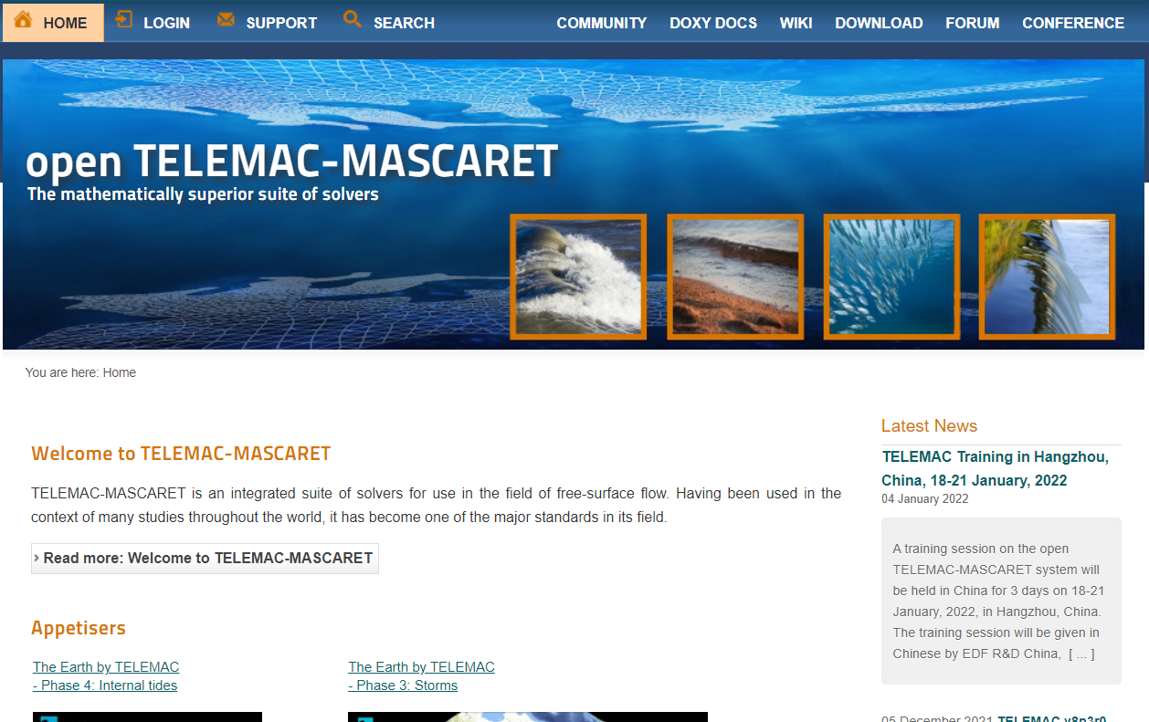

Figure 1 The open TELEMAC-MASCARET webpage

1. To be able to download a copy of the installer, you must create an account first and login. Create your account by clicking “**REGISTER**”.

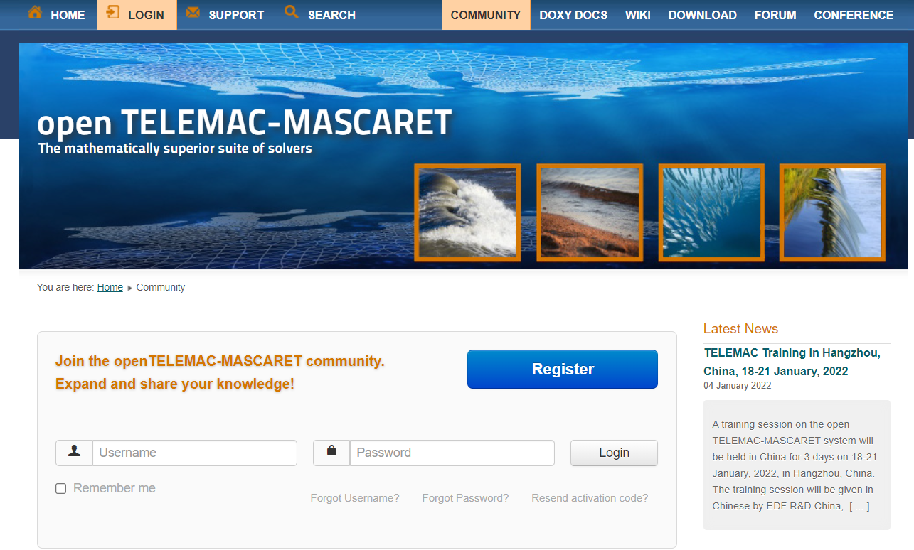

Figure 2 Registration Section Used in Creating and Logging in to Account

1. Once logged in, head to the “**DOWNLOAD**” section and find the “**automatic installer**” option.

Figure 3 The Automatic Installer Link

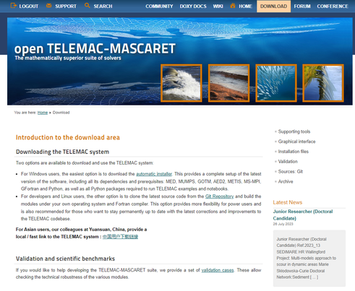

1. Scroll down until the “**TELEMAC V8P4 Setup**” section and click the link.

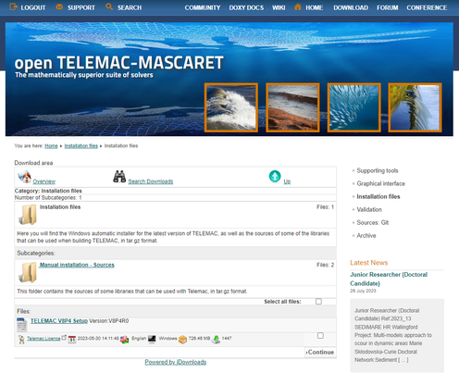

Figure 4 The Automatic Installation: Opentelemac-Windows Link

1. Read provided License Agreement, and, if you accept, tick the “**I Accept the above-listed conditions**” option and then click “**Download**”.

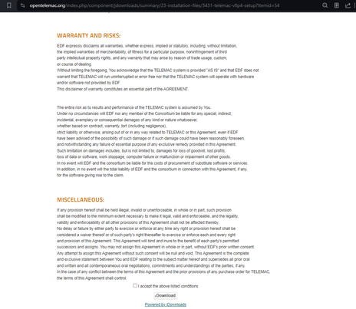

Figure 5 The TELEMAC-MASCARET License Agreement

1. Save the file to your computer and wait for it to finish. The file is about 726 MB.
2. Alternatively, if the current download system is not working, you can download the V8P4 installer from this direct link:

<http://opentelemac.org/downloads/Installation%20files/telemac_v8p4r0_setup.exe>

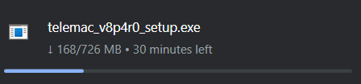

Figure 6 Approximate download size of the installer

1. Once finished, open the installer and click “**YES**” to proceed.



1. Once opened, click “**NEXT**” in the setup wizard to continue.

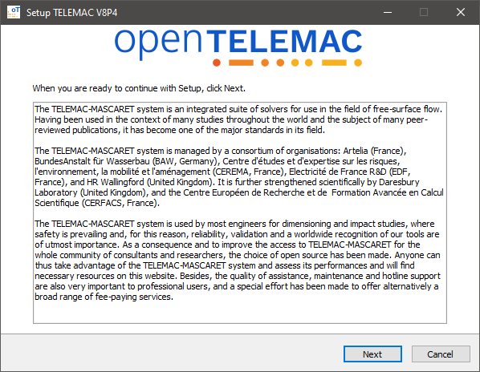

Figure 7 The Open TELEMAC-MASCARET Setup Wizard

1. Select desired installation location where setup will install TELEMAC V8P4. For this example, the installation directory will be set at C:\TELEMAC\V8P4. The reason for doing so is to prevent having a white space within the workig directory (The default directory is at C:\Program Files). Click “**Browse**” if a different location is desired. Click “**Next**” to continue.

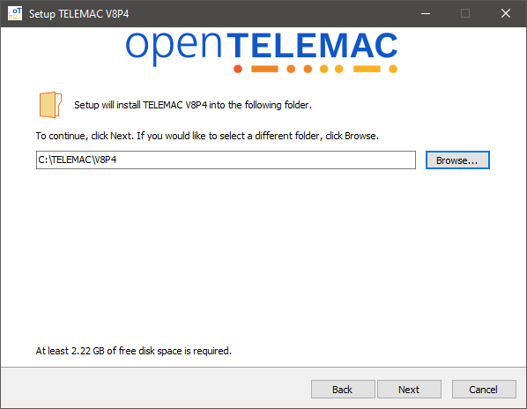

Figure 8. Selected directory for installation

1. For the “Working Directory” folder, navigate to C:\. Setup will copy all examples and notebooks to this location. Click “**Next**” to continue.

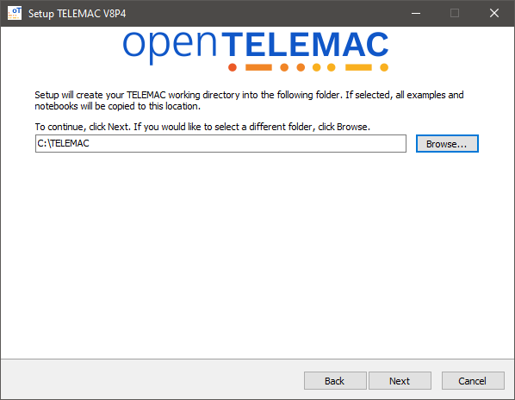

1. Leave the default location for program shortcuts. Click “**Next**” to continue.

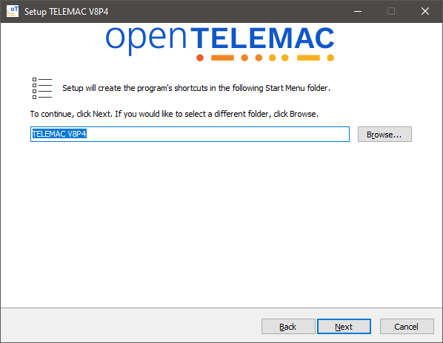

1. You can choose additional tasks. Click “**Next**” to continue.

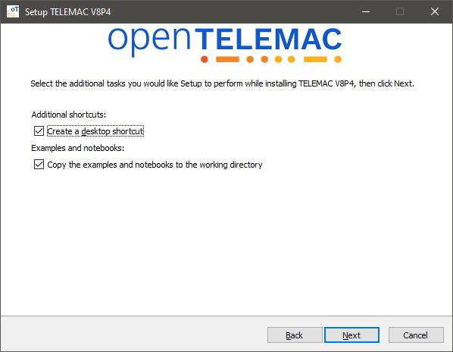

Figure 9 The License Agreement before proceeding to the installation

1. Click “**Install**” to proceed with the installation.

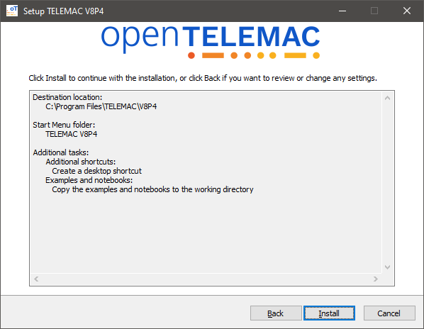

1. The setup will start extracting files with the set settings.

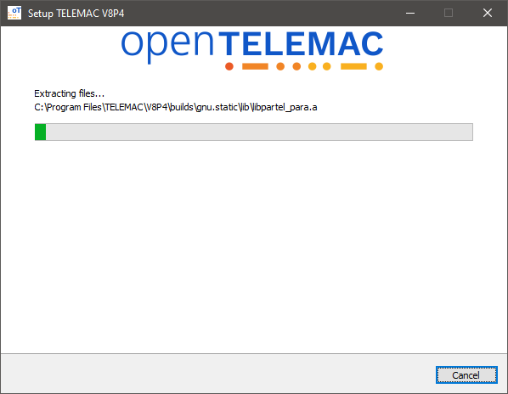

1. Wait for the setup to finish.

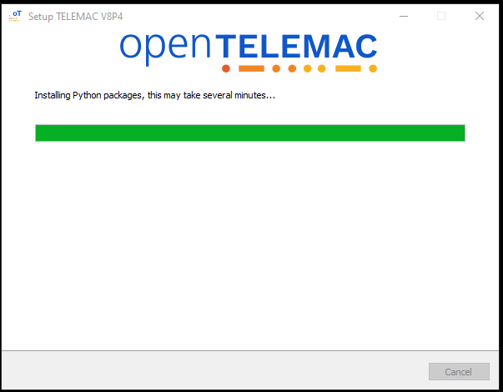

1. Click “**Finish**” to exit setup.

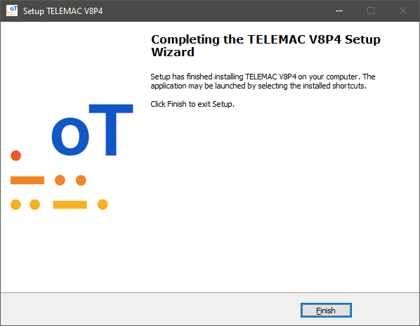

1. The next step would be to test whether the installation is successful or not. Proceed to the next section to run a Sample test.

### Example Run Test

1. Open the generated shortcut called “**TELEMAC Command Prompt**” located in the desktop.

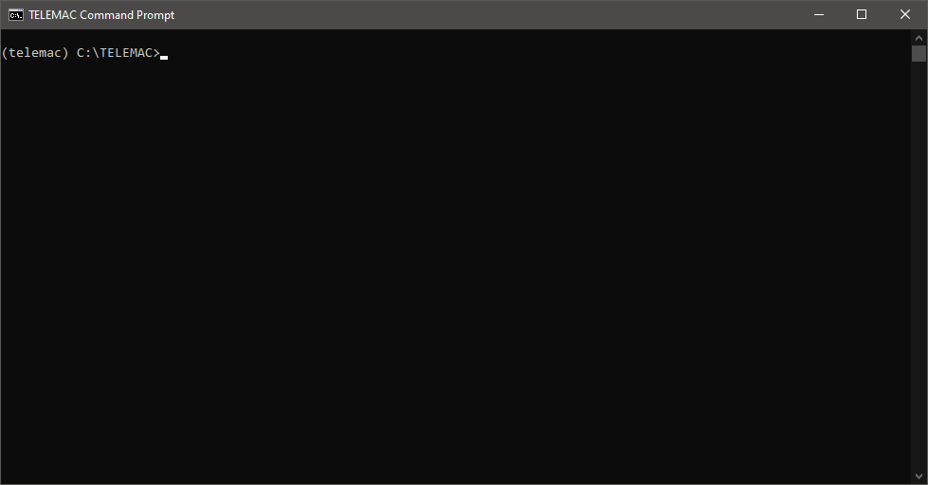

1. Type “**dir**” and press <**Enter**> to show the contents of current directory.

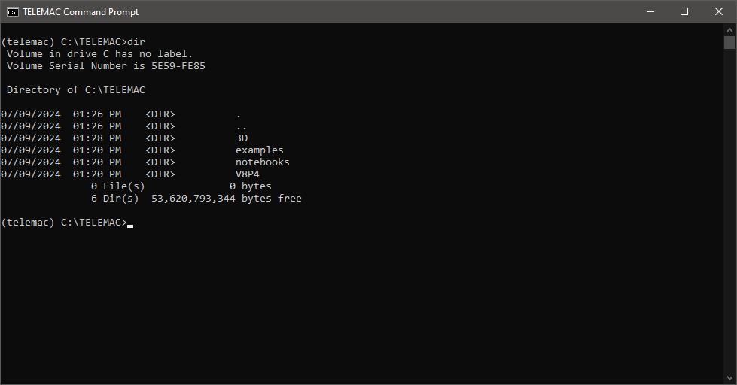

1. Change directory into the examples folder by typing “**cd examples**” and pressing <**Enter**>.

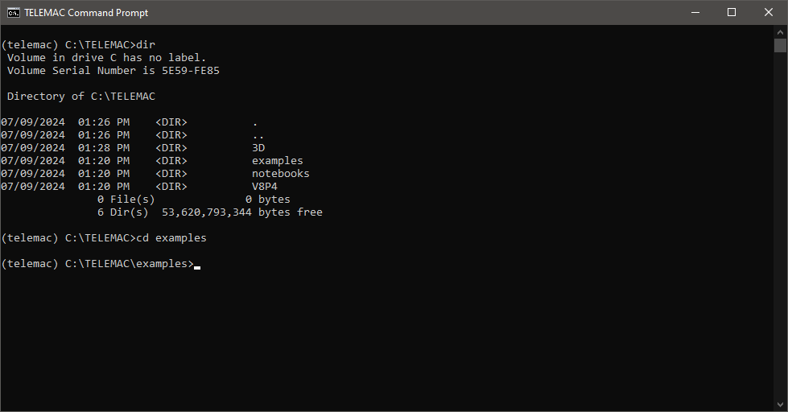

1. You are now inside the “**examples**” folder. Type “**dir**” and press <**Enter**> again to show the contents.

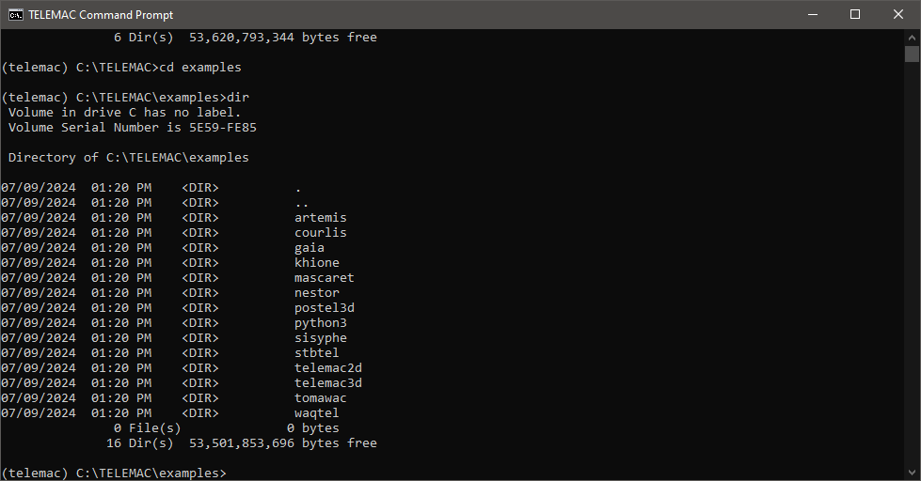

1. For this test run, type “**cd telemac2d**”to select telemac2d examples.

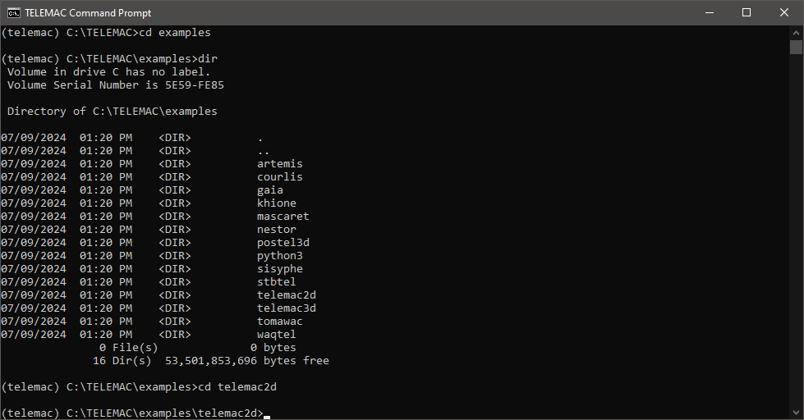

1. Type “**dir**” and press <**Enter**> again to show contents of current directory.
2. For this test run we’ll be running a sample from the “**okada**” folder. So go ahead and type “**cd okada**” and press <**Enter**>.

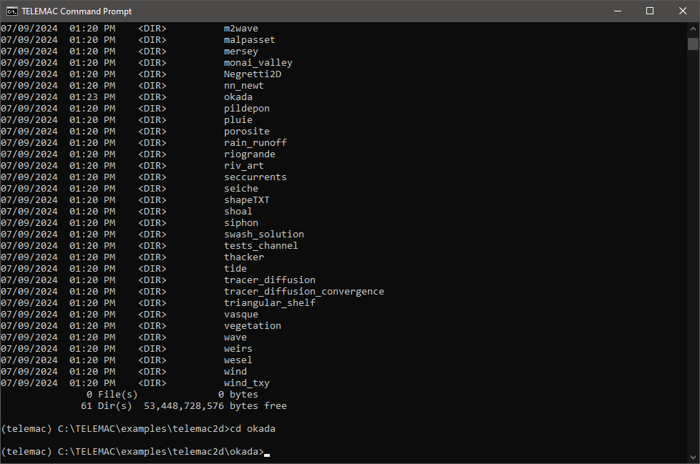

1. Now that we are in the directory where simulation files (okada) are located, we can start the simulation properly.
2. Type **dir** to display the contents of the said folder.

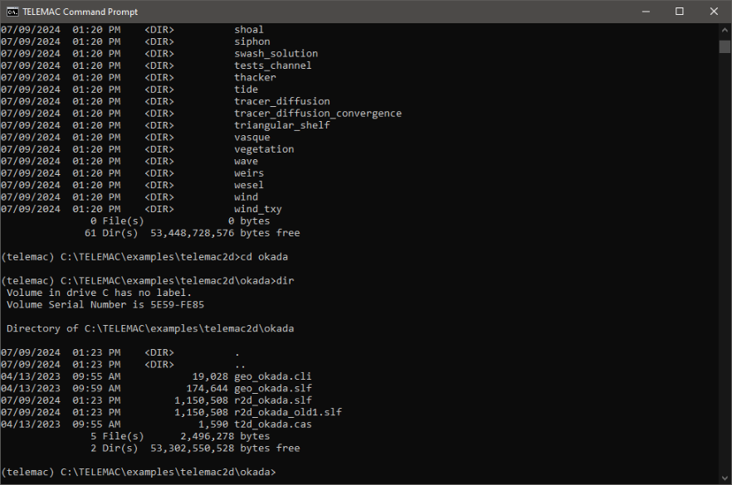

Figure 10 Typing dir to Display Contents

1. Note that all the mandatory files (i.e., the *.cli, *.slf, and *.cas files) are available in this folder.

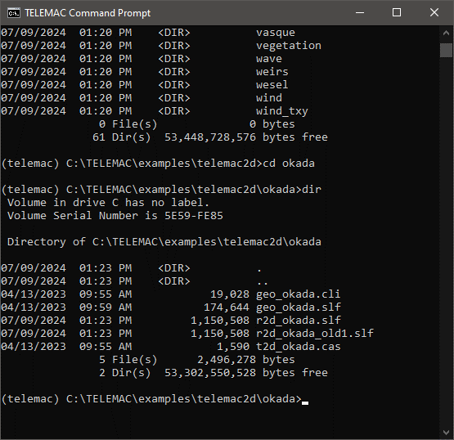

Figure 11 The Contents of the Okada Folder after Running the **dir** Command

1. To start the simulation, type **“python C:\TELEMAC\V8P4\scripts\python3\telemac2d.py t2d_okada.cas**” and press <**Enter**>.

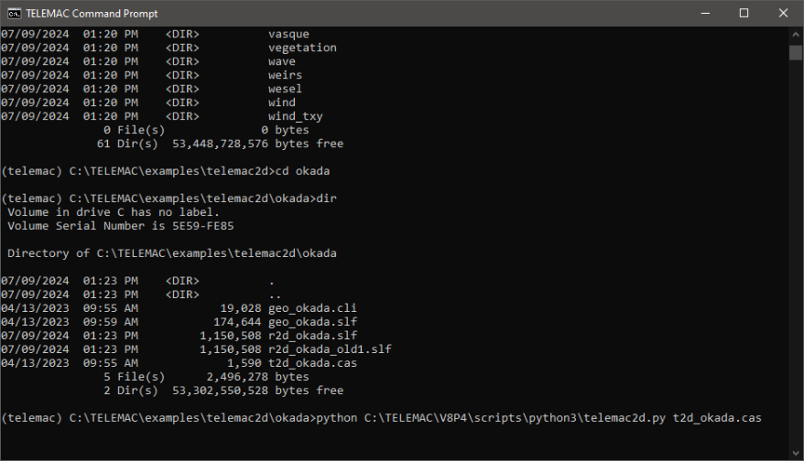

Figure 12 The Command Used to Start the Simulation

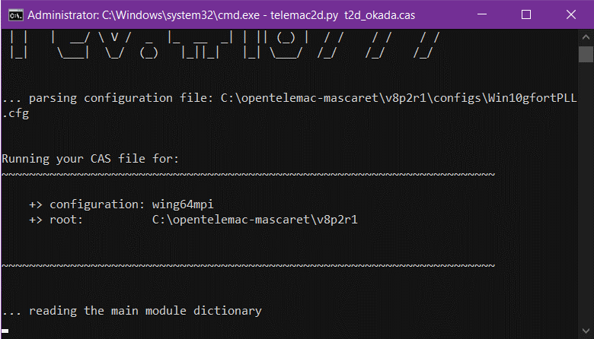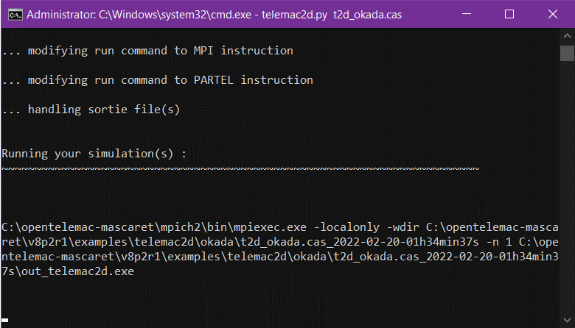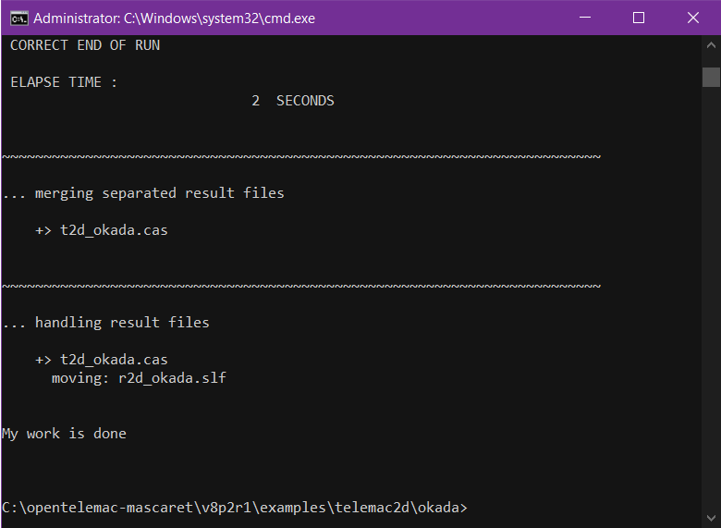

Figure 13 Correct end of run

1. The “**My work is done**” message signifies that our installation worked and that TELAMAC has been successfully installed and properly running.

## Installing Blue Kenue

1. Open your web browser and navigate to <https://nrc.canada.ca/en/research-development/products-services/software-applications/blue-kenuetm-software-tool-hydraulic-modellers>. Click the “**Download Blue Kenue**” button.

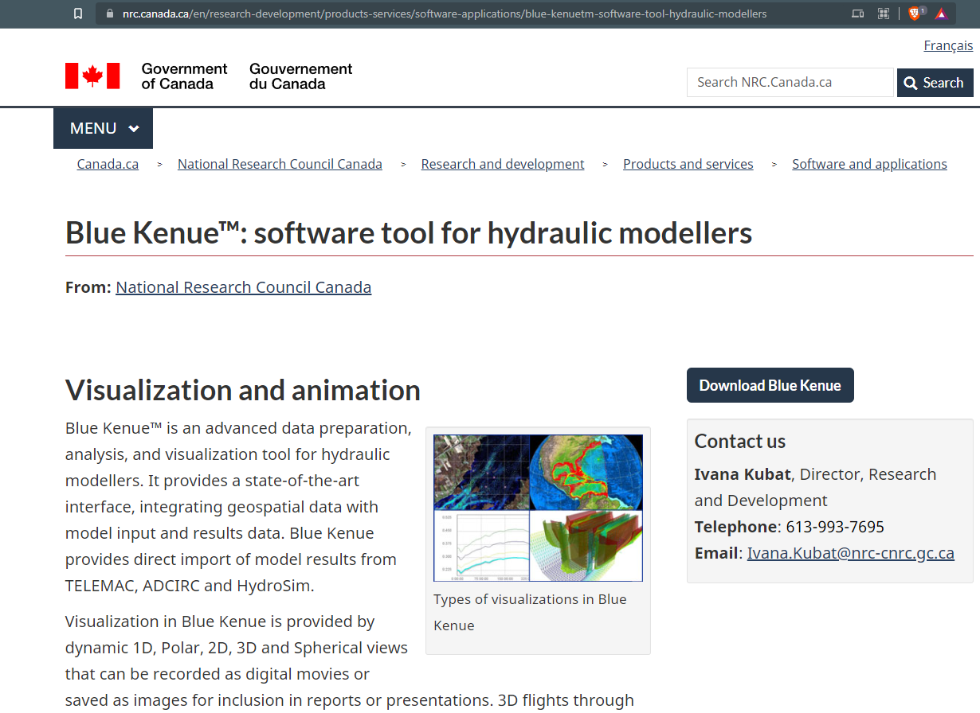

Figure 14. The National Research Council Webpage

1. Fill up the request form then click “**Submit**” once finished.

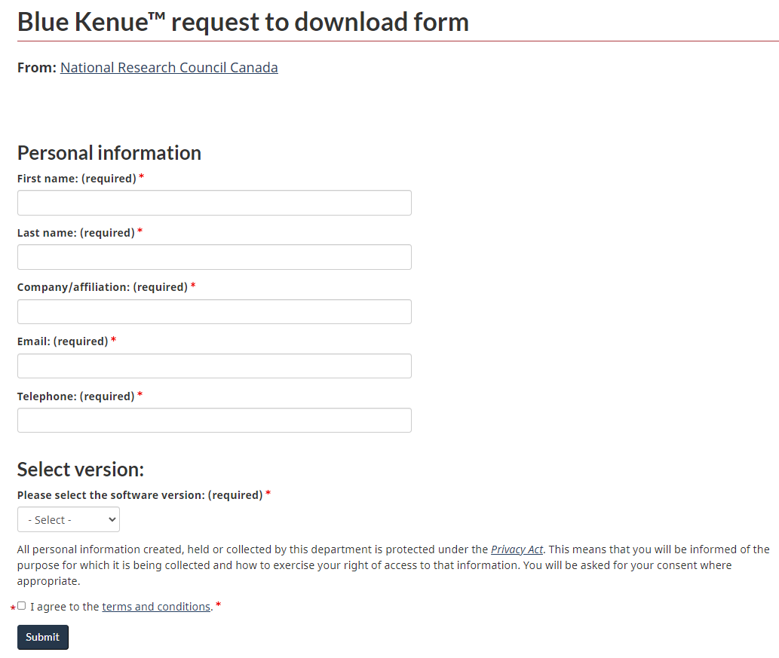

Figure 15. The Request Form to be Filled Up

1. Download the application, wait for it to finish, and then open the file to start installing. Then click “**Next**”>>” **Next**”>>” **Next**” to proceed.

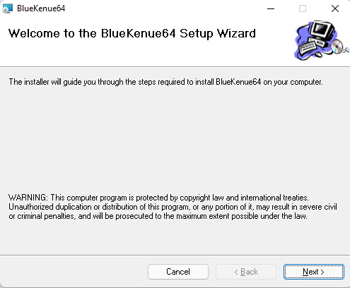

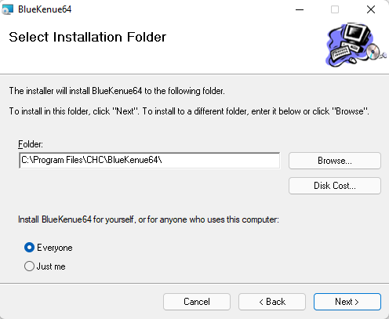

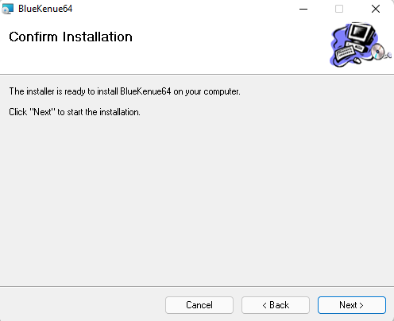

Figure 16. The Confirmation of the Installation

1. Wait for a few seconds and once finished, you can click close to finish the installation.

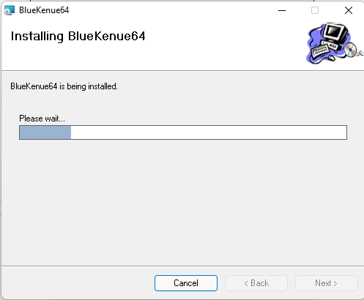

Figure 17. The Duration of the Installation

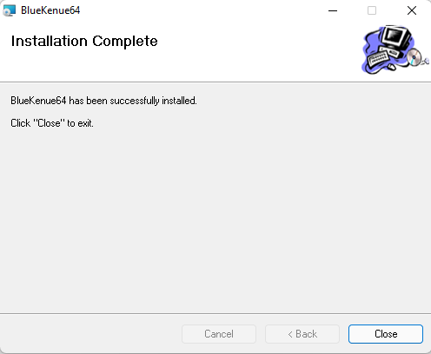

Figure 18. Finishing the Installation Process

# Pre-processing utilizing Blue Kenue

Pre-processing encompasses the abstraction of the river landscape into a computational mesh (grid) with boundary conditions and interpolation of DEM data into the generated computational mesh. Various software programs are available for this purpose, which include but are not limited to the following:

1. QGIS and the BASEmesh plugin
2. The National Research Council Canada’s Blue Kenue GUI software (primarily for Windows but can be used in Linux systems using Wine).
3. SALOME-HYDRO for generating computational meshes in the MED files format

However, this manual will only focus on utilizing Blue Kenue since it is advantageous for computation speed and model stability.

## Generating Selafin File using Blue Kenue (Geometry File)

Blue Kenue™ is an advanced data preparation, analysis, and visualization tool for hydraulic modelers. It provides a state-of-the-art interface, thereby integrating geospatial data with model input and results from data. It also provides direct import of model results from TELEMAC and other software.

### The Blue Kenue Interface

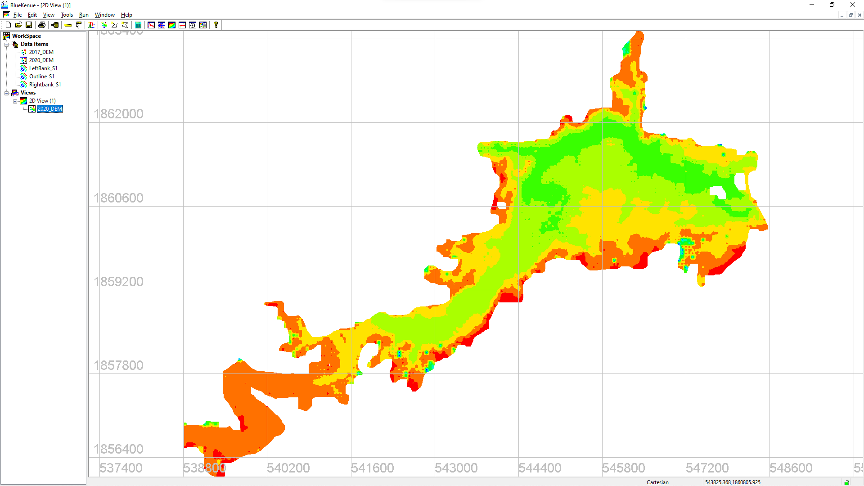

Figure 19. The Blue Kenue User Interface

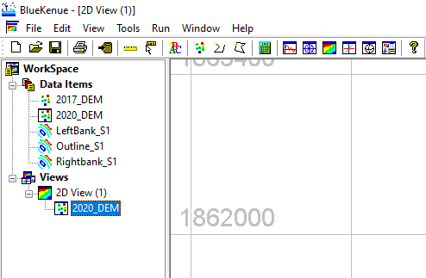

Figure 20. Parts of the Blue Kenue User Interface

1. Title Bar
2. Menu Bar
3. Tool Bar
4. Workspace
5. Data Items
6. Views
7. Canvass

### Opening/Importing Data in Blue Kenue

1. Download and extract the TELEMAC Training Folder from <https://drive.google.com/drive/folders/1NNKCd2PWkojGpmtA3L9Ic5Eo-TYkNNH0?usp=sharing> and extract the contents into your desired directory. In this manual, we are going to extract the contents into the **desktop folder**. The contents of the extracted TELEMAC Training folder are shown on the next page:

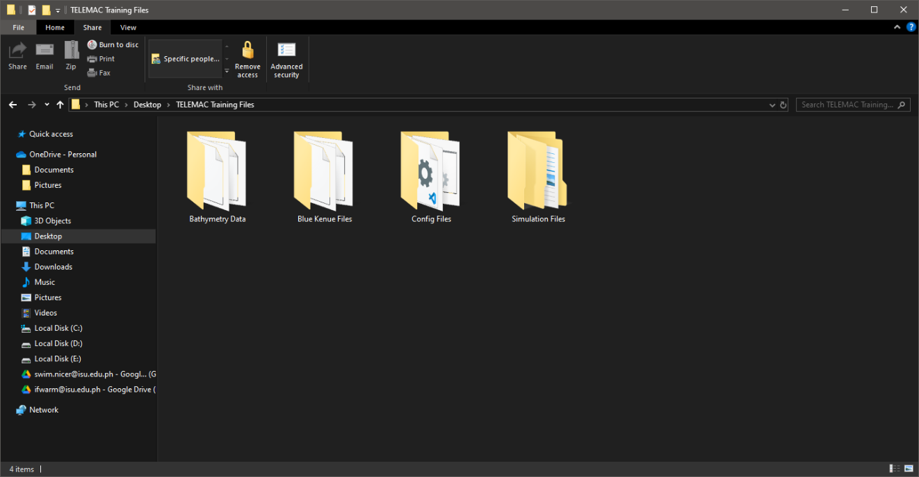

Figure 21. The Extracted Contents of the TELEMAC Training Folder

1. Start the Blue Kenue application and open the (.xyz) geometry file from the extracted **TELEMAC Training Folder** >> **Bathymetry_Data** >> **2017_DEM.xyz**. To see your XYZ dataset, change the file type drop-down menu from Selafin to All Files as shown in Figure 22.

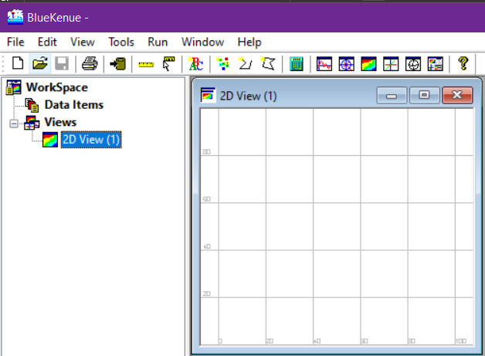

Open the (.xyz) geometry file using the **open** button.

Figure 22. Importing the Bathymetry Data Using the Open Button

1. From the “**Open Files**” window, click the “**Telemac Selafin File(*.slf)**” and change it to “**All Files**” to see your XYZ data set.

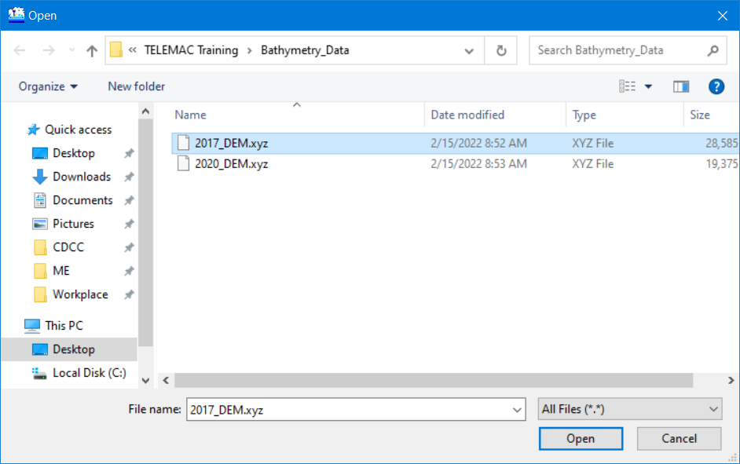

Open the (.xyz) geometry file.

In order to view the XYZ dataset, select

All Files option from the drop-down list.

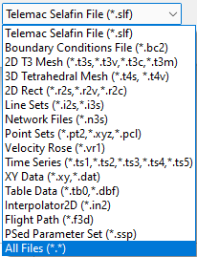Figure 23. Toggling All Files (*.*) in Opening/Importing Bathymetry Data

### Viewing Data in Blue Kenue

1. Notice that the “**DEM_2017**” is now displayed under the Data Items. Drag it into the “**2D View**” to display the item in the canvass.

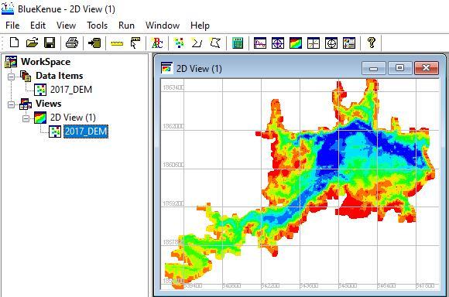

Drag DEM xyz data into the 2D view object.

Figure 24. Viewing Items in Blue Kenue through a Views Object

*Note: In Blue Kenue, data items are not automatically displayed in the canvas. You must drag the item into the “****View****” section. Additionally, other view options like “****1D View****”, “****3D******View*** *“, “****Polar Views****”, “****Spherical Views****”, and “****Report View****” can also be used from the tool bar. Try to hover your mouse over each option. The example shown in Figure 87 features the 3D view option.*

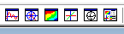

Figure 25. Other View Options Available in Blue Kenue

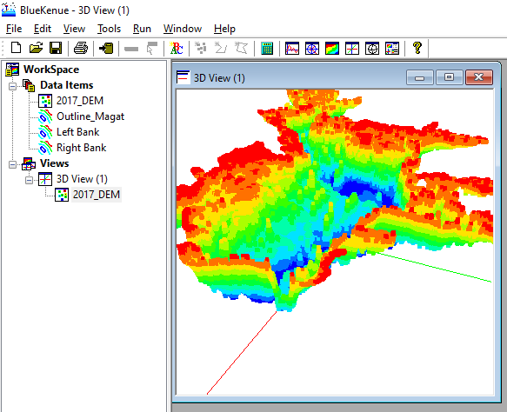

Figure 26. An Example of a 3D Isometric View

### Mesh Generation

#### Step 1: Model Boundary (Closed Line)

1. In Blue Kenue, the “**New Closed Line**” tool is used to delineate the outline or boundary of the area to be studied.



Create a new closed line to represent the extent of the Magat Reservoir.

Figure 27. Step 1: Creating New Closed Line to Represent the Reservoir Boundaries

1. Click the “**New Closed Line**” icon. Notice that your mouse pointer icon will change into something like this: . Try to follow the extent of the DEM file and delineate the outline boundaries. You can zoom in and out with the mouse wheel button, and do a pan with the left click then drag.
2. Start by clicking the edge of the DEM and work your way around it by patiently left-clicking along the edge lines. Notice the magenta-colored connecting lines being generated.

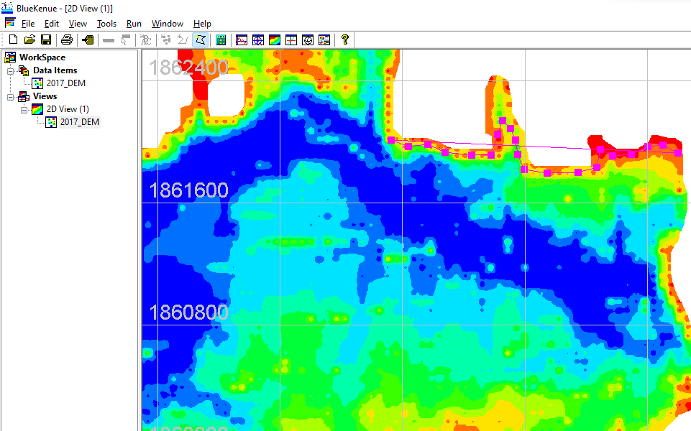

Upon finishing creating the outline, press **ESC** to name the object.

Figure 28. Naming the Newly Created Outline

1. Once finished, press the “**ESC**” button on your keyboard. A query toast will pop up. Enter the desired outline name (i.e., Outline Magat). The units should be in meters (m) and leave the rest at their default values.

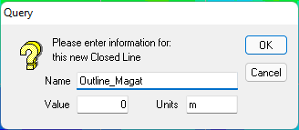

Figure 29. Query upon Pressing ESC

1. Again, drag the newly created item into the 2D view. See figure 85 for reference.

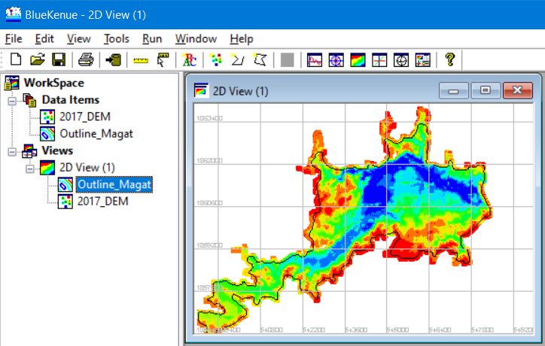

Figure 30. The Current Workspace with the Outline in Dragged into the View Object

Note: Please see Appendix VI: Importing an existing shapefile as an outline.

#### Step 2: The T3 Mesh Generator

To create a spatial representation of the domain to be studied (in this case, the Magat River Main Reservoir), a computational mesh must be created first.

Now, in generating a mesh, a closed line (outline) is enough and can be generated using the steps shown above.

Following the above steps, you should now have a workspace in Blue Kenue with the following files open:

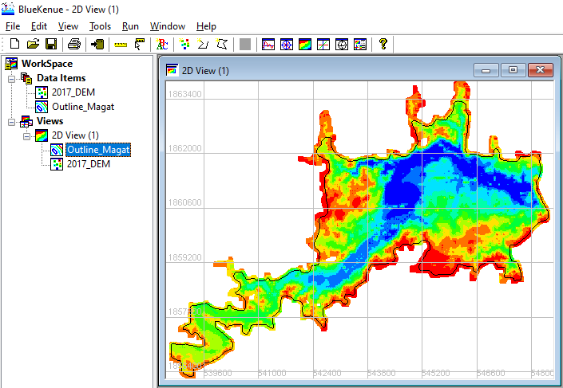

Open a **New** **T3 Mesh Generator**

Figure 31. Current Workspace

1. From the Menu bar, click “**File**” > “**New**” > “**T3 Mesh Generator**”.

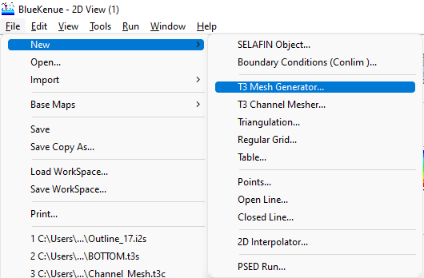

Figure 32. Opening a New T3 Mesh Generator

*Note: The T3 Mesh Generator is used to produce two-dimensional scalar triangular meshes that can be used in models such as TELEMAC and similar programs*

1. Upon clicking, a properties window for the “**newT3Mesh**” will pop up:

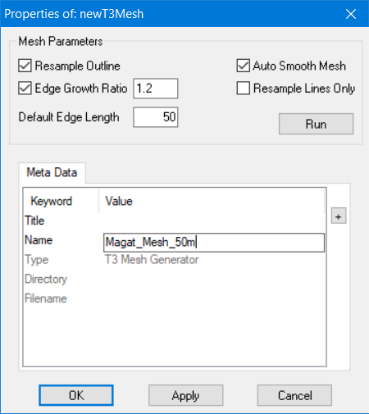

Set **Default Edge Length** to maximum size of element desired.

Change **T3 Mesh Generator Name.**

Figure 33. The New T3 Mesh Properties Window

1. Change “**Default Edge Length**” to “**50”.** Leave the rest settings at their default settings. If desired, you can change the “**Name**” of newT3Mesh by simply clicking on the “**newT3Mesh**” and typing the desired new name (i.e., “**Magat_Mesh_50m**”. Don’t run yet, just click “**OK**”.

*Note:*

* *Resample Outline: If this box is checked, the Mesher will resample the supplied outline, considering the values provided by the various density objects and the default edge length. If this box is unchecked, the triangular mesh will only employ the points that make up the polygon used to form the contour as edge nodes. This box is checked by default.*
* *Auto Smooth Mesh: If this box is checked, the mesh will be adjusted by the Laplacian mesh smoothing algorithm after the mesh has been generated. This box is checked by default.*
* *Edge Growth Ratio: This box, if checked, defines the maximum ratio between the lengths of edges at a given node. This box is checked by default and has a default value of 1.2.*
* *Resample Lines Only: If this box is selected, the outline and soft lines will be resampled according to the density objects, but no mesh will be generated.*
* *Default Edge Length: This value defines the default distance between nodes using the same units as the closed polygon that defines the perimeter of the mesh. The default value is 1, whereas the lower edge length is equal to a higher density.*

1. Drag “**Outline_Magat**” into the “**Outline**” slot.

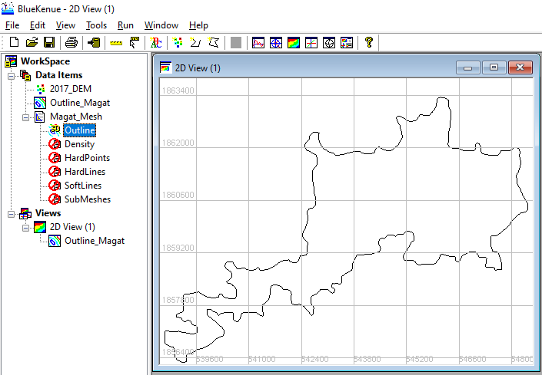

Drag **Outline_Magat** into the generator’s slot for **Outline**

Figure 34. Dragging the Generated Outline into the Generator

*Note:*

* *For now, we can leave the other slots untouched.*
* *Hard points specify the locations of certain nodes as well as modify the local density of nodes.*
* *Any combination of points, polylines, closed polygons, triangular meshes, or rectangular grids is used by the density object to define areas of constant or varying density.*
* *Closed hard lines are used to produce islands with fixed outline geometry. These are also used in generated break lines with fixed geometry.*
* *Closed soft lines are used to produce islands with geometry determined from the density object. On the other hand, open soft lines produce break lines where the node spacing is determined by the density object.*

1. Once the “**Outline**” slot is filled, go to the “**Magat_Mesh_50m**” properties again by either double-clicking it or right-click >> P**roperties**.

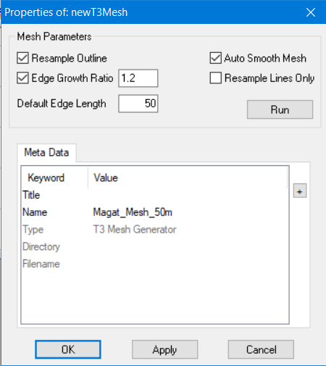

Figure 35. Running the Mesh Generator

1. We can now click “**Run**”. A dialog containing Outer Boundary Area and other parameters will appear. Simply click “**Yes**” to continue.

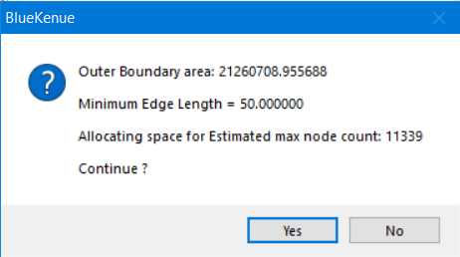

Figure 36. Running the Generator

1. In this example, the program can generate mesh within about a few seconds.

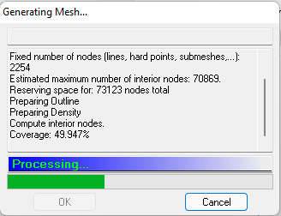

Figure 37. The Mesh Generator

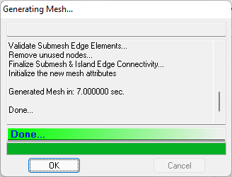

Figure 38. The Mesh Generator after a Successful Run

1. Click “**Ok**”>> “**Ok”.**
2. Once finished, notice that a child object called “**New Mesh (NodeType)**” has been added under the “**Magat_Mesh_50m**” item. Then, rename it into “**Magat_Full_Mesh**”.

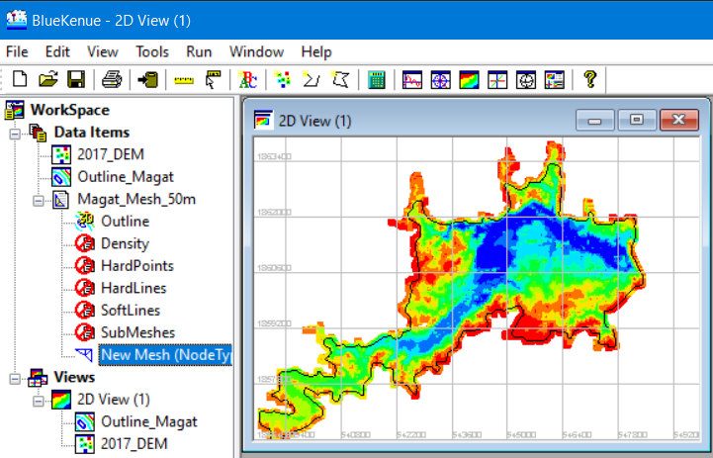

A new item called **New Mesh (NodeType)** is generated.

Figure 39. A Newly Generated Mesh

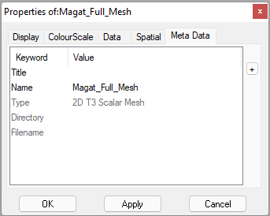

Rename mesh by going into its properties, under the Meta Data.

Figure 40. Renaming the Mesh

1. To see whether the process has been successful, drag the newly generated and renamed “**Magat_Full_Mesh**” into the 2D View.

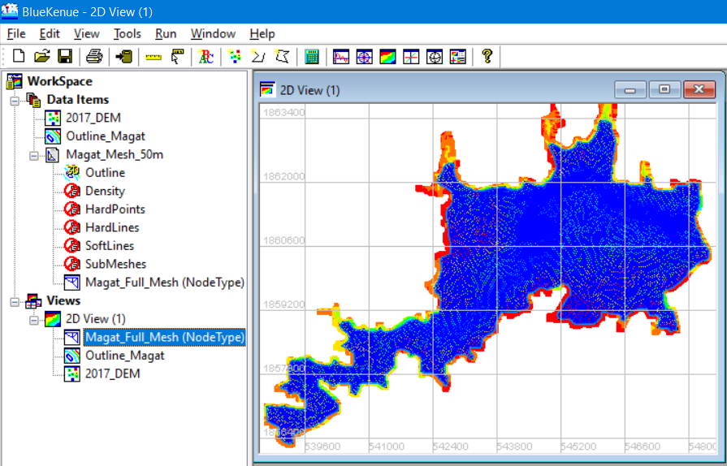

Drag the created mesh into 2D view

Figure 41. The Newly Created Mesh in 2D View

1. To deactivate an object in the 2D view, simply right-click the object of interest and click “**Visible”**.

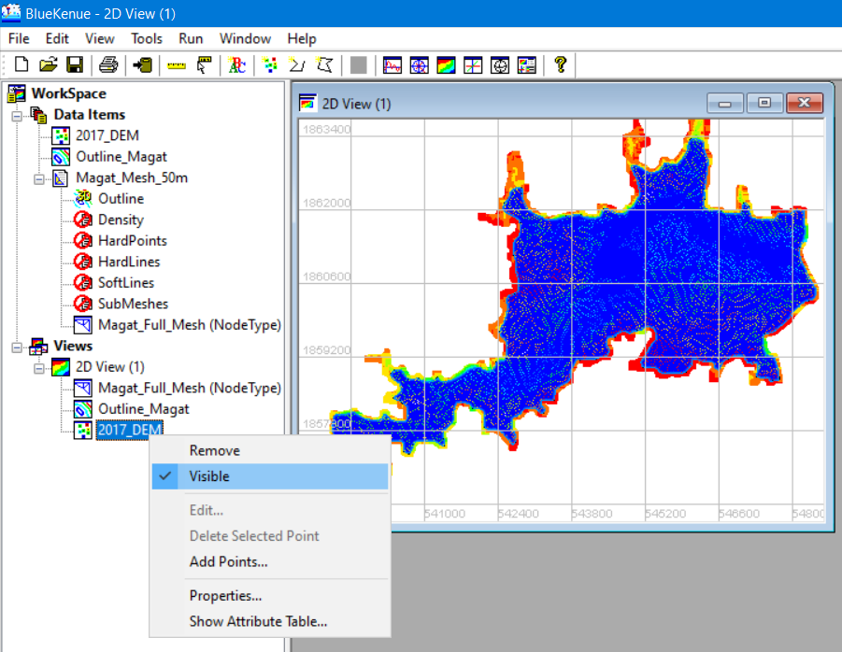

To deactivate an object in the **Views** section, **Right click** > **Visible.** A check mark means the object is visible.

Figure 42. Process of Deactivating an Object in the View Section

### Interpolating the DEM into the Created Mesh

1. Continuing from the last section, create a new Selafin object by clicking the “**New Selafin Object**” icon, which will create a “**newSelafin**” object under the Data Items Menu.

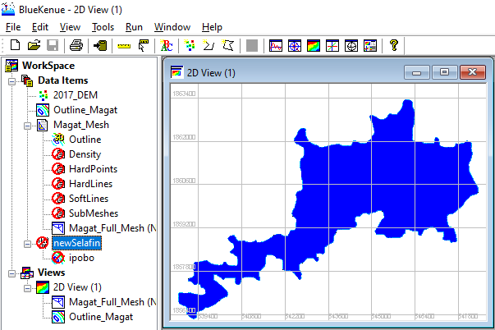

Right click and select **Add Variable.**

Create a **New Selafin Object.**

Figure 43. Creating a New Selafin Object

1. Right click the said Selafin object and select “**Add Variable**”.

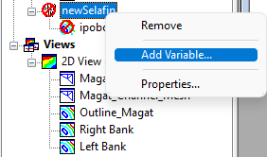

Figure 44. Adding a New Variable to the Selafin Object

1. After which, an “**Add New SELAFIN Variable**” window opens.

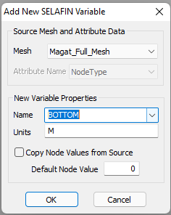

Change mesh property to **BOTTOM** and make sure units is in **m (meters).**

Change the source mesh to **Magat_Full_Mesh.**

Figure 45. The Add New SELAFIN Variable Window

1. Leave the rest at their default values, then click “**OK**”.

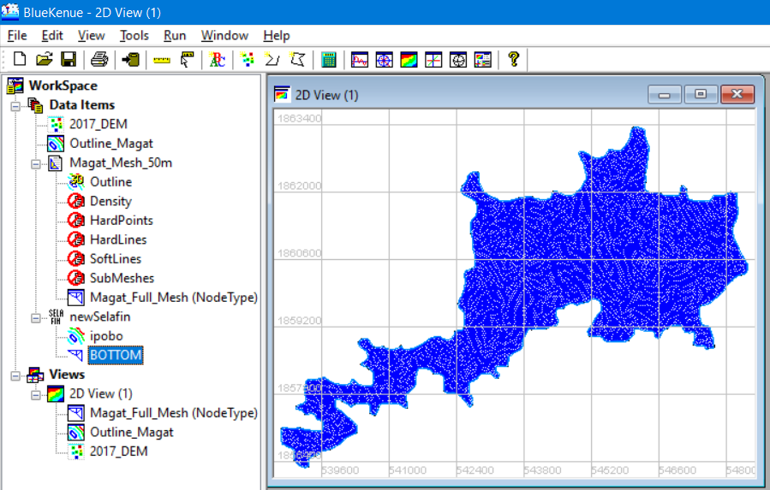

A new **Variable** called **BOTTOM** has been created.

Figure 46 The new **Variable** has been added

1. Next, from the Menu Bar, click “**File”** >> “**New**” >> “**2D Interpolator**”.

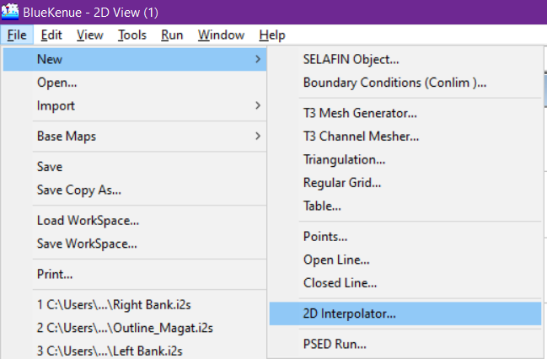

Figure 47. Adding a 2D Interpolator

1. Notice that a “**newInterpolator2D**” is now available in the Data Items menu.
2. Drag the “**2017_DEM**” into the newly created 2D interpolator.

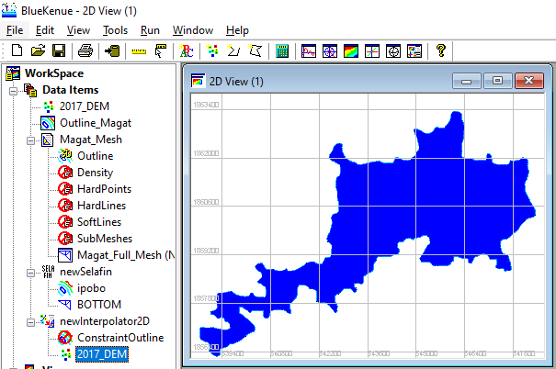

Drag **2017 DEM** into **2D interpolator.**

Figure 48. Dragging the 2017_DEM Item into the Newly Added 2D Interpolator Tool

1. Next, click the “**BOTTOM**” item under the **newSelafin** file to highlight it.

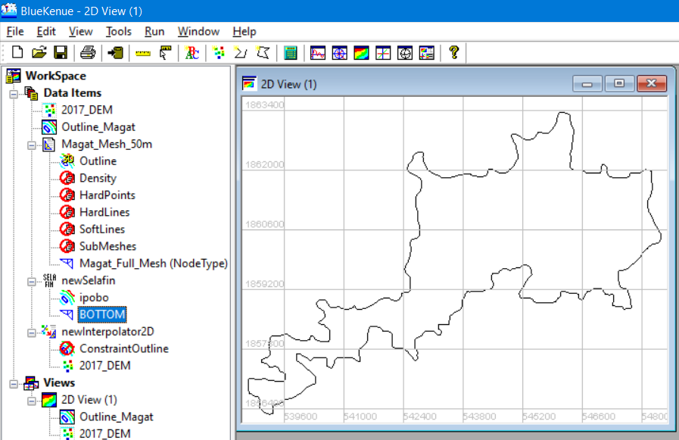

Click **BOTTOM** underthe newSelafin Item to highlight it.

Figure 49. Selecting the Bottom Item

1. Then from the Menu Bar, click “**Tools**” >> “**Map Object**”.

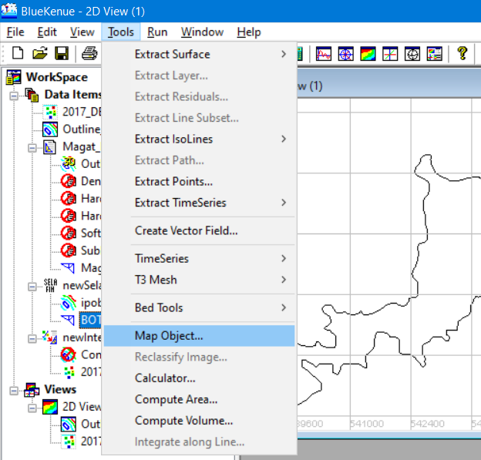

While the **BOTTOM** item is highlighted, activate the **Map Object** tool.

Figure 50. The Map Object Tool

1. A pop-up window appears showing the **Available Objects** from which you select the “**newInterpolator2D**” that we have just created. Then click “**OK**”.

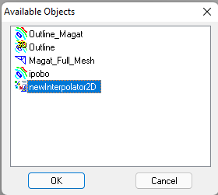

Figure 51. Choosing the NewInterpolator2D

1. A processing window will be shown, then once done, click the “**OK**” button.

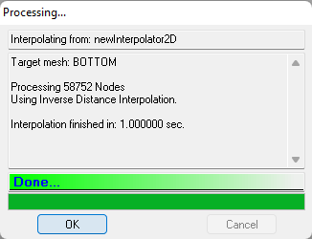

Figure 52. A Successful Interpolation Finished in 1.000 Seconds

1. Now, to check whether the process is successful, drag the “**BOTTOM**” item into the 2D View.

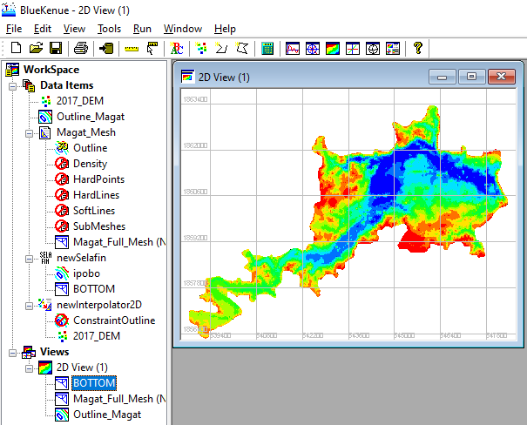

Drag the **BOTTOM** item into 2D view.

Figure 53. Bottom Item in 2D View

1. If you try to zoom in, you can see that the mesh now possesses the same color as that of the DEM file used.

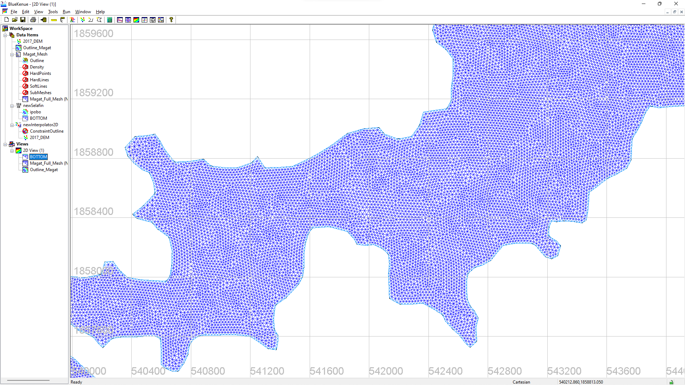

Figure 54. The Mesh before the Interpolation

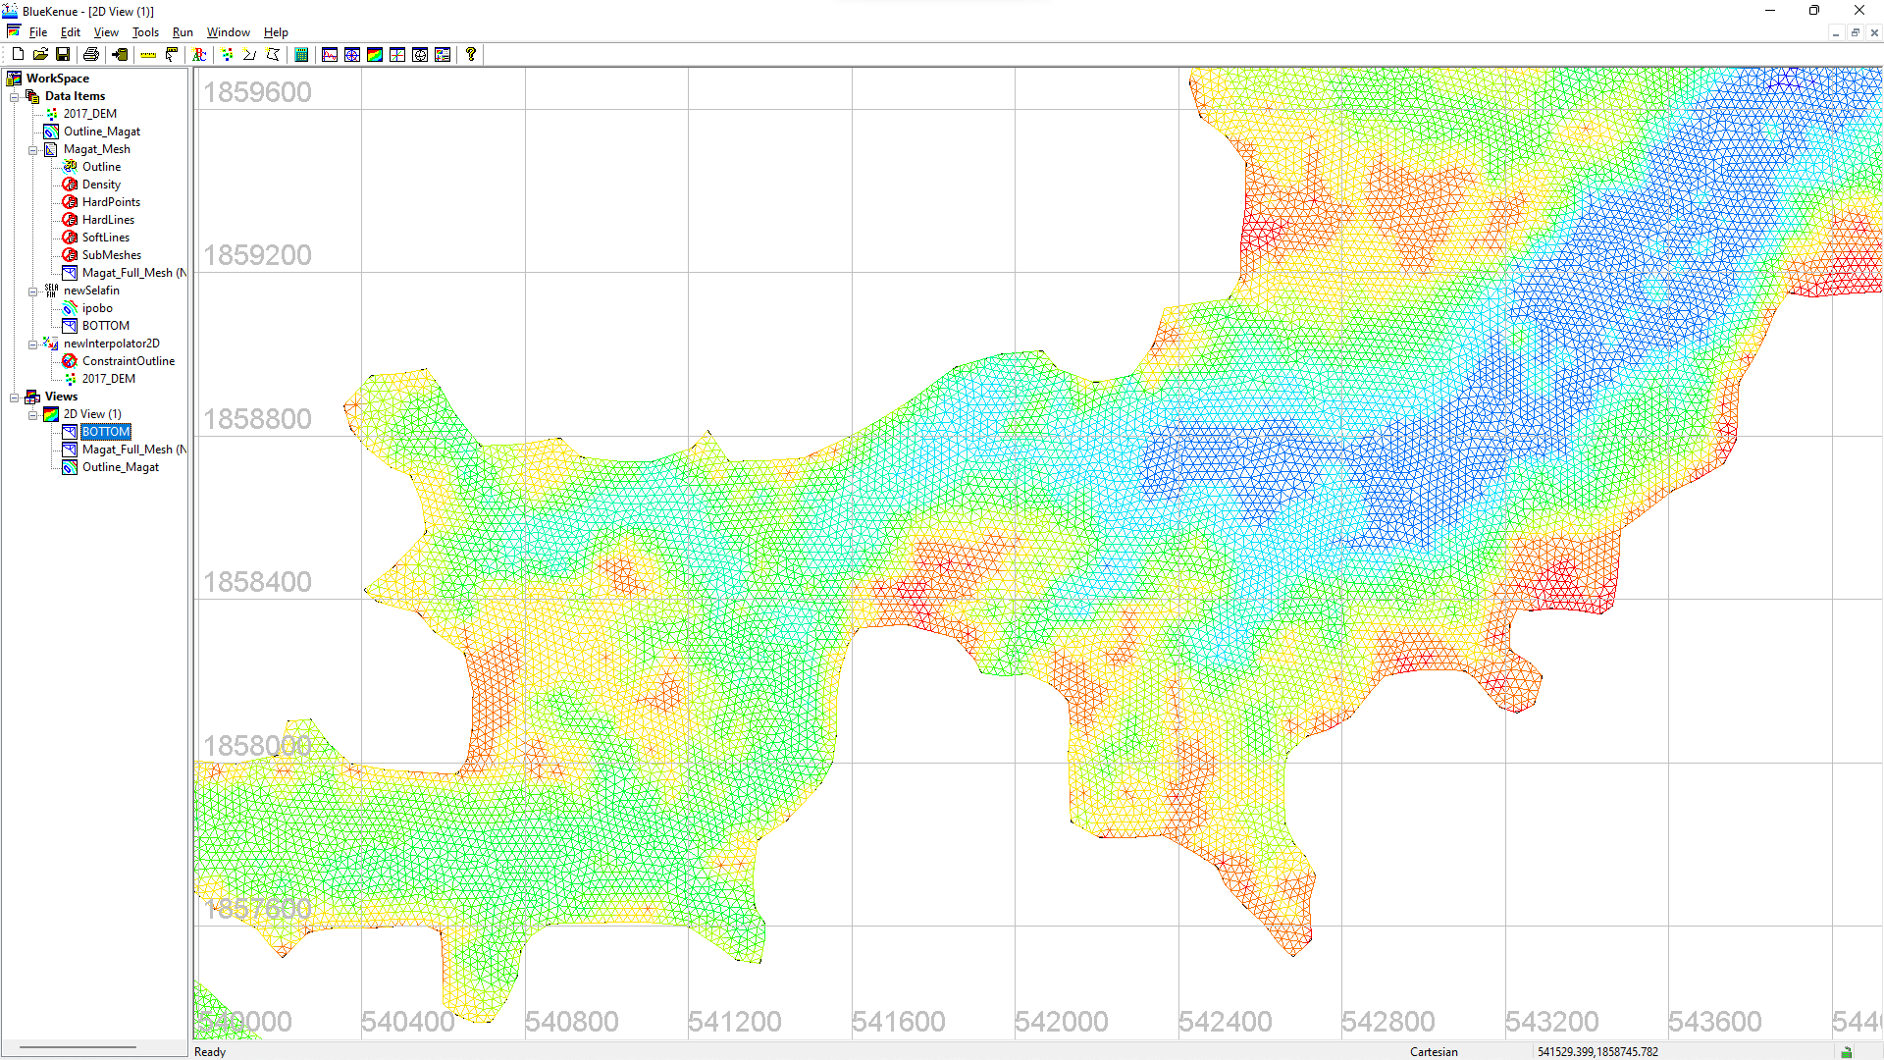

Figure 55. The Mesh after the Interpolation

1. The final step would be to save the Selafin file which is one of the mandatory files needed to run a TELEMAC simulation.
2. Click the “**newSelafin**” item to highlight it, then click the **Save** icon in the file.

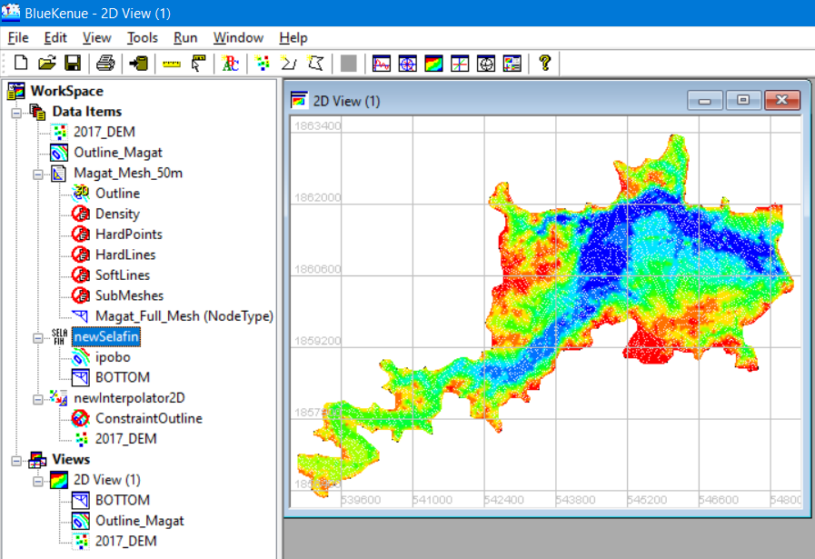

Highlight the **newSelafin** item and click the **Save** icon.

Figure 56. Highlighting Selafin Item and Saving it into File

1. Enter an appropriate name (i.e., Bottom_50m.slf), then click “**Save**”.

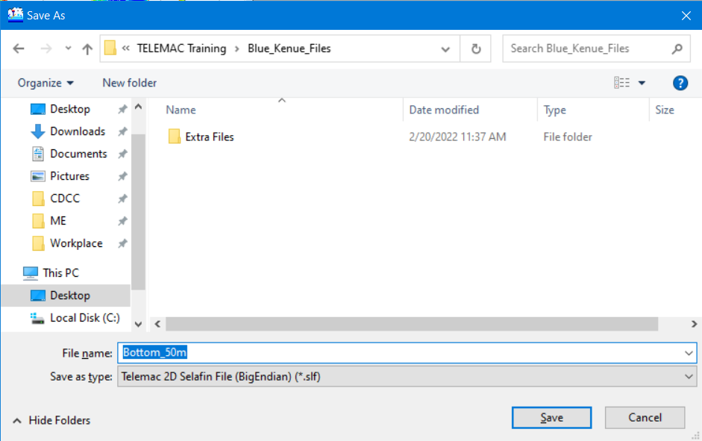

1. Finally, save your workspace by following the steps described on the next page:

### Saving Files and the Workspace

1. We can save the whole workspace into a file which can be useful when transferring to another computer or when picking up from an unfinished session.
2. From the menu bar, click “**File**” >> “**Save Workspace**”.

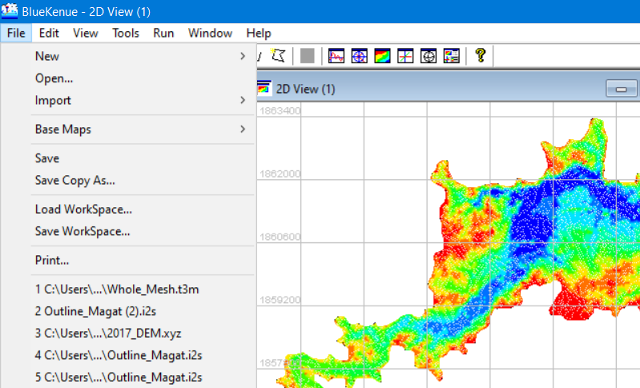

Click **File** >> **Save Workspace.**

Figure 57 Saving an entire Workspace in Blue Kenue

1. Enter a suitable file name for the Workspace (i.e., Magat_Workspace) then click “**Save**”.

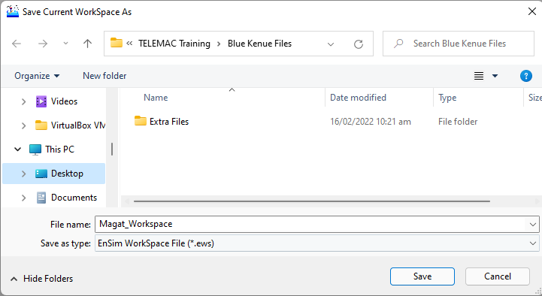

Figure 58. Entering the File Name and Saving Your Workspace

1. A toast with a message that the unsaved objects must be saved first before the Workspace can be saved will pop up. Click “**Yes**” to continue.

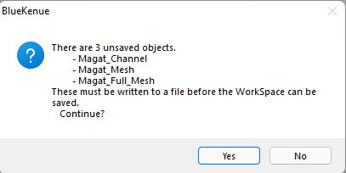

Figure 59. Saving All Unsaved Items

1. Enter appropriate names for each file then click “**Save**”.

*Note: The Workspace File contains all the data object settings, including color scales, legend options, scaling, rendering options, line width, point size, etc. for all currently open objects. Aside from saving data object settings, it also saves the settings for all the views and the object view relationships.*

## Generating Boundary Conditions File Using Blue Kenue

Boundary conditions in the TELEMAC modeling system are specified through a table of variables known as the CONLIM table. Each record in this table corresponds to a boundary (or edge) node in a model’s finite element mesh.

Information regarding inflow and outflow nodes is contained in the boundary file in *.cli format (coordinated and IDs).

1. Continuing from the previous section, we have a workspace containing all the generated meshes and Selafin objects.

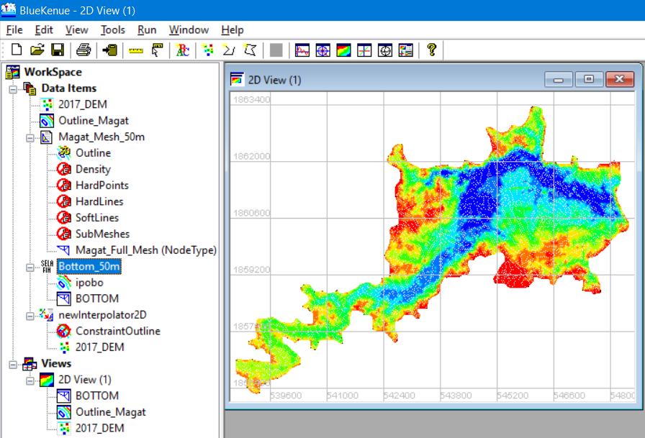

Click **File** >> **New** >> **Boundary Conditions (Conlim).**

Figure 60. Current Workspace

1. From the menu bar, again, click “**File**” >> “**New**” >> “**Boundary Conditions (Conlim).**”

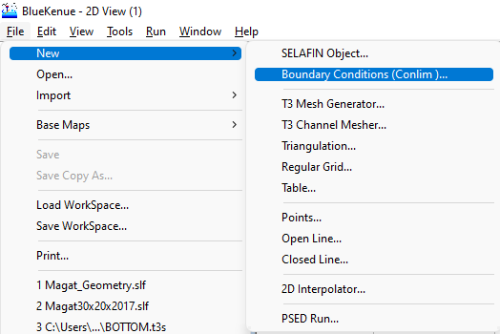

Figure 61. Steps in Creating a New Boundary Conditions Item

1. A window showing the available t3s Objects will show. Select “**Bottom**”, then click “**OK**”.

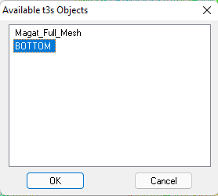

Figure 62. Available t3s Objects

1. Notice that a “**BOTTOM_BC**” item has been added under the Data Item menu.

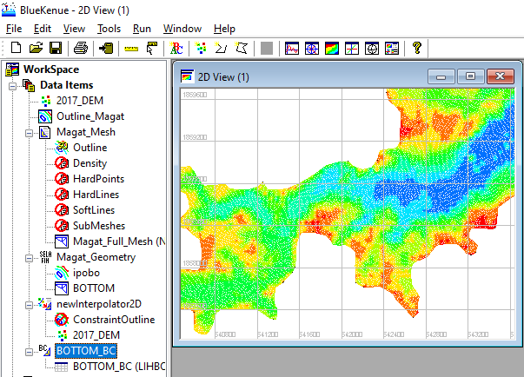

A New **Boundary Conditions (Conlim)** has been added under the **Data Items** menu.

Figure 63. The Newly Created Boundary Conditions Item

1. To start working on the boundary conditions file, drag the “**BOTTOM_BC**” item into the **2D View.**

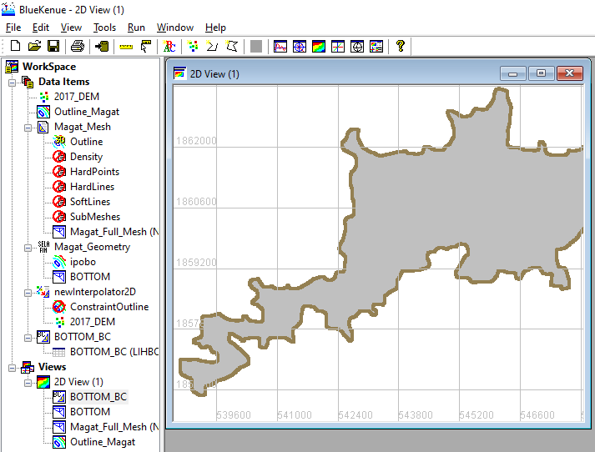

Figure 64. Dragging BOTTOM_BC into 2D View

1. Notice that the color of the mesh in the 2D view now turned gray and the boundary nodes are colored brown. By default, this node color representation means a **Closed Boundary (wall)**.

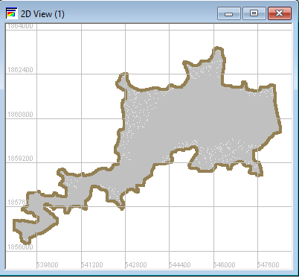

Zoom in into the upstream section of the reservoir.

Figure 65. The 2D View after Dragging BOTTOM_BC

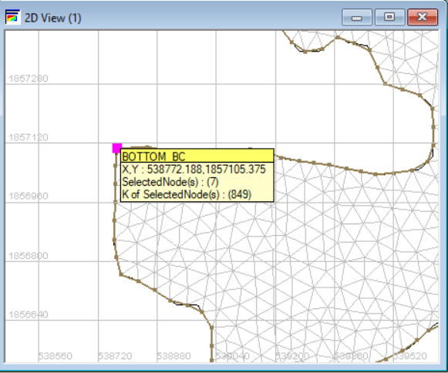

Use your mouse scroll wheel to zoom in.

Figure 66. Zooming in on the Upstream Section of the Reservoir

1. It would help if you maximize your 2D View window.
2. Once zoomed in, point the cursor into a node at the edge and double-click. This will create a magenta-colored dot. Now hold the “**SHIFT**” key on your keyboard and double-click on the other side of the mesh. This will create a magenta-colored line with nodes.



Hold **SHIFT.**

Figure 67. Double-clicking a Node to Start

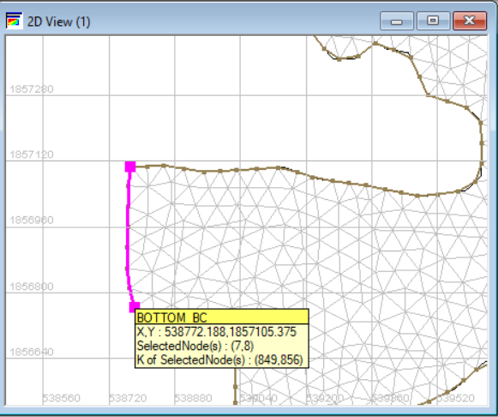

Hold **SHIFT.**

Figure 68. Double-clicking the Other End of the Upstream Section

1. Now, right-click the magenta-colored line and select “**Add Boundary Segment**”.

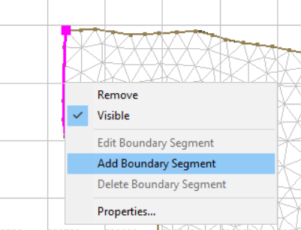

Right click and select “**Add boundary segment”.**

Figure 69. Selecting Add Boundary Segment

1. A “**Conlim Boundary Segment Editor**” window will pop up.

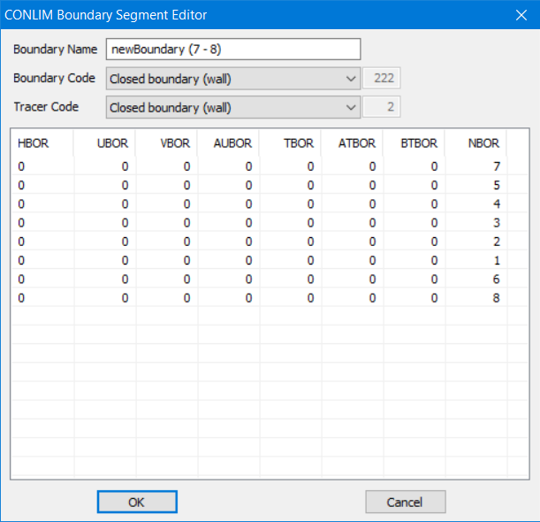

Figure 70. The Conlim Boundary Segment Editor

1. In the “**Boundary Name**” section, type “**Inflow**”, while in the “**Boundary Code**”, choose “**Open boundary with prescribed Q**”. Leave the rest unmodified, and click “**OK**”.

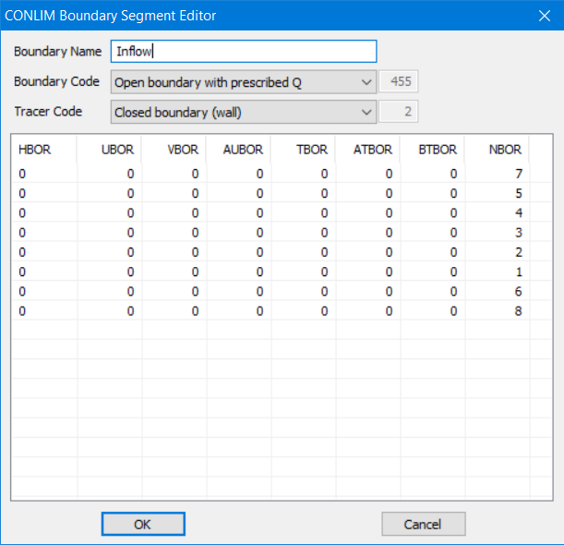

Figure 71. Boundary Properties for the Upstream Boundary Section

*Note:*

* *Q stands for volumetric flowrate, H is for water depth, and UV is for velocity.*
* *The magenta-colored nodes have been changed into blue nodes, which represents an open boundary with prescribed Q.*

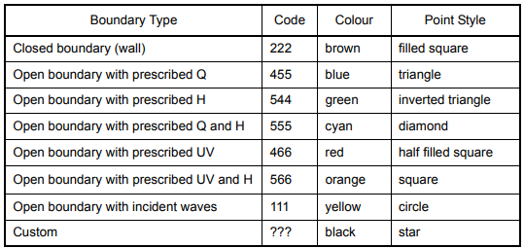

1. Do the same process for the outflow/downstream boundary. A GIS-derived image is attached herein as a reference.

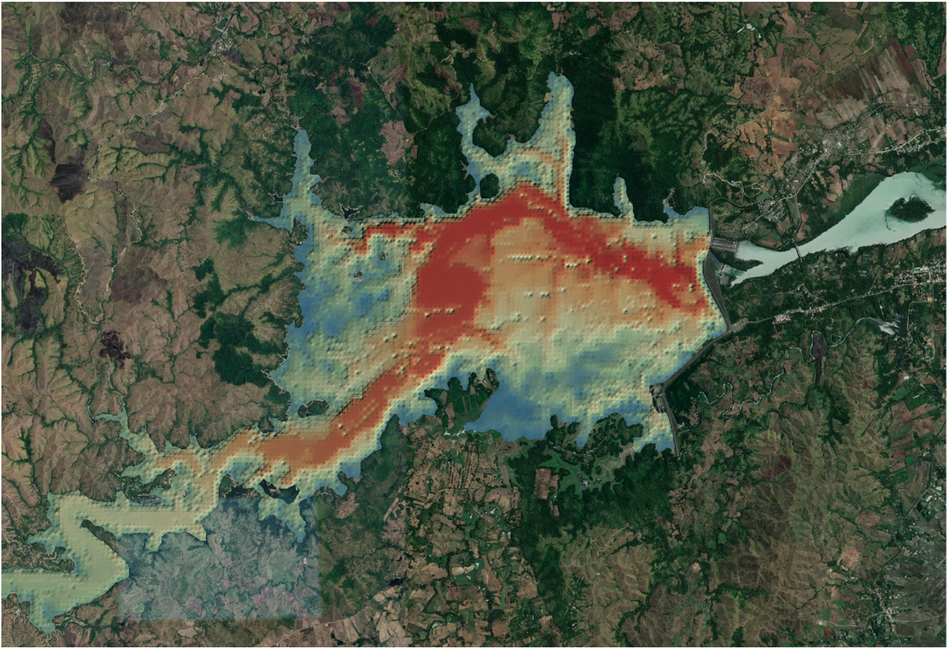

Figure 72. Base Map and the Digital Elevation File for Magat Reservoir

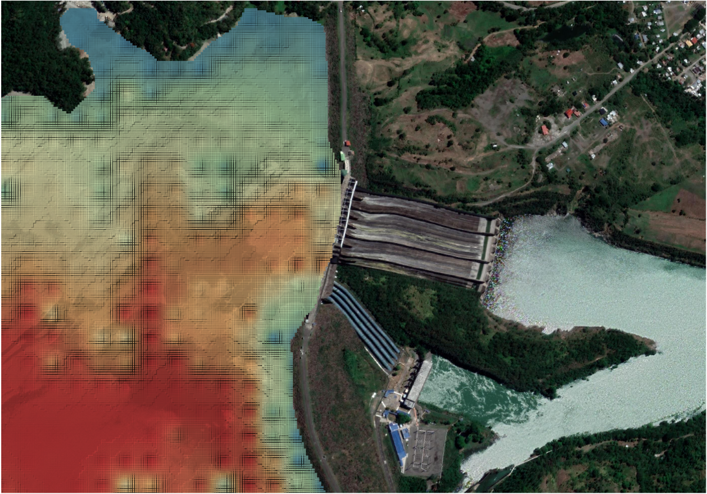

Figure 73. Zooming in on the Discharge Section

1. Back to Blue Kenue, zoom in on the discharge boundary.
2. Execute the same process, double-click to start, hold the **SHIFT** key, then double-click again approximately where the penstock pipes end.

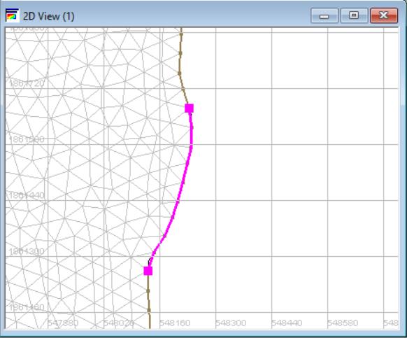

Still while holding **SHIFT** key.

Figure 74. Double-clicking up to the End of the Downstream Section

1. Right-click and select “**Add Boundary Segment.**”

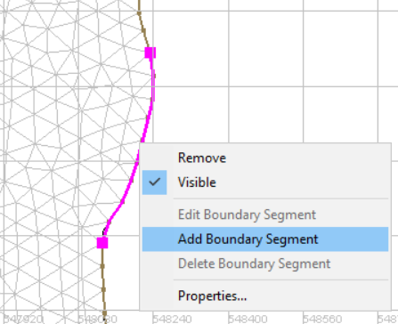

Figure 75. Adding Boundary Segment for the Downstream Boundary

1. In the "**Boundary Name**" section, type "**Outflow**", while in the "**Boundary Code**", choose "**Open boundary with prescribed H**". Leave the rest unmodified, then click "**OK**".

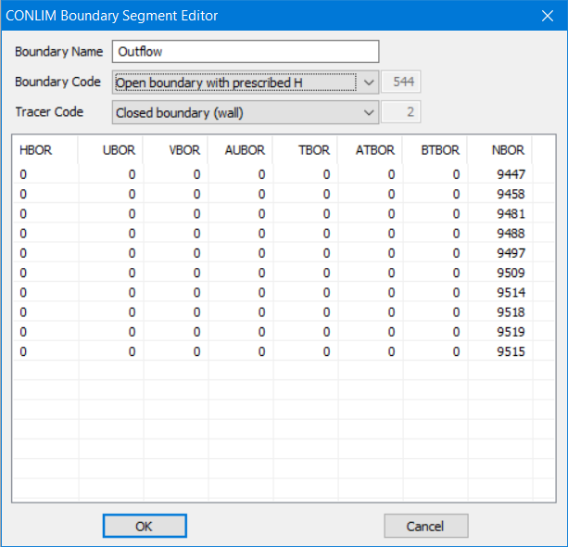

Figure 76. Boundary Properties for the Downstream Boundary Section

1. Again, the magenta-colored nodes now turn to green, a color representation for **Open boundaries with prescribed H nodes**.
2. Rename the newly generated Conlim file into “**Boundary_Conditions**”.

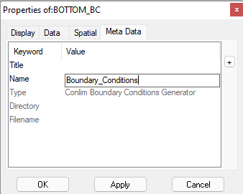

Figure 77. Rename the Items

1. Finally, highlight the child object under it named “**Boundary_Conditions (LIHBOR)** and click the “**Save**” icon to save it into a file.

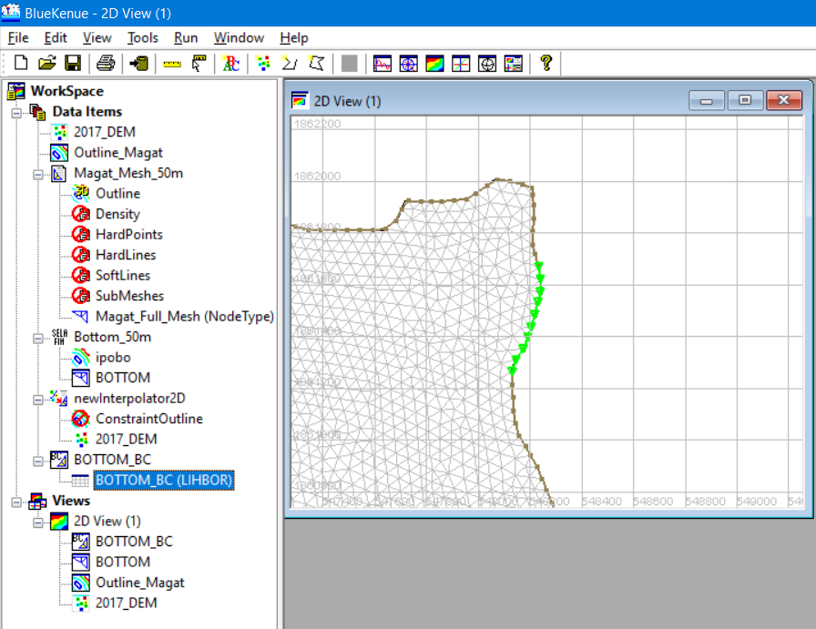

Highlight **BOTTOM_BC(LIHBOR)** and click **save** icon**.**

Figure 78. Saving the Generated Conlim Item

1. Enter the appropriate name (i.e., “**Boundary_Conditions**”) and then save.

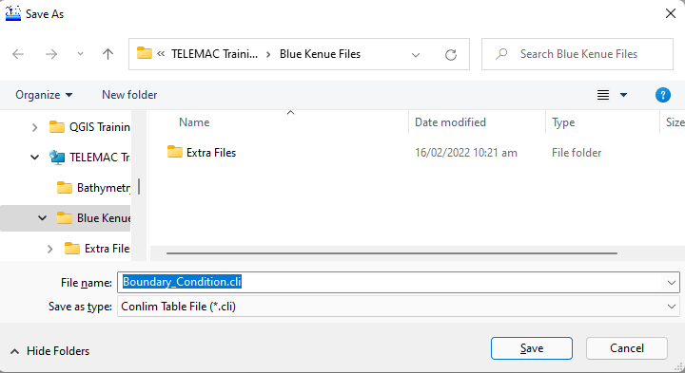

Figure 79. Saving the Boundary Conditions into a File

Note:

*Various Types of Boundary Conditions and their descriptions.*

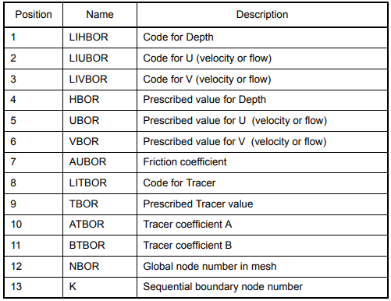

Figure 80. Various Types of Boundary Conditions

1. Finally, save your workspace again by following the steps described above.

## Understanding and Creating a Steering File (CAS File)

The steering file is the file ending in the *.cas file extension. It is the main simulation file with information about references to the two mandatory files (i.e., the SELAFIN *.slf geometry and the *.cli boundary files) and optional files, as well as definitions of simulation parameters. It can be created or edited with a basic text editor or advanced GUI software such as Fudaa PrePro or BlueKenue.

In this manual, we will try to show a sample steering file ***before*** and ***after*** corrections and adjustments.

### Sample Steering File for a **Purely Hydrodynamic Scenario** in Magat Reservoir (Initial/Uncorrected)

/----------------------------------------------------------------------

/ FILE DEFINITION

/----------------------------------------------------------------------

BOUNDARY CONDITIONS FILE : 'BOTTOM_BC.cli'

GEOMETRY FILE : 'Bottom_50m.slf'

RESULTS FILE : 'Magat_V2.slf'

/----------------------------------------------------------------------

/ GENERAL OPTIONS

/----------------------------------------------------------------------

TITLE : 'Magat'

/

VARIABLES FOR GRAPHIC PRINTOUTS : 'U,V,F,H,B,S,Q,W,L'

TIME STEP : 60 /it should be determined by Courant Number

NUMBER OF TIME STEPS : 600

GRAPHIC PRINTOUT PERIOD : 1

LISTING PRINTOUT PERIOD : 10

TIDAL FLATS : YES

OPTION FOR THE TREATMENT OF TIDAL FLATS : 1

/----------------------------------------------------------------------

/ BOUNDARY CONDITIONS

/----------------------------------------------------------------------

PRESCRIBED ELEVATIONS :188.28; 0.0 /downstream boundary

PRESCRIBED FLOWRATES :0.0; 183.78 /upstream boundary

/----------------------------------------------------------------------

/ INITIAL CONDITIONS

/----------------------------------------------------------------------

INITIAL CONDITIONS :'CONSTANT ELEVATION'

INITIAL ELEVATION : 188.28 /initial water level

/----------------------------------------------------------------------

/ NUMERICAL OPTIONS (not necessary to modify for beginner)

/----------------------------------------------------------------------

MASS-BALANCE : YES

SOLVER : 1

SOLVER OPTION : 2

SOLVER ACCURACY : 1.E-4

MAXIMUM NUMBER OF ITERATIONS FOR SOLVER : 1000

PRECONDITIONING : 2

TYPE OF ADVECTION : 14;14

SUPG OPTION : 0;0

DISCRETIZATIONS IN SPACE : 11; 11

MATRIX STORAGE : 3

IMPLICITATION FOR DEPTH : 1.0

IMPLICITATION FOR VELOCITY : 1.0

VELOCITY PROFILES : 1;1

MASS-LUMPING ON H : 1.0

MASS-LUMPING ON VELOCITY : 1.0

MASS-LUMPING ON TRACERS : 1.0

TREATMENT OF THE LINEAR SYSTEM : 2

FREE SURFACE GRADIENT COMPATIBILITY : 0.5

CONTINUITY CORRECTION : YES

TREATMENT OF NEGATIVE DEPTHS : 2

OPTION FOR LIQUID BOUNDARIES : 1;1

OPTION FOR THE DIFFUSION OF VELOCITIES : 1

/----------------------------------------------------------------------

/ TURBULENCE MODEL

/----------------------------------------------------------------------

TURBULENCE MODEL : 3 / 1:constant; 3:K-EPSILON; 4:SMAGORINSKI; 5:MIXING LENGTH

VELOCITY DIFFUSIVITY : 1.E-6

TURBULENCE REGIME FOR SOLID BOUNDARIES : 2

/--------------------------------------------------------/

/ FRICTION PARAMETERS /

/--------------------------------------------------------/

LAW OF BOTTOM FRICTION : 4 /2:CHEZY; 4:MANNING; 5:NIKURADSE

FRICTION COEFFICIENT : 0.023

/----------------------------------------------------------------------

*Note:*

*Please see Appendix III to see visualized results files*

*These files will be provided for the actual training session. See the* ***Simulation_Files*** *folder.*

### Sample Steering File for a Purely Hydrodynamic Scenario in Magat Reservoir (Adjusted/Corrected)

/----------------------------------------------------------------------

/ FILE DEFINITION

/----------------------------------------------------------------------

BOUNDARY CONDITIONS FILE : 'BOTTOM_BC.cli'

GEOMETRY FILE : 'Bottom_50m.slf'

RESULTS FILE : 'Magat_V2.slf'

/----------------------------------------------------------------------

/ GENERAL OPTIONS

/----------------------------------------------------------------------

TITLE : 'Magat'

/

VARIABLES FOR GRAPHIC PRINTOUTS : 'U,V,F,H,B,S,Q,W,L'

TIME STEP : 25 /it should be determined by Courant Number

NUMBER OF TIME STEPS : 3456

GRAPHIC PRINTOUT PERIOD : 10

LISTING PRINTOUT PERIOD : 10

TIDAL FLATS : YES

OPTION FOR THE TREATMENT OF TIDAL FLATS : 1

/----------------------------------------------------------------------

/ BOUNDARY CONDITIONS

/----------------------------------------------------------------------

PRESCRIBED ELEVATIONS :191.65; 0.0 /downstream boundary

PRESCRIBED FLOWRATES :0.0; 4847.74 /upstream boundary

/----------------------------------------------------------------------

/ INITIAL CONDITIONS

/----------------------------------------------------------------------

INITIAL CONDITIONS :'CONSTANT ELEVATION'

INITIAL ELEVATION : 191.65 /initial water level

/----------------------------------------------------------------------

/ NUMERICAL OPTIONS (not necessary to modify for beginner)

/----------------------------------------------------------------------

/

MASS-BALANCE : YES

SOLVER : 1

SOLVER OPTION : 2

SOLVER ACCURACY : 1.E-4

MAXIMUM NUMBER OF ITERATIONS FOR SOLVER : 1000

PRECONDITIONING : 2

TYPE OF ADVECTION : 14;14

SUPG OPTION : 0;0

DISCRETIZATIONS IN SPACE : 11; 11

MATRIX STORAGE : 3

IMPLICITATION FOR DEPTH : 1.0

IMPLICITATION FOR VELOCITY : 1.0

VELOCITY PROFILES : 1;1

MASS-LUMPING ON H : 1.0

MASS-LUMPING ON VELOCITY : 1.0

MASS-LUMPING ON TRACERS : 1.0

TREATMENT OF THE LINEAR SYSTEM : 2

FREE SURFACE GRADIENT COMPATIBILITY : 0.5

CONTINUITY CORRECTION : YES

TREATMENT OF NEGATIVE DEPTHS : 2

OPTION FOR LIQUID BOUNDARIES : 1;1

OPTION FOR THE DIFFUSION OF VELOCITIES : 1

/----------------------------------------------------------------------

/ TURBULENCE MODEL

/----------------------------------------------------------------------

TURBULENCE MODEL : 3 / 1:constant; 3:K-EPSILON; 4:SMAGORINSKI; 5:MIXING LENGTH

VELOCITY DIFFUSIVITY : 1.E-6

TURBULENCE REGIME FOR SOLID BOUNDARIES : 2

/--------------------------------------------------------/

/ FRICTION PARAMETERS /

/--------------------------------------------------------/

LAW OF BOTTOM FRICTION : 4 /2:CHEZY; 4:MANNING; 5:NIKURADSE

FRICTION COEFFICIENT : 0.023

### Sample Steering File for Modelling a Sediment Transport Scenario using TELEMAC coupled with the GAIA Module (Initial/Uncorrected)

The steering files used in coupling hydrodynamics (TELEMAC 2D/3D) and morphodynamics (Gaia) are fairly the same as the sample described above. However, a couple of new keywords for the sediment transport must be added to the steering file:

/----------------------------------------------------------------------

/ FILE DEFINITION

/----------------------------------------------------------------------

BOUNDARY CONDITIONS FILE : 'BOTTOM_BC.cli'

GEOMETRY FILE : 'Bottom_50m.slf'

RESULTS FILE : 'Magat_V2.slf'

/----------------------------------------------------------------------

/ GENERAL OPTIONS

/----------------------------------------------------------------------

TITLE : 'Magat'

/

VARIABLES FOR GRAPHIC PRINTOUTS : 'U,V,F,H,B,S,Q,W,L'

TIME STEP : 60 /it should be determined by Courant Number

NUMBER OF TIME STEPS : 600

GRAPHIC PRINTOUT PERIOD : 1

LISTING PRINTOUT PERIOD : 10

TIDAL FLATS : YES

OPTION FOR THE TREATMENT OF TIDAL FLATS : 1

Added keywords are highlighted

**/----------------------------------------------------------------------**

**/ COUPLING**

**/----------------------------------------------------------------------**

**COUPLING WITH : 'GAIA'**

**GAIA STEERING FILE : 'Gaia_Magat_2D.cas' /steering file name of gaia**

**/----------------------------------------------------------------------**

/ BOUNDARY CONDITIONS

/----------------------------------------------------------------------

PRESCRIBED ELEVATIONS :188.28; 0.0 /downstream boundary (water level)

PRESCRIBED FLOWRATES :0.0; 183.78 /upstream boundary (inflow discharge)

PRESCRIBED TRACERS VALUES :0.0; 1.0 /upstream boundary (inflow sediment)

/----------------------------------------------------------------------

/ INITIAL CONDITIONS

/----------------------------------------------------------------------

INITIAL CONDITIONS :'CONSTANT ELEVATION'

INITIAL ELEVATION : 188.28 /initial water level

/----------------------------------------------------------------------

/ NUMERICAL OPTIONS (not necessary to modify for beginner)

/----------------------------------------------------------------------

MASS-BALANCE : YES

SOLVER : 1

SOLVER OPTION : 2

SOLVER ACCURACY : 1.E-4

MAXIMUM NUMBER OF ITERATIONS FOR SOLVER : 1000

PRECONDITIONING : 2

TYPE OF ADVECTION : 14;14

SUPG OPTION : 0;0

DISCRETIZATIONS IN SPACE : 11; 11

MATRIX STORAGE : 3

IMPLICITATION FOR DEPTH : 1.0

IMPLICITATION FOR VELOCITY : 1.0

VELOCITY PROFILES : 1;1

MASS-LUMPING ON H : 1.0

MASS-LUMPING ON VELOCITY : 1.0

MASS-LUMPING ON TRACERS : 1.0

TREATMENT OF THE LINEAR SYSTEM : 2

FREE SURFACE GRADIENT COMPATIBILITY : 0.5

CONTINUITY CORRECTION : YES

TREATMENT OF NEGATIVE DEPTHS : 2

OPTION FOR LIQUID BOUNDARIES : 1;1

OPTION FOR THE DIFFUSION OF VELOCITIES : 1

/----------------------------------------------------------------------

/ TURBULENCE MODEL

/----------------------------------------------------------------------

TURBULENCE MODEL : 3 / 1:constant; 3:K-EPSILON; 4:SMAGORINSKI; 5:MIXING LENGTH

VELOCITY DIFFUSIVITY : 1.E-6

TURBULENCE REGIME FOR SOLID BOUNDARIES : 2

/--------------------------------------------------------/

/ FRICTION PARAMETERS /

/--------------------------------------------------------/

LAW OF BOTTOM FRICTION : 4 /2:CHEZY; 4:MANNING; 5:NIKURADSE

FRICTION COEFFICIENT : 0.023

/----------------------------------------------------------------------

As stated, an additional steering file called “**Gaia_Magat_2D.cas**” must be also present and is described herein as:

/ TITLE: Gaia_Magat_2D.cas

/----------------------------------------------------------------------/

GEOMETRY FILE = Bottom_50m.slf

BOUNDARY CONDITIONS FILE = BOTTOM_BC.cli

RESULTS FILE = gai_Magat.slf

/----------------------------------------------------------------------/

/ OUTPUTS /

/----------------------------------------------------------------------/

VARIABLES FOR GRAPHIC PRINTOUTS : 'U,V,H,S,R,B,E,TOB,KS' /evolution du fond

MASS-BALANCE : YES

/----------------------------------------------------------------------/

/ PHYSICAL OPTIONS

/----------------------------------------------------------------------/

CLASSES TYPE OF SEDIMENT : CO

CLASSES SEDIMENT DENSITY : 2650.0

CLASSES SEDIMENT DIAMETERS = 0.000008

CLASSES SETTLING VELOCITIES : -9

NUMBER OF LAYERS FOR INITIAL STRATIFICATION : 1

LAYERS INITIAL THICKNESS : 0.D0

LAYERS MASS TRANSFER : 0.D0

LAYERS PARTHENIADES CONSTANT : 5.D-3

LAYERS MUD CONCENTRATION : 900.D0

LAYERS CRITICAL EROSION SHEAR STRESS OF THE MUD : 0.05

CLASSES CRITICAL SHEAR STRESS FOR MUD DEPOSITION : 1000

SKIN FRICTION CORRECTION : 0

/----------------------------------------------------------------------/

/ NUMERICAL OPTIONS

/----------------------------------------------------------------------/

ADVECTION-DIFFUSION SCHEME WITH SETTLING VELOCITY : 1 / SET_DIF scheme

SOLVER FOR DIFFUSION OF SUSPENSION = 1

### Sample Steering File for Modelling a Sediment Transport Scenario by Coupling TELEMAC with the GAIA Module (Adjusted/Corrected)

/----------------------------------------------------------------------

/ FILE DEFINITION

/----------------------------------------------------------------------

Adjusted parameters are shown in bold letters

BOUNDARY CONDITIONS FILE : 'BOTTOM_BC.cli'

GEOMETRY FILE : 'Bottom_50m.slf'

RESULTS FILE : 'Magat_V2.slf'

/----------------------------------------------------------------------

/ GENERAL OPTIONS

/----------------------------------------------------------------------

TITLE : 'Magat'

/

**VARIABLES FOR GRAPHIC PRINTOUTS : 'U,V,F,H,B,S,Q,W,L,T*'**

**TIME STEP : 25 /it should be determined by Courant Number**

**NUMBER OF TIME STEPS : 3456**

**GRAPHIC PRINTOUT PERIOD : 10**

**LISTING PRINTOUT PERIOD : 10**

TIDAL FLATS : YES

OPTION FOR THE TREATMENT OF TIDAL FLATS : 1

/----------------------------------------------------------------------

COUPLING

/----------------------------------------------------------------------

COUPLING WITH : 'GAIA'

GAIA STEERING FILE : 'Gaia_Magat_2D.cas' /steering file name of gaia

/----------------------------------------------------------------------

/ BOUNDARY CONDITIONS

/----------------------------------------------------------------------

PRESCRIBED ELEVATIONS :**191.65; 0.0** /downstream boundary (water level)

PRESCRIBED FLOWRATES :**0.0; 4847.74** /upstream boundary (inflow discharge)

PRESCRIBED TRACERS VALUES :**0.0; 19.07** /upstream boundary (inflow sediment)

/----------------------------------------------------------------------

/ INITIAL CONDITIONS

/----------------------------------------------------------------------

**INITIAL CONDITIONS :'CONSTANT ELEVATION'**

**INITIAL ELEVATION : 191.65 /initial water level**

/

/----------------------------------------------------------------------

/ NUMERICAL OPTIONS (not necessary to modify for beginner)

/----------------------------------------------------------------------

MASS-BALANCE : YES

SOLVER : 1

SOLVER OPTION : 2

SOLVER ACCURACY : 1.E-4

MAXIMUM NUMBER OF ITERATIONS FOR SOLVER : 1000

PRECONDITIONING : 2

TYPE OF ADVECTION : 14;14

SUPG OPTION : 0;0

DISCRETIZATIONS IN SPACE : 11; 11

MATRIX STORAGE : 3

IMPLICITATION FOR DEPTH : 1.0

IMPLICITATION FOR VELOCITY : 1.0

VELOCITY PROFILES : 1;1

MASS-LUMPING ON H : 1.0

MASS-LUMPING ON VELOCITY : 1.0

MASS-LUMPING ON TRACERS : 1.0

TREATMENT OF THE LINEAR SYSTEM : 2

FREE SURFACE GRADIENT COMPATIBILITY : 0.5

CONTINUITY CORRECTION : YES

TREATMENT OF NEGATIVE DEPTHS : 2

OPTION FOR LIQUID BOUNDARIES : 1;1

OPTION FOR THE DIFFUSION OF VELOCITIES : 1

/----------------------------------------------------------------------

/ TURBULENCE MODEL

/----------------------------------------------------------------------

/

TURBULENCE MODEL : 3 / 1:constant; 3:K-EPSILON; 4:SMAGORINSKI; 5:MIXING LENGTH

VELOCITY DIFFUSIVITY : 1.E-6

TURBULENCE REGIME FOR SOLID BOUNDARIES : 2

/

/--------------------------------------------------------/

/ FRICTION PARAMETERS /

/--------------------------------------------------------/

LAW OF BOTTOM FRICTION : 4 /2:CHEZY; 4:MANNING; 5:NIKURADSE

FRICTION COEFFICIENT : 0.023

/----------------------------------------------------------------------

### Sample Steering File for Modelling a Sediment Transport Scenario using TELEMAC coupled with GAIA Module and imposing a Hydrograph File (Initial/Uncorrected)

/----------------------------------------------------------------------

/ FILE DEFINITION

/----------------------------------------------------------------------

BOUNDARY CONDITIONS FILE : 'BOTTOM_BC.cli'

GEOMETRY FILE : 'Bottom_50m.slf'

RESULTS FILE : 'Magat_V2.slf'

LIQUID BOUNDARIES FILE = Magat_Boundary.txt /hydrograph B.C. file

/----------------------------------------------------------------------

/ GENERAL OPTIONS

/----------------------------------------------------------------------

TITLE : 'Magat'

/

VARIABLES FOR GRAPHIC PRINTOUTS : 'U,V,F,H,B,S,Q,W,L'

TIME STEP : 60 /it should be determined by Courant Number

NUMBER OF TIME STEPS : 600

GRAPHIC PRINTOUT PERIOD : 1

LISTING PRINTOUT PERIOD : 10

TIDAL FLATS : YES

OPTION FOR THE TREATMENT OF TIDAL FLATS : 1

/----------------------------------------------------------------------

/ COUPLING

/----------------------------------------------------------------------

COUPLING WITH : 'GAIA'

GAIA STEERING FILE : 'Gaia_Magat_2D.cas' /steering file name of gaia

/----------------------------------------------------------------------

/ BOUNDARY CONDITIONS

/----------------------------------------------------------------------

PRESCRIBED ELEVATIONS :188.28; 0.0 /downstream boundary (water level)

PRESCRIBED FLOWRATES :0.0; 183.78 /upstream boundary (inflow discharge)

PRESCRIBED TRACERS VALUES :0.0; 1.0 /upstream boundary (inflow sediment)

/----------------------------------------------------------------------

/ INITIAL CONDITIONS

/----------------------------------------------------------------------

INITIAL CONDITIONS :'CONSTANT ELEVATION'

INITIAL ELEVATION : 188.28 /initial water level

/

/----------------------------------------------------------------------

/ NUMERICAL OPTIONS (not necessary to modify for beginner)

/----------------------------------------------------------------------

MASS-BALANCE : YES

SOLVER : 1

SOLVER OPTION : 2

SOLVER ACCURACY : 1.E-4

MAXIMUM NUMBER OF ITERATIONS FOR SOLVER : 1000

PRECONDITIONING : 2

TYPE OF ADVECTION : 14;14

SUPG OPTION : 0;0

DISCRETIZATIONS IN SPACE : 11; 11

MATRIX STORAGE : 3

IMPLICITATION FOR DEPTH : 1.0

IMPLICITATION FOR VELOCITY : 1.0

VELOCITY PROFILES : 1;1

MASS-LUMPING ON H : 1.0

MASS-LUMPING ON VELOCITY : 1.0

MASS-LUMPING ON TRACERS : 1.0

TREATMENT OF THE LINEAR SYSTEM : 2

FREE SURFACE GRADIENT COMPATIBILITY : 0.5

CONTINUITY CORRECTION : YES

TREATMENT OF NEGATIVE DEPTHS : 2

OPTION FOR LIQUID BOUNDARIES : 1;1

OPTION FOR THE DIFFUSION OF VELOCITIES : 1

/----------------------------------------------------------------------

/ TURBULENCE MODEL

/----------------------------------------------------------------------

TURBULENCE MODEL : 3 / 1:constant; 3:K-EPSILON; 4:SMAGORINSKI; 5:MIXING LENGTH

VELOCITY DIFFUSIVITY : 1.E-6

TURBULENCE REGIME FOR SOLID BOUNDARIES : 2

/--------------------------------------------------------/

/ FRICTION PARAMETERS /

/--------------------------------------------------------/

LAW OF BOTTOM FRICTION : 4 /2:CHEZY; 4:MANNING; 5:NIKURADSE

FRICTION COEFFICIENT : 0.023

### Sample Steering File for Modelling a Sediment Transport Scenario using TELEMAC coupled with GAIA Module and imposing a Boundary File (Corrected/Adjusted)

/----------------------------------------------------------------------

/ FILE DEFINITION

/----------------------------------------------------------------------

BOUNDARY CONDITIONS FILE : 'BOTTOM_BC.cli'

GEOMETRY FILE : 'Bottom_50m.slf'

RESULTS FILE : 'Magat_V2.slf'

LIQUID BOUNDARIES FILE = Magat_Boundary.txt /hydrograph B.C. file

/----------------------------------------------------------------------

/ GENERAL OPTIONS

/----------------------------------------------------------------------

TITLE : 'Magat'

VARIABLES FOR GRAPHIC PRINTOUTS : 'U,V,F,H,B,S,Q,W,L,T*'

**TIME STEP : 25** /it should be determined by Courant Number

**NUMBER OF TIME STEPS : 20592**

**GRAPHIC PRINTOUT PERIOD : 10**

**LISTING PRINTOUT PERIOD : 10**

TIDAL FLATS : YES

OPTION FOR THE TREATMENT OF TIDAL FLATS : 1

/----------------------------------------------------------------------

/ COUPLING

/----------------------------------------------------------------------

COUPLING WITH : 'GAIA'

GAIA STEERING FILE : 'Gaia_Magat_2D.cas' /steering file name of gaia

/----------------------------------------------------------------------

/ BOUNDARY CONDITIONS

/----------------------------------------------------------------------

**PRESCRIBED ELEVATIONS :189.02; 0.0** /downstream boundary (water level)

**PRESCRIBED FLOWRATES :0.0; 301** /upstream boundary (inflow discharge)

**PRESCRIBED TRACERS VALUES :0.0; 1.26** /upstream boundary (inflow sediment)

/----------------------------------------------------------------------

/ INITIAL CONDITIONS

/----------------------------------------------------------------------

INITIAL CONDITIONS :'CONSTANT ELEVATION'

**INITIAL ELEVATION : 189.02** /initial water level

/----------------------------------------------------------------------

/ NUMERICAL OPTIONS (not necessary to modify for beginner)

/----------------------------------------------------------------------

MASS-BALANCE : YES

SOLVER : 1

SOLVER OPTION : 2

SOLVER ACCURACY : 1.E-4

MAXIMUM NUMBER OF ITERATIONS FOR SOLVER : 1000

PRECONDITIONING : 2

TYPE OF ADVECTION : 14;14

SUPG OPTION : 0;0

DISCRETIZATIONS IN SPACE : 11; 11

MATRIX STORAGE : 3

IMPLICITATION FOR DEPTH : 1.0

IMPLICITATION FOR VELOCITY : 1.0

VELOCITY PROFILES : 1;1

MASS-LUMPING ON H : 1.0

MASS-LUMPING ON VELOCITY : 1.0

MASS-LUMPING ON TRACERS : 1.0

TREATMENT OF THE LINEAR SYSTEM : 2

FREE SURFACE GRADIENT COMPATIBILITY : 0.5

CONTINUITY CORRECTION : YES

TREATMENT OF NEGATIVE DEPTHS : 2

OPTION FOR LIQUID BOUNDARIES : 1;1

OPTION FOR THE DIFFUSION OF VELOCITIES : 1

/----------------------------------------------------------------------

/ TURBULENCE MODEL

/----------------------------------------------------------------------

TURBULENCE MODEL : 3 / 1:constant; 3:K-EPSILON; 4:SMAGORINSKI; 5:MIXING LENGTH

VELOCITY DIFFUSIVITY : 1.E-6

TURBULENCE REGIME FOR SOLID BOUNDARIES : 2

/--------------------------------------------------------/

/ FRICTION PARAMETERS /

/--------------------------------------------------------/

LAW OF BOTTOM FRICTION : 4 /2:CHEZY; 4:MANNING; 5:NIKURADSE

FRICTION COEFFICIENT : 0.023

/----------------------------------------------------------------------

The Hydrograph (Boundary Condition File)

*Note: Displaying the first 60 hours only*

# Open boundary file of Magat_upstream_2020

# Simulation duration is from 11/9/2020 00:00 to 11/14/2020

#

T SL(1) Q(2) TR(1,1) TR(2,1)

s m m3/s kg/m3 kg/m3

0 189.02 301 0 1.26209784

3600 189.04 408 0 1.700375418

7200 189.07 453 0 1.88397049

10800 189.11 535 0 2.2176069

14400 189.16 675 0 2.784938155

18000 189.34 1751 0 7.087911415

21600 189.53 1823 0 7.373416954

25200 189.74 2009 0 8.10995036

28800 189.95 2108 0 8.501411778

32400 190.17 2184 0 8.80167725

36000 190.35 1896 0 7.662657678

39600 190.51 1784 0 7.218796697

43200 190.65 1517 0 6.158340916

46800 190.8 1629 0 6.603596377

50400 190.92 1418 0 5.764220215

54000 191.03 1538 0 6.241874992

57600 191.1 1477 0 5.999164123

61200 191.12 1251 0 5.098119621

64800 191.16 1417 0 5.760236452

68400 191.18 1291 0 5.257818321

72000 191.2 1218 0 4.966291423

75600 191.2 1038 0 4.245914694

79200 191.2 1048 0 4.285997515

82800 191.2 1067 0 4.362133864

86400 191.2 1094 0 4.470281102

90000 191.2 1111 0 4.538346341

93600 191.18 915 0 3.75223932

97200 191.16 939 0 3.848665248

100800 191.13 868 0 3.563257342

104400 191.09 728 0 2.999070049

108000 191.06 870 0 3.571303221

111600 191.02 751 0 3.091896846

115200 190.98 727 0 2.995032784

118800 190.95 747 0 3.075757189

122400 190.93 814 0 3.345875484

126000 190.89 701 0 2.890024441

129600 190.85 710 0 2.926382154

133200 190.79 588 0 2.43269486

136800 190.74 624 0 2.578568992

140400 190.7 716 0 2.950615502

144000 190.66 745 0 3.067686713

147600 190.6 557 0 2.30693814

151200 190.56 732 0 3.015218002

154800 190.51 672 0 2.772807663

158400 190.45 571 0 2.363748379

162000 190.41 749 0 3.083827233

165600 190.38 800 0 3.289470873

169200 190.34 785 0 3.229015439

172800 190.3 742.71 0 3.058445485

176400 190.27 832.55 0 3.420581768

180000 190.24 861.78 0 3.538232282

183600 190.2 738.72 0 3.042342596

187200 190.17 849.3 0 3.488010307

190800 190.14 878.53 0 3.605614756

194400 190.1 813.73 0 3.344787865

198000 190.07 742.06 0 3.055822326

201600 190.04 833.29 0 3.423561269

205200 190 735.73 0 3.030274378

208800 189.95 704.48 0 2.904083857

212400 189.89 618.61 0 2.556739349

216000 189.86 742.64 0 3.058162993

### Creating a Steering File Using Notepad (or any basic text editing software available)

1. Copy the text files described in Section 3.3.2. [*Sample Steering File for a Purely Hydrodynamic Scenario in Magat Reservoir (Adjusted)*]
2. In the Windows start menu, type “**Notepad**”.

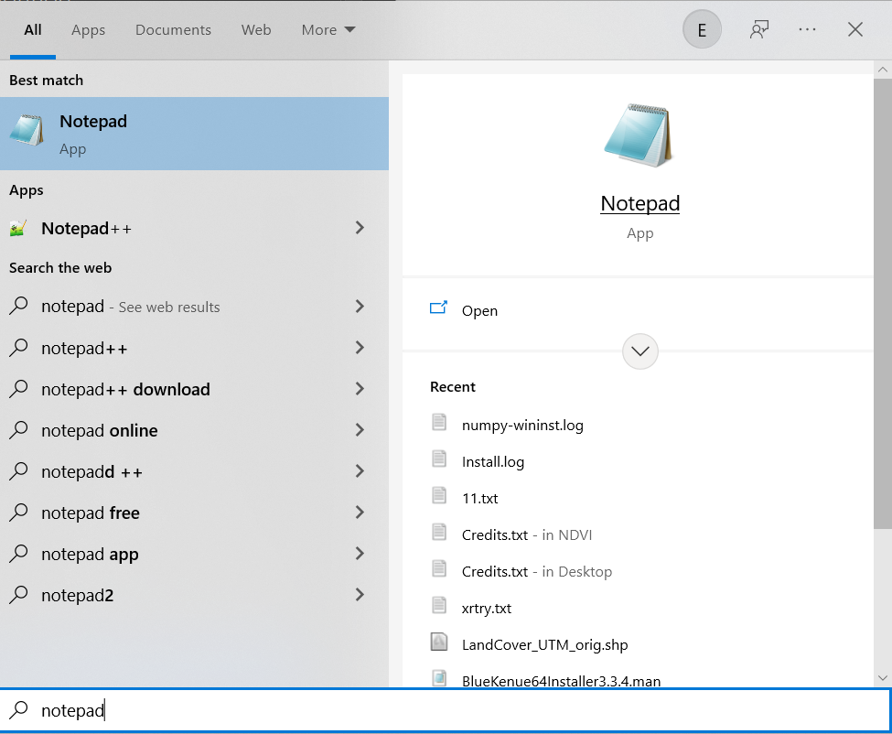

Figure 81. Using Notepad in the Windows Files and Programs Search Option

1. Paste (or manually type if preferred) the copied text files.

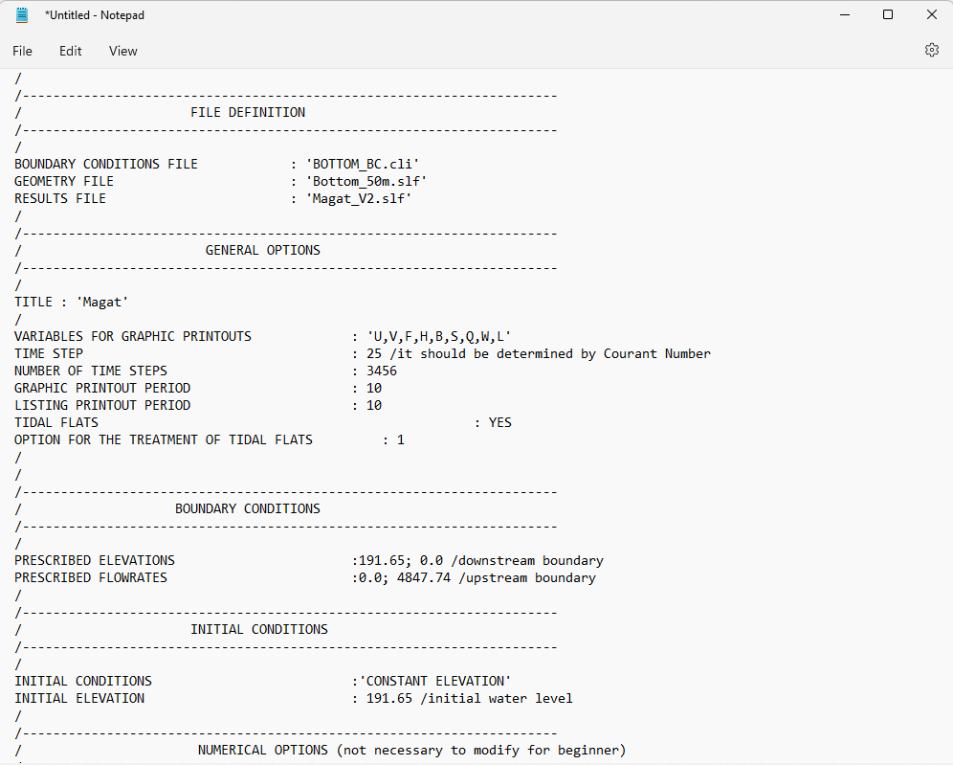

Figure 82. A Sample Steering File for a Purely Hydrodynamic Scenario

1. Click **File** >> **Save as:**

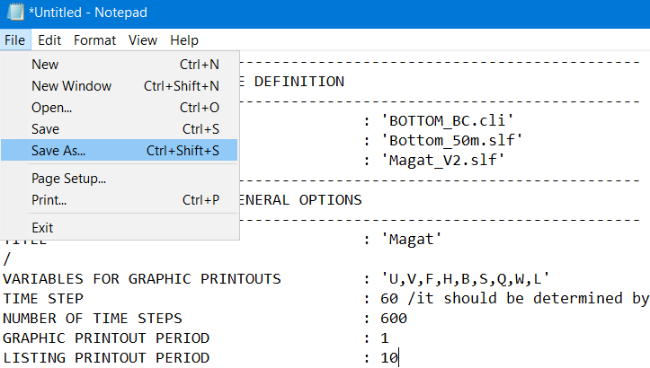

Or simply press **CTRL+Shift+S**.

1. Enter the appropriate file name (i.e., Magat_2D.cas) and do not forget to add the **.cas** extension, and then click “**Save”.**

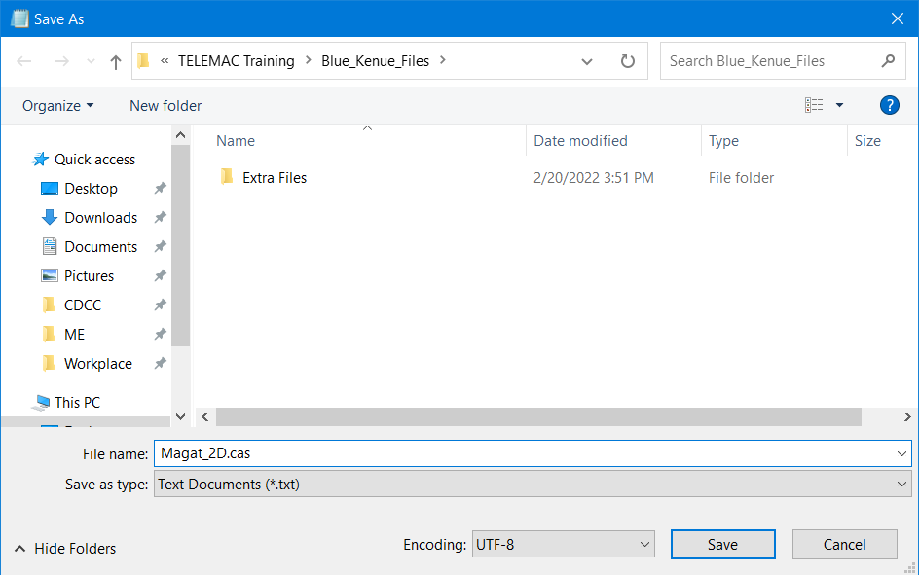

Figure 83. Adding .cas File Extension

# Running the Model Setup

With the steering file (*.cas) generated from the last section, all the necessary files for the TELEMAC 2D simulation are now available. In summary, we have also generated the geometry file (*.slf) which can be found on page 34, and the boundary conditions (*.cli) files on page 57.

Make sure that all these files are now located in a single simulation folder. For the trainees’ convenience, these files have been generated beforehand and are housed in the **Simulation_Files** folder.

## Running a Hydrodynamic Simulation on Windows Environment

### Step 1: Open TELEAMC Command Prompt.

* 1. Open the generated shortcut called “**TELEMAC Command Prompt**” located in the desktop.



### Step 2: Change the directory in the **Simulation_Files** folder

1. Given that the files from the drive folder have been downloaded and extracted into your **Desktop** folder, type the following in the next cmd line:

**C:\Users**username\**\Desktop\TELEMAC Training Files\Simulation Files\Magat_Initial\Sce1_hydroFiles\Magat_Initial\Sce1_hydro**

*Note: Insert your computer’s user name at the *username*, and make sure to remove the asterisk signs afterward. Do not forget to press* ***Enter****.*

### Step 3: Start the simulation.

1. Continuing from the previous step, type **dir** in the next line.

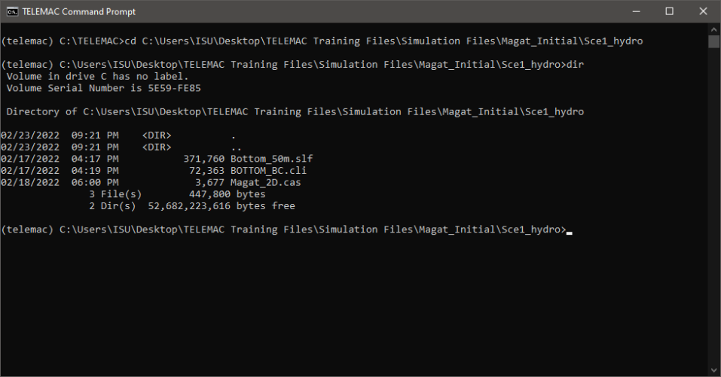

Figure 84. Typing dir in the Next Line

Figure 85. The Contents of the Current Directory

1. Now, type **“python C:\TELEMAC\V8P4\scripts\python3\telemac2d.py Magat_2D.cas**” and press <**Enter**>.

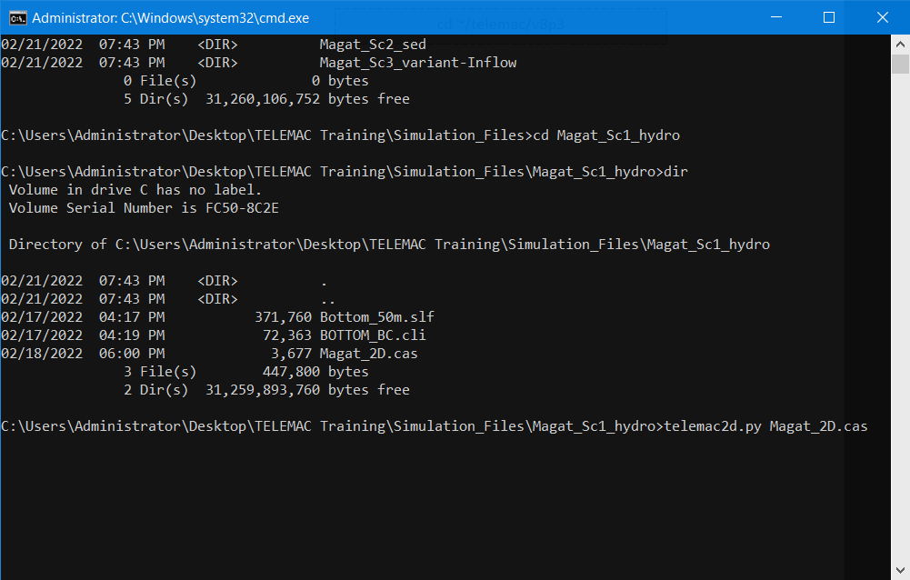

Figure 86. Starting the Simulation through Line of Code

1. Wait for the simulation to finish.

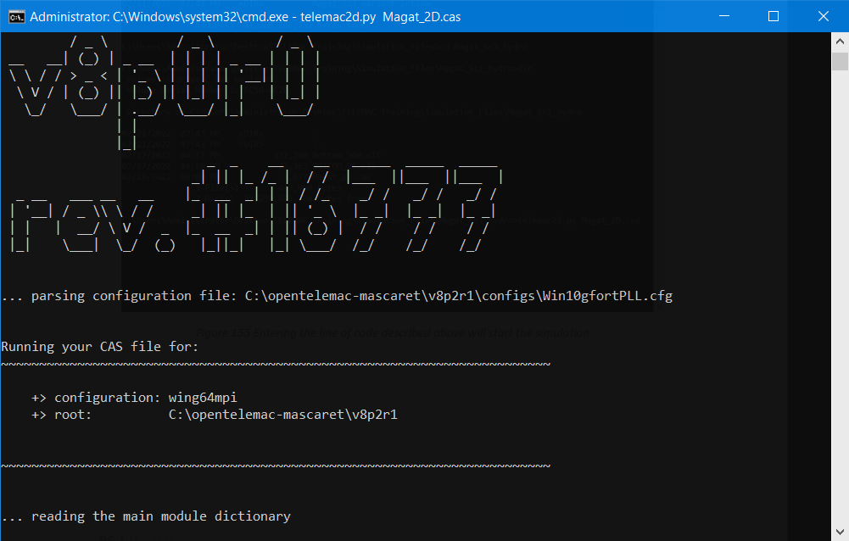

Figure 87. A Snapshot at the Start of the Simulation

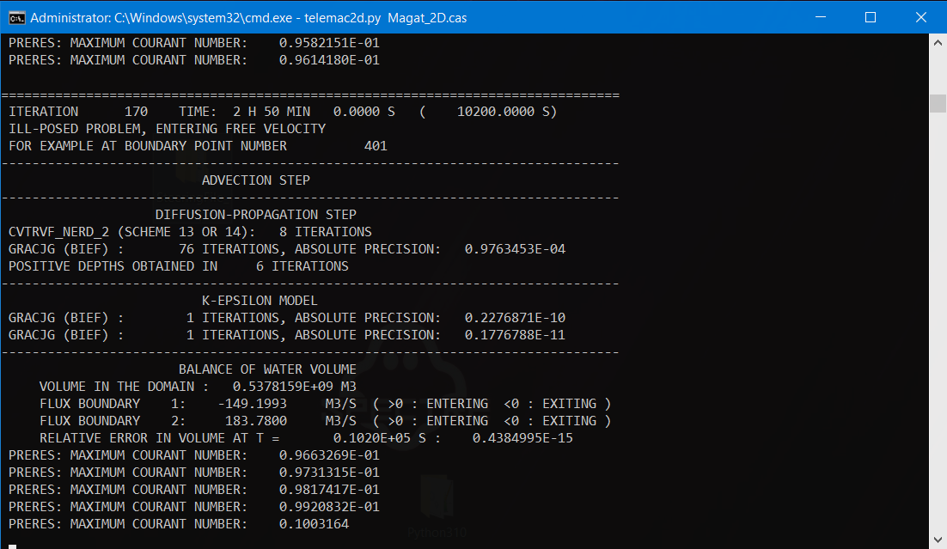

Figure 88. A Snapshot during the Simulation

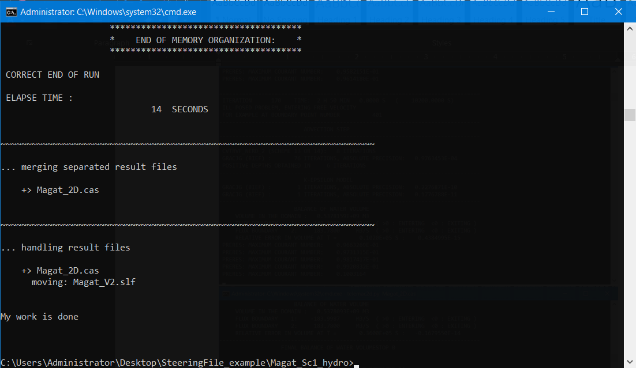

Figure 89. A Successful End of Run

*Note:*

*The steps shown above portray the steps in running the uncorrected steering file. To run the corrected steering file for the scenarios, simply change the directory where the files are stored and follow the same steps shown above.*

# Post-Processing

## Post-Processing Using Blue-Kenue

1. Continuing from a successful run, a new *.slf file called “**Magat_V2.slf**” should have been created inside our simulations file folder.

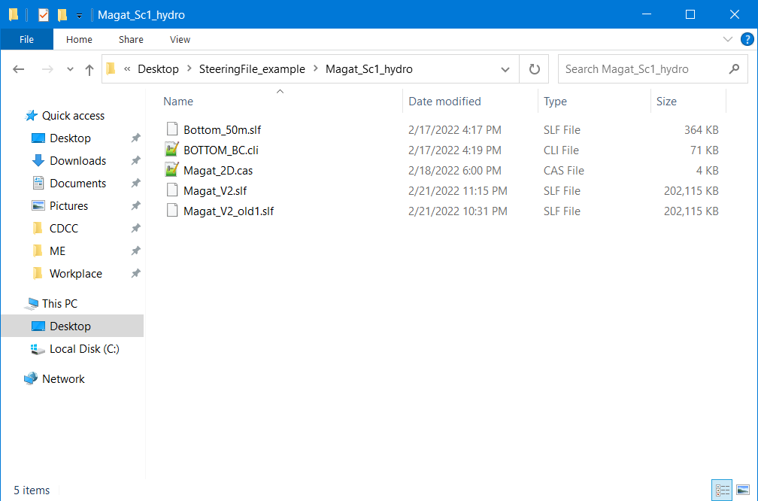

If ever you have run a simulation twice, a “**-old**” will be added into the file name of the first results file. (i.e., **Magat_V2_old.slf)**

Figure 90. The New File Called Magat_V2.slf

1. Open the Blue Kenue application.

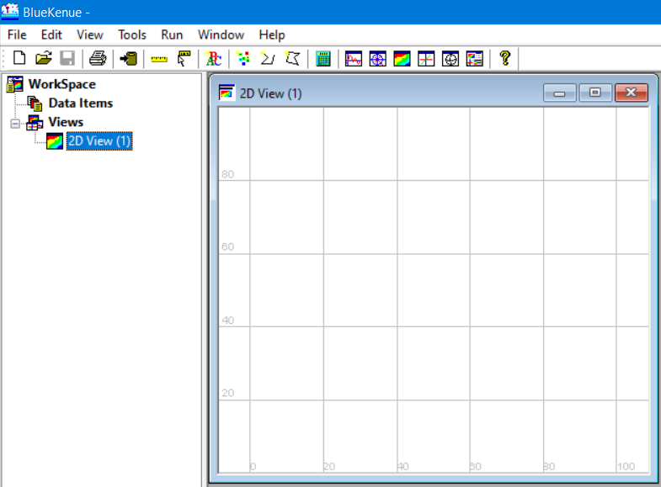

Open the newly generated result of the simulation.

Figure 91. The Blue Kenue User Interface

1. Open the Magat_V2.slf file.

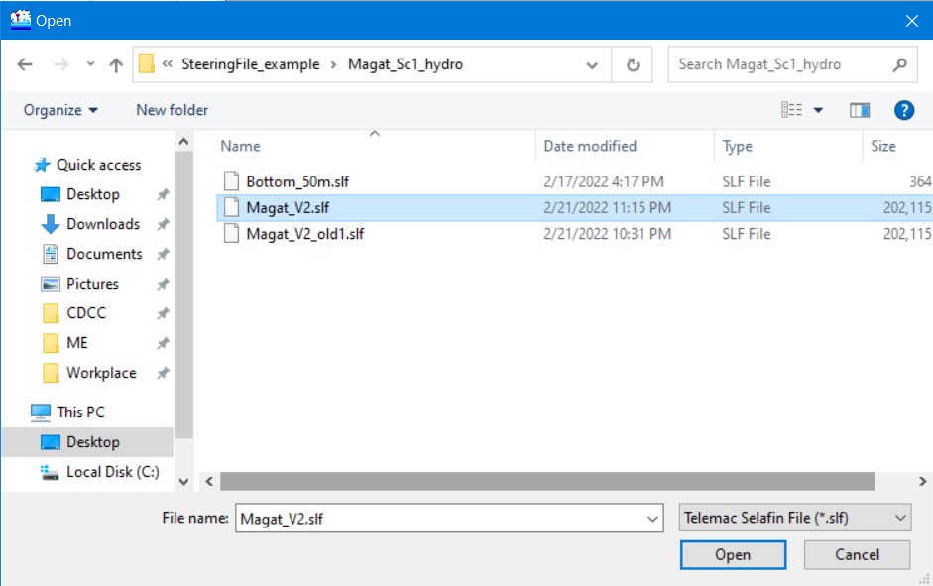

Figure 92. Opening Magat_V2.slf

1. Blue Kenue will read the Selafin file and after a few seconds, display a **Done** message window.

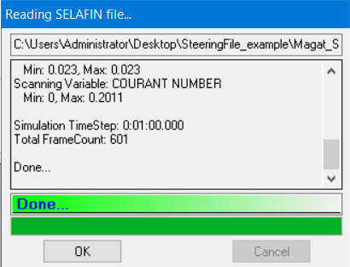

Click **OK.**

Figure 93. A successful Reading and Opening of the Results File

1. Results are now loaded and can be seen under the **Data Items** menu.

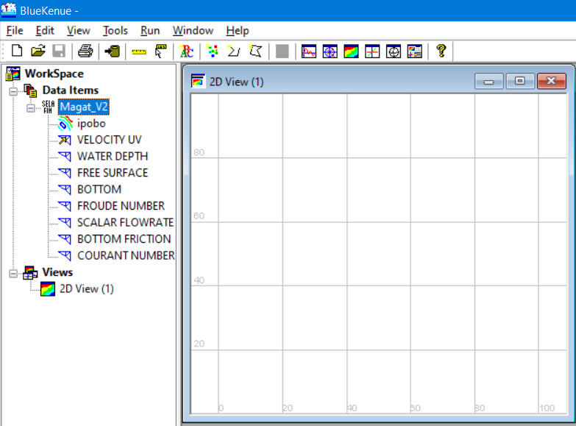

Figure 94 Results file content successfully loaded

### Visualizing Velocity in Blue Kenue

1. Drag the **VELOCITY UV** item into the **2D View.**

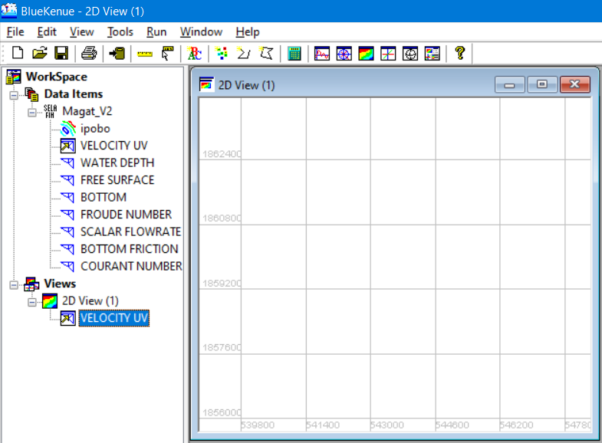

Figure 95. Velocity UV under 2D View

1. Notice that the 2D view window is still empty even after dragging the **VELOCITY UV item** into it.
2. To display the result, right-click the **VELOCITY UV** (the one under 2D View) and select **Animate.**

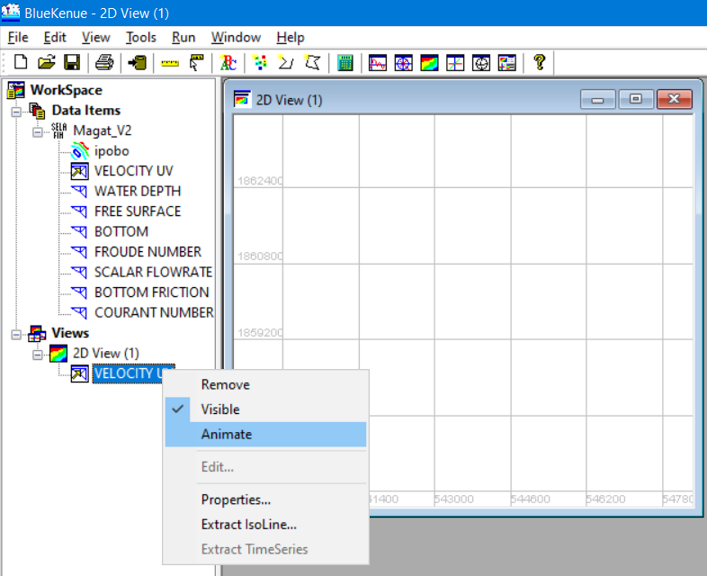

Right click>> **Animate.**

Figure 96. Right Clicking on the VELOCITY UV to Display the Result

1. Notice new **Playback options** are now added to the 2D View. Hit the “**play”** icon.

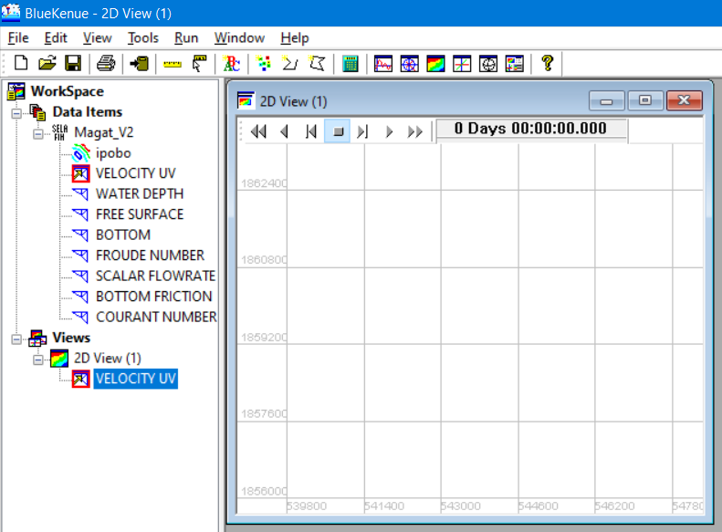

Click the “**play”** icon.

Figure 97. The 2D View with the Animate Playback Option

1. An animation showing the simulated velocity will be shown:

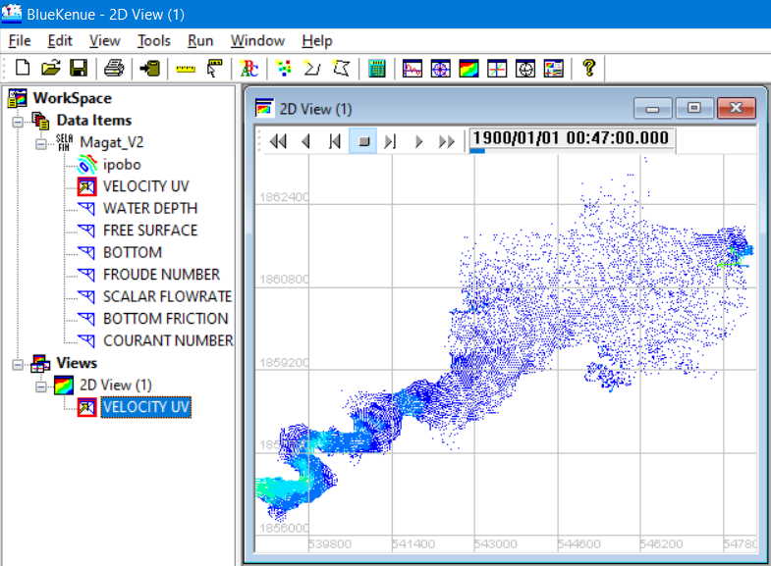

Figure 98. The Animated VELOCITY UV

1. You can modify the properties of the item to show another rendering style, show legend, etc.

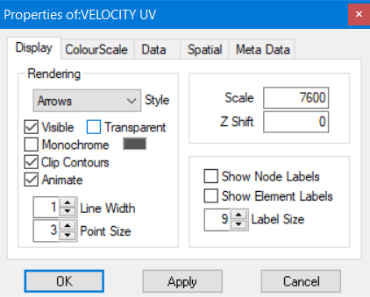

Figure 99. The Display Option Properties

1. Feel free to explore and tinker with the settings to suit your preference.
2. To show the legend, select the “**ColourScale”** tab and activate the “**Legends”** tick box.

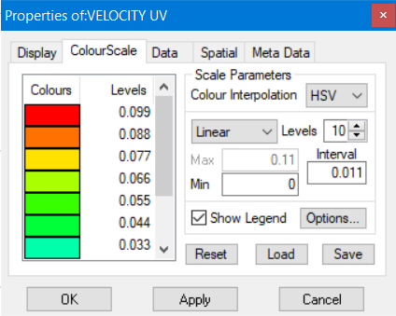

Activate “**Legend”.**

Figure 100. The Activation of the Legend Box

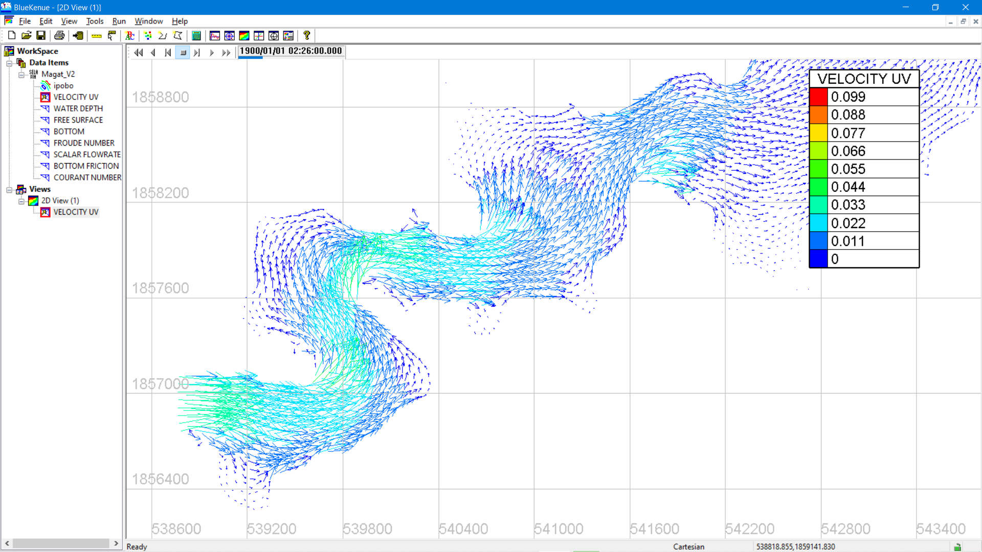

Figure 101. A Simple Visualization of the VELOCITY Profile Using Blue Kenue

# Appendix I: Enabling .NET Framework 3.5

1. Type and search for “**Windows Features**” on your windows start menu.

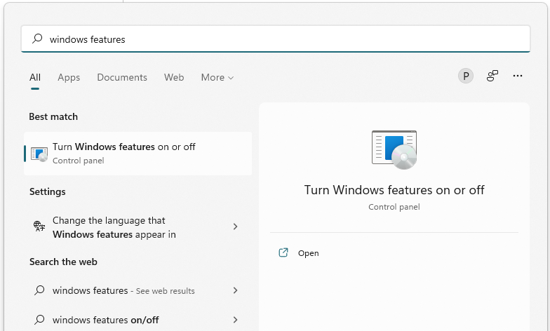

Figure 102. Searching for Windows Features

1. Select “**Turn Windows features on or off**”.

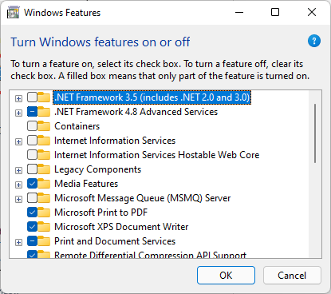

Figure 103. The Windows Features window

1. Make sure to select and enable the “**.NET Framework 3.5 (includes .NET 2.0 and 3.0)”.**

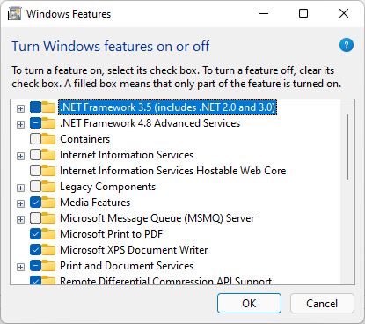

Figure 104. Enabling the .NET Framework 3.5

1. Click **“OK”** to finish. On some devices, your computer/s might have to search and download some components. This will be done automatically so the user/s don’t have to worry about it.

# Appendix II: Adding items into the System Variables Path

1. Once python and the libraries are installed, the next step is to make sure that the **path** to python3.10 and your newly created folder is recognized by your system. To do so, go to Windows start menu or simply press the windows start button and type “**variables**” and press “**Enter”**.

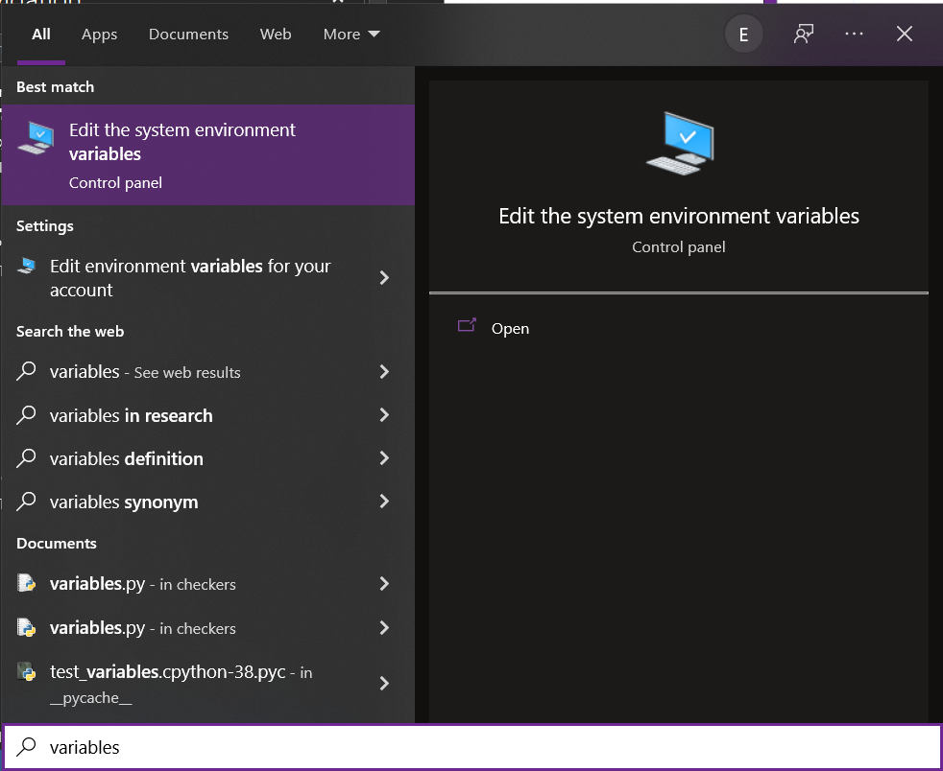

Figure 105 Editing the System Environment Variables

1. After pressing Enter, a system properties window will open then click on **“Environment variables**”.

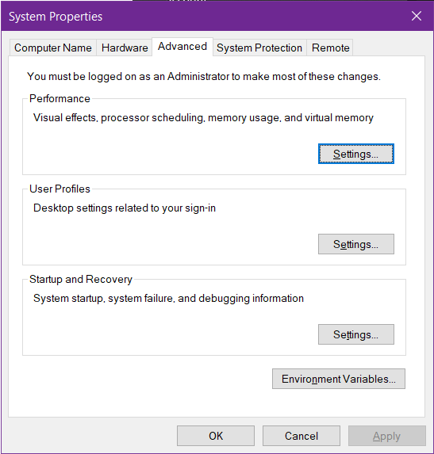

Figure 106 The System Properties Window

1. After that, another window for **Environment Variables** will pop up.

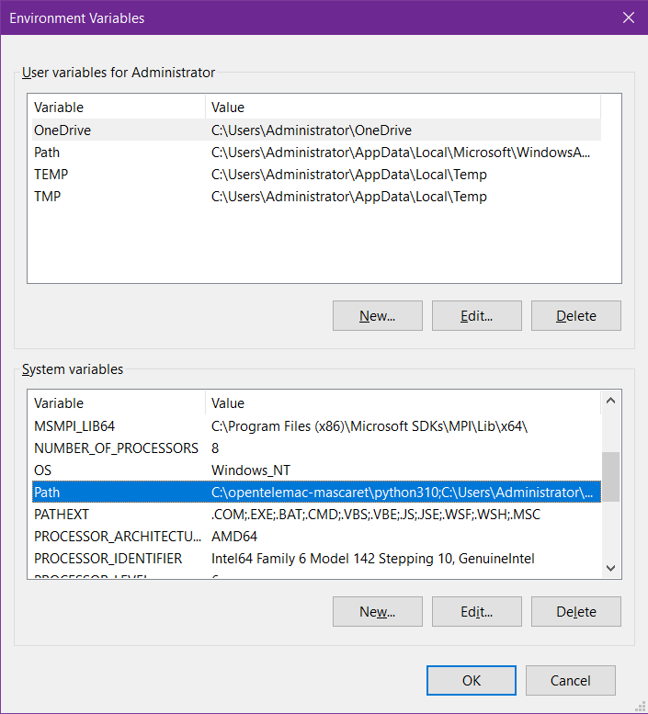

Figure 107 The Environment Variables Window

1. Under **System Variables**, double click on “**Path**”. Doing so will open another window called “**Edit Environment Variable**” and in this window, make sure that the following directory paths are added:

C:\Users\\**your_username*\*\AppData\Local\Programs\Python\Python310\

C:\opentelemac-mascaret\mingw64\bin

C:\opentelemac-mascaret\mpich2\bin

C:\opentelemac-mascaret\mpich2\lib

C:\opentelemac-mascaret\python27

*Note: Insert your computer’s user name at the <your_username>, and make sure to remove the asterisk signs afterwards.*

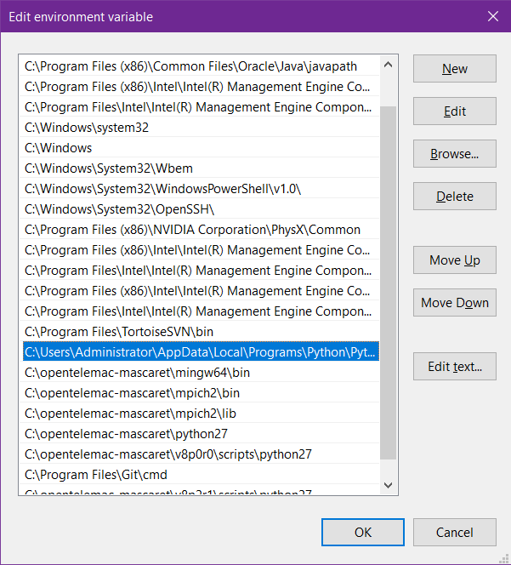

Figure 108 The Edit Environment Variable Window

1. If they are not yet present, add them individually by clicking “**New**” typing each of them individually, and clicking “**OK**” once finished.

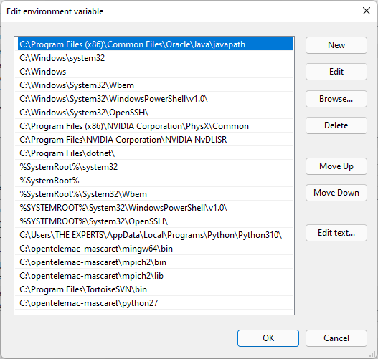

Figure 109 Adding a New Path

1. Click “**OK**” for each of the windows previously opened.

# Appendix III: List of Possible Errors

1. This happens when TELEMAC automatic installer fails.

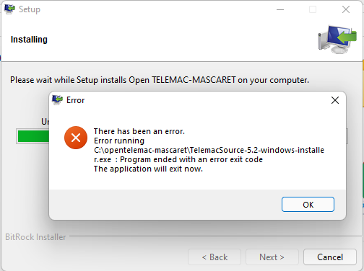

Figure 110. TELEMAC Automatic Installation Failure

This error can be caused by an unstable internet connection. To solve this, please see the Automatic Installer Failure section.

1. This error occurs when pip3 is not recognized as an internal or external command, operable program, or batch file.

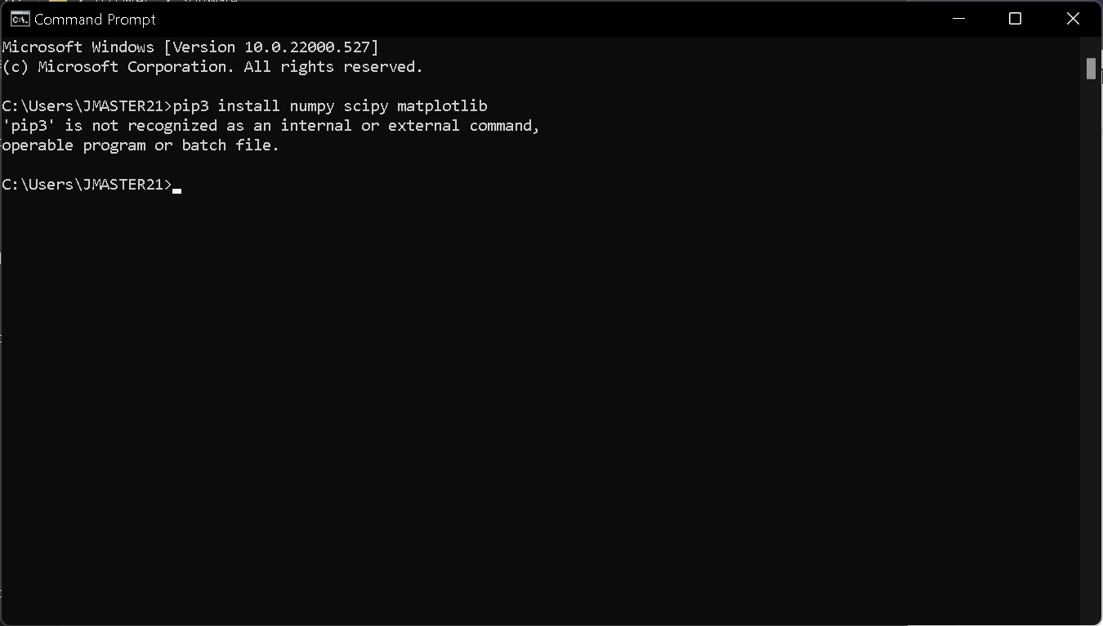

Figure 111. pip3 Error

This error can be possibly encountered after trying to manually install the numpy, scipy, and matplotlib libraries. Please see page 30 for reference.

Probable cause:

* Python 3.10 (or the newly installed python) is not added to the path.

Solution:

* Follow properly the steps in Installing Python 3. or
* Manually add it to the path. See Adding items into the System Variables Path.

1. ImportError: No module named configparser.

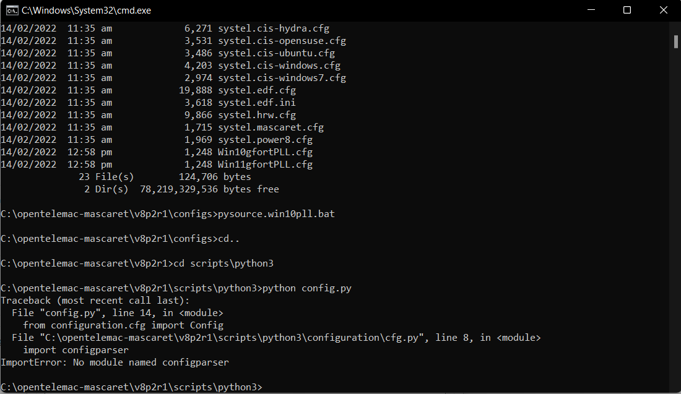

Figure 112. The Configparser Error

This same error might be encountered after trying to load the **config.py** file. This can be solved by making sure that both the config and batch files (**pysource.win10pll.bat** and **Win10gfortPLL.cfg**) are extracted in the correct directory. Please see Figure 43 on page 35.

Additionally, make sure also that the steps in Adding items into the System Variables Path in the system variables are correctly followed.

1. ImportError: No module named request.

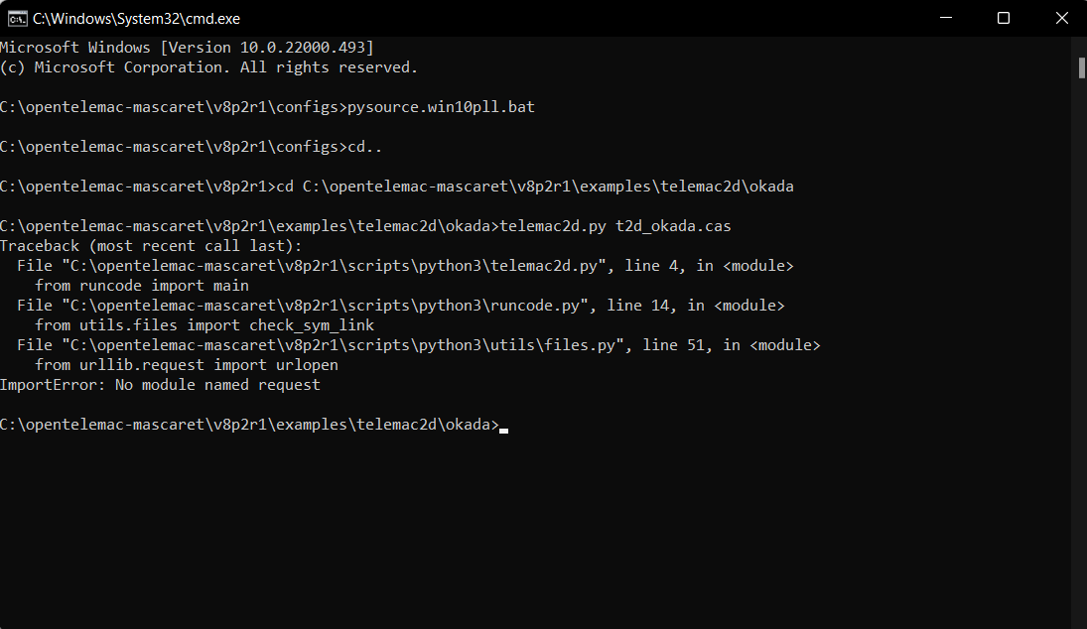

Figure 113. No Module Named Request Error

This error can be resolved also by making sure that the steps in Adding items into the System Variables Path in the system variables are correctly followed.

1. This occurs when telemac2d.py is not recognized as an internal or external command operable program or batch file.

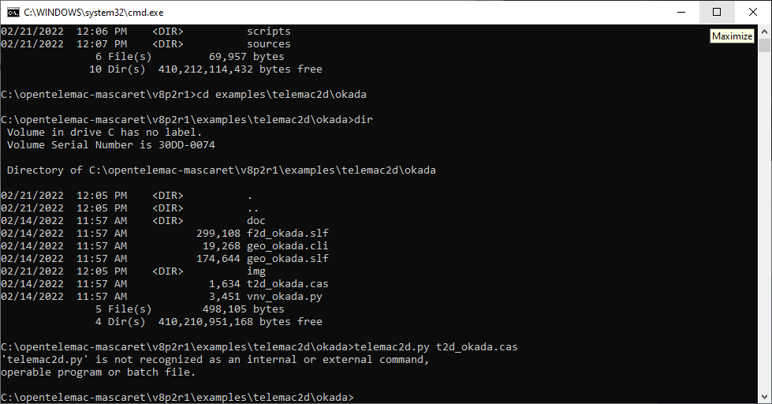

This error can be resolved also by making sure that the steps in Adding items into the System Variables Path in the system variables are correctly followed.

*Note:*

*If, for some reason, the above steps do not solve the problem, try to uninstall Python and reinstall it again by following the steps described in the* *Installing Python 3* *section.*

1. Issue with installing at default location. Contains white space at “C:\Program Files” and may cause “Unrecognized command” especially at parallel computations.

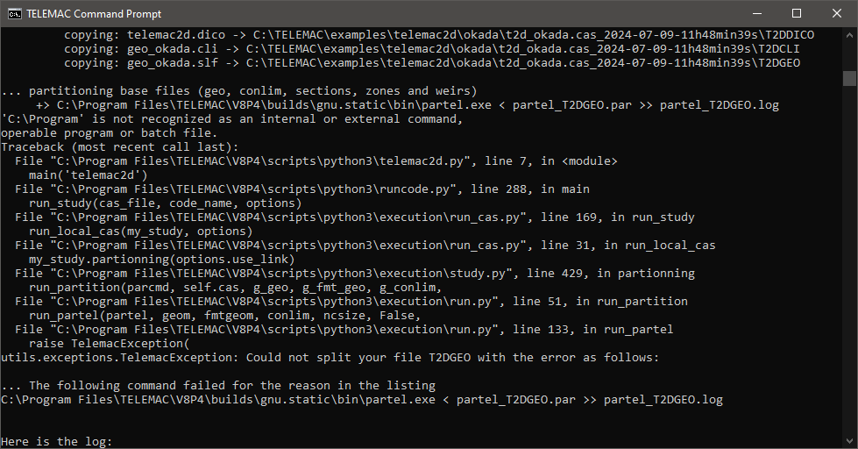

# Appendix IV: General Summary of Steps in Running a Model

For Windows Environment

1. Load cmd environment.
2. Change the directory where simulation files are located.
3. Start the simulation by typing telemac2d.py *filename*.cas.

*Note:*

*Please see the* *Running the Model Setup* *section for more information.*

# Appendix V: Visualized Results Files

## Scenario 1 – Initial/ Uncorrected Steering File

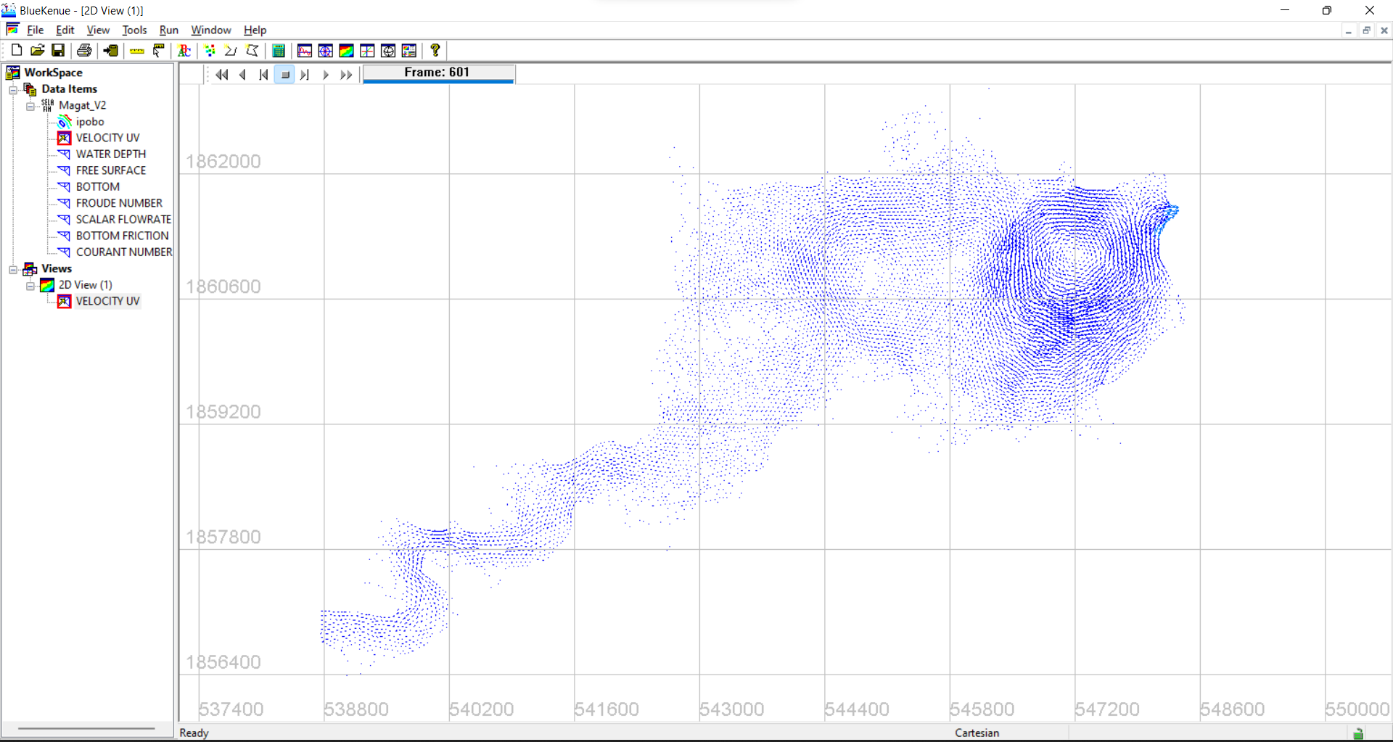

Figure 114. Scenario 1 Velocity Profile Visualized in BlueKenue

## Scenario 1– Adjusted Steering File

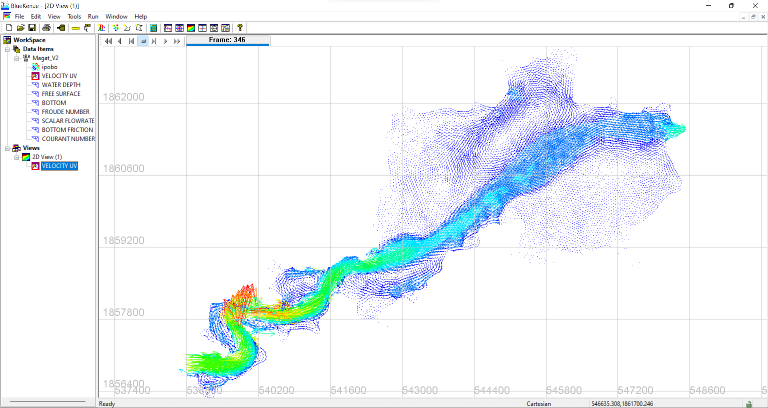

Figure 115 Scenario 1 Velocity Profile Visualized in BlueKenue

## Scenario 2 – Initial/ Uncorrected Steering File

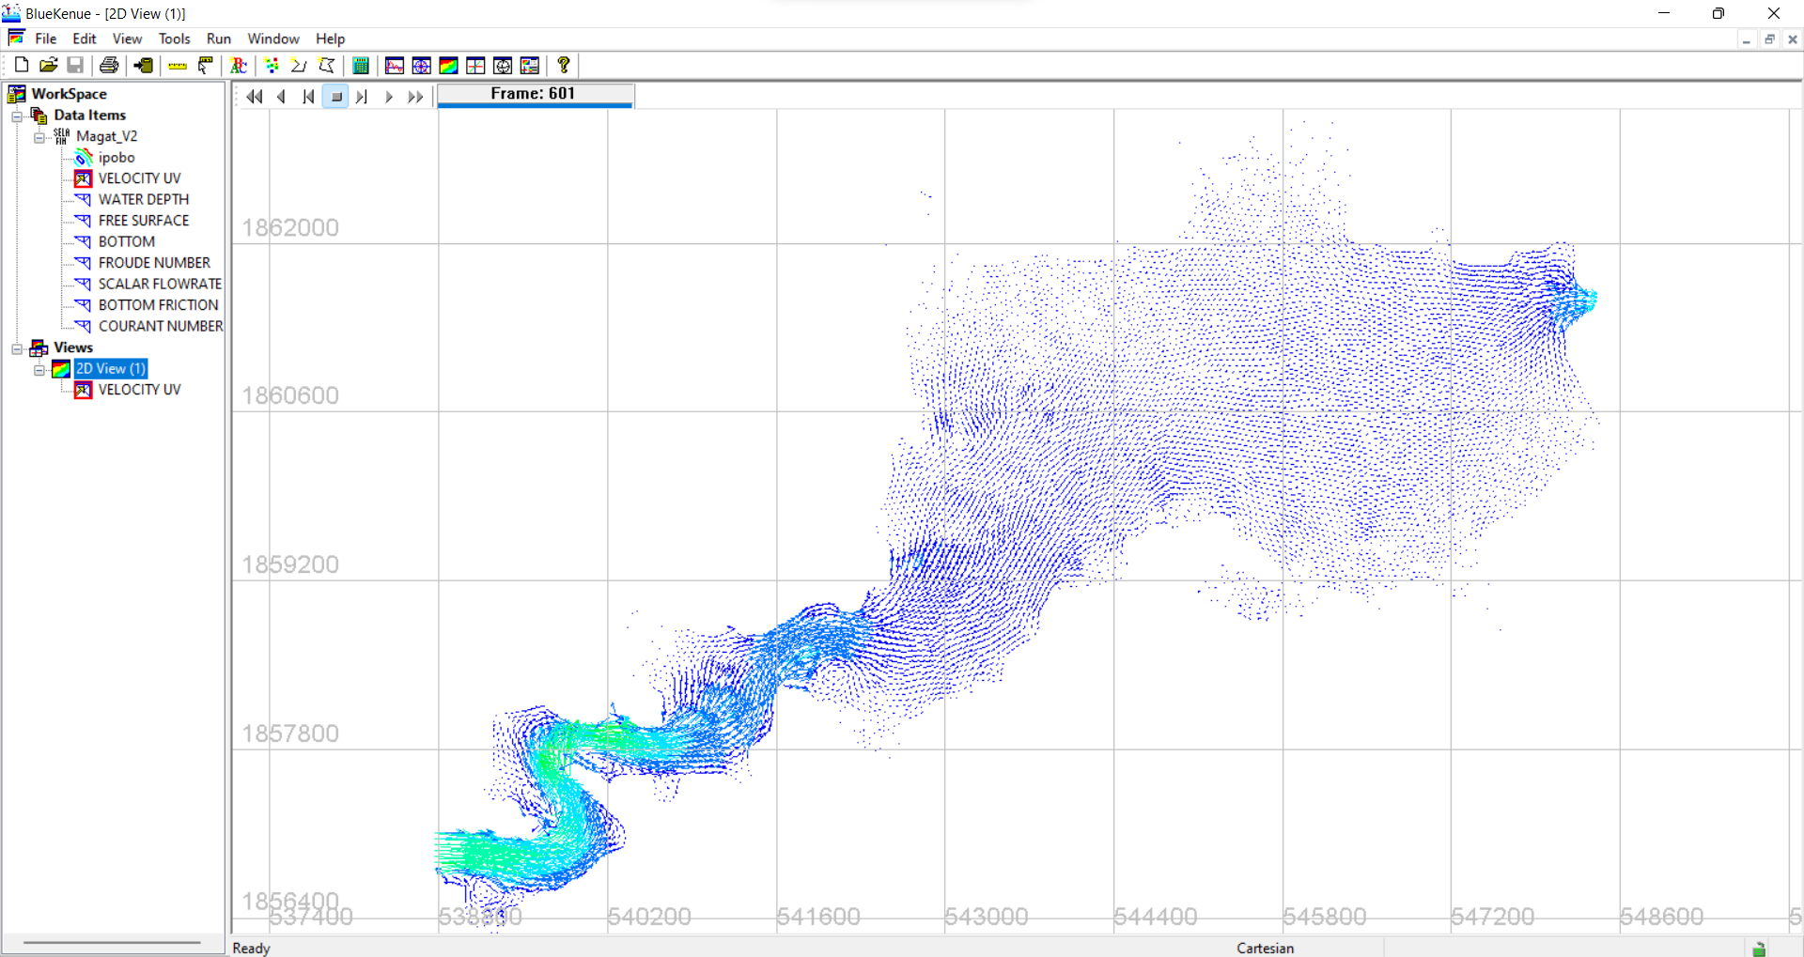

Figure 116. Scenario 2 Velocity Profile Visualized in BlueKenue

## Scenario 2 – Adjusted Steering File

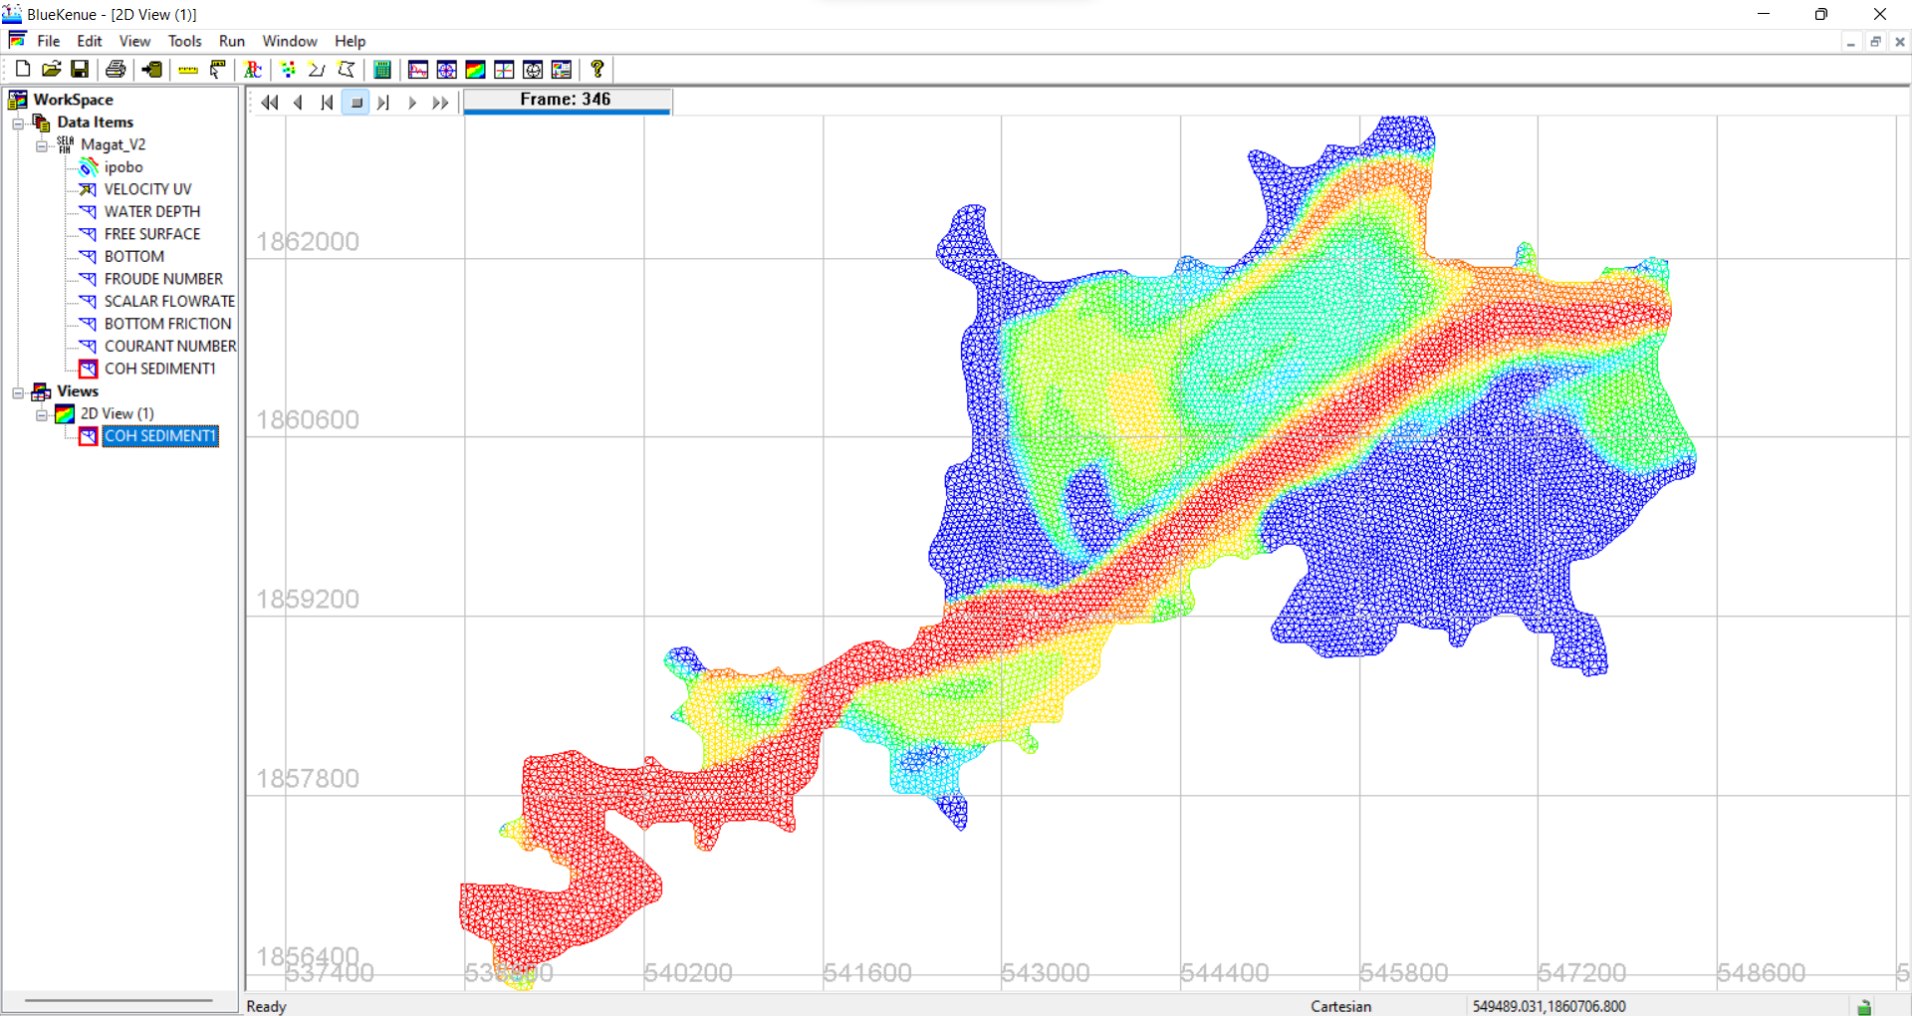

Figure 117. Scenario 2 Sediment Transport Profile Visualized in BlueKenue

## Scenario 3 – Initial/ Uncorrected Steering File

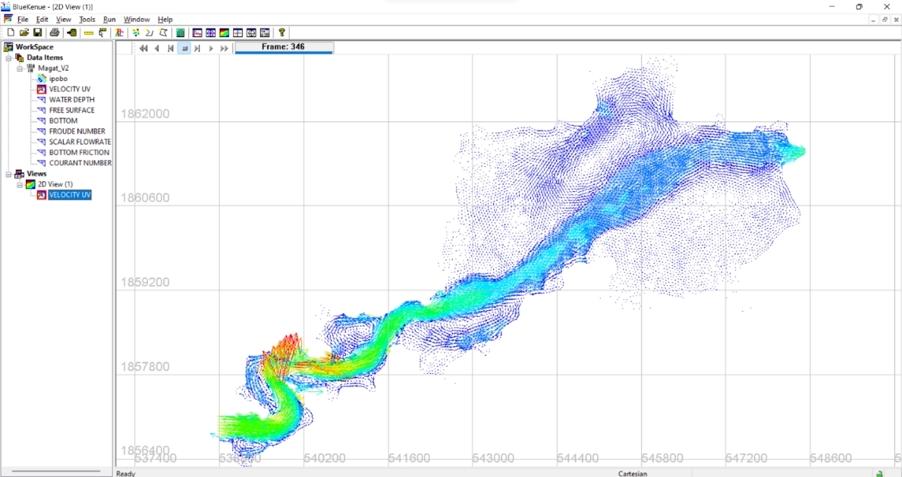

Figure 118. Scenario 3 Velocity Profile Visualized in BlueKenue

## Scenario 3 – Adjusted Steering File

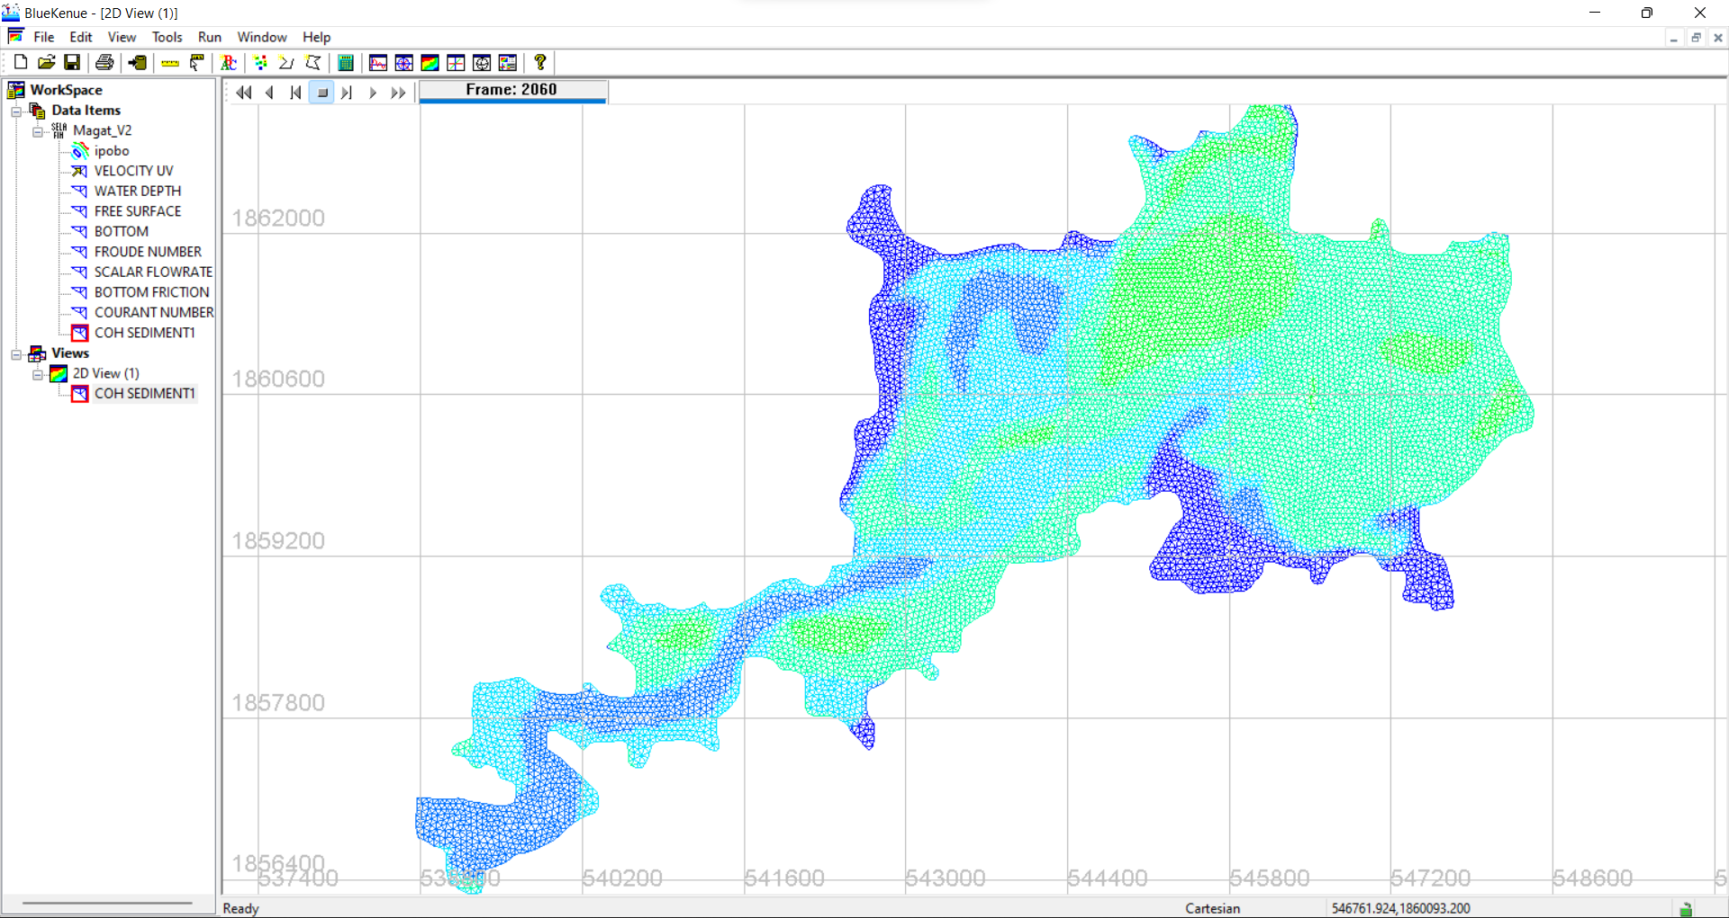

Figure 119. Scenario 3 Sediment Transport Profile Visualized in BlueKenue

# Appendix VI: Downloading the latest release, TELEMAC v8p5

1. Go to <http://www.opentelemac.org/> and log in using your account.

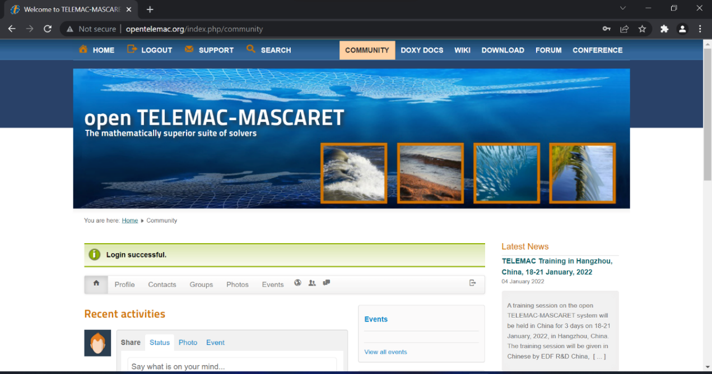

Figure 120. Logging in to your Telemac account

1. On the search bar, type “v**8p4**” or you can check the latest version in the **Latest News** section located on the right side of your screen.

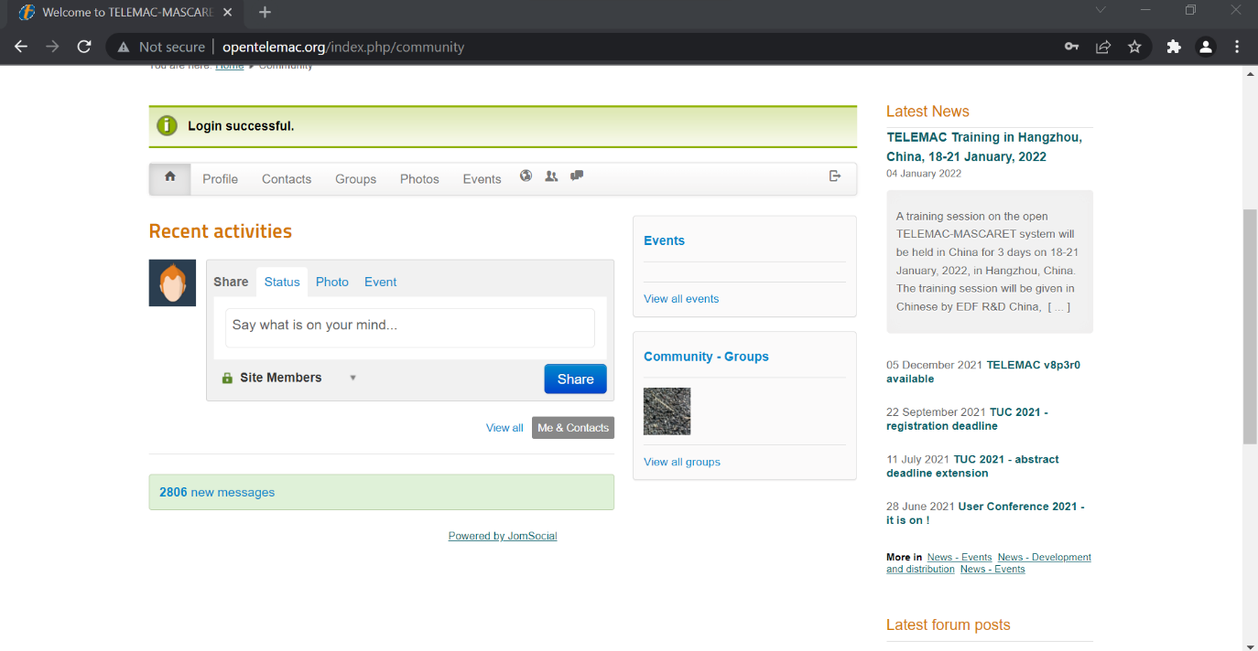

Figure 121. The Latest News section of the Telemac website

1. Click “**v8p4**” to navigate to the downloading page.

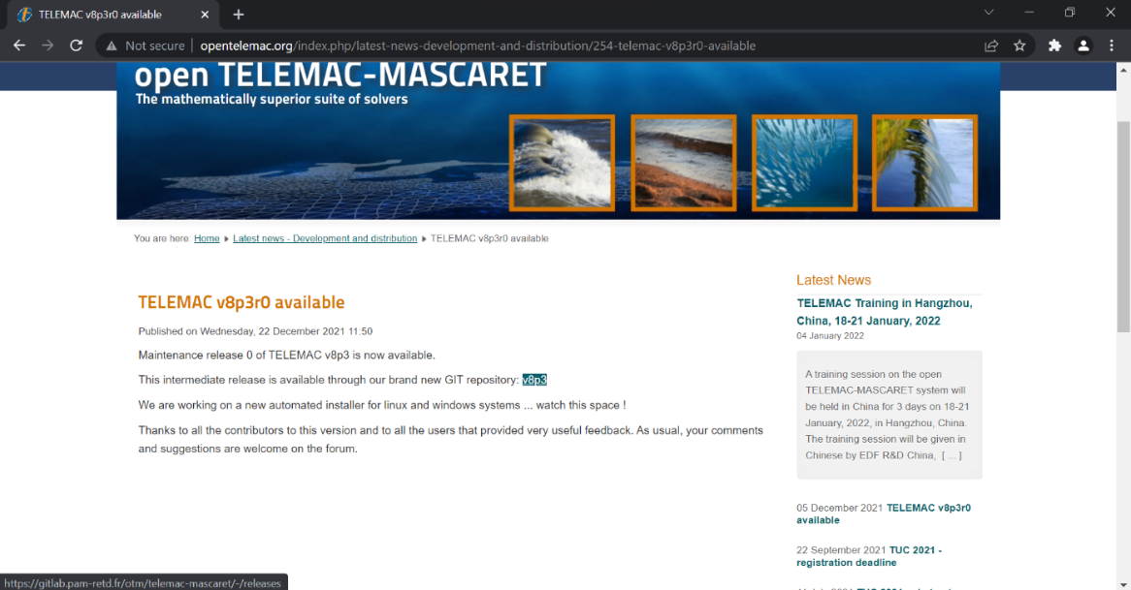

Figure 122. A short release statement regarding the availability of v8p3 version

1. The latest release is hosted through Git and will provide a faster checkout process compared to the traditional SVN. Click on “**Source Code”** to start downloading. Note: The latest release is V8P5R0.

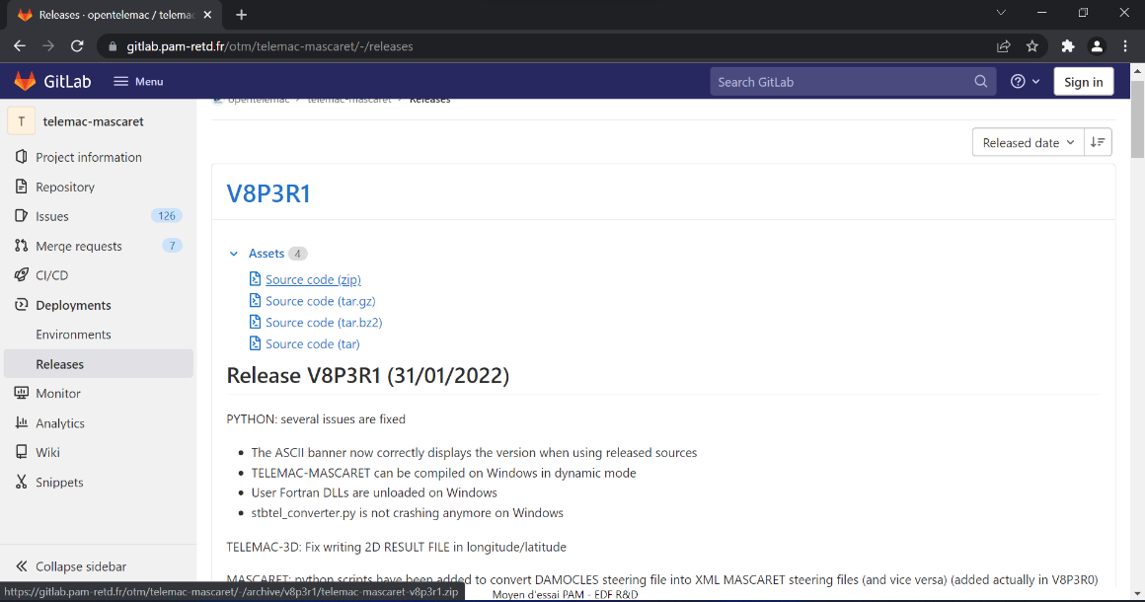

Figure 123. The source code download section

1. Download and save the compressed file into your TELEMAC installation folder (**C:\opentelemac-mascaret**).
2. Extract the contents of the downloaded compressed file.

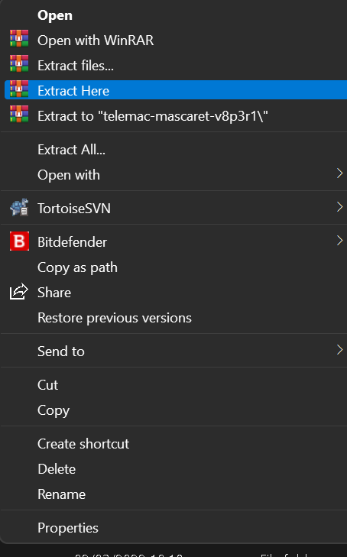

Figure 124. Extracting the contents of the downloaded compressed file

# Appendix VI: Importing an existing shapefile as an outline.

If, for instance, you have already generated an outline for your study area using any GIS application, you can use and import it into BlueKenue to save some time in drawing your outline.

1. Click on File >> Import >> ArcView Shape File.

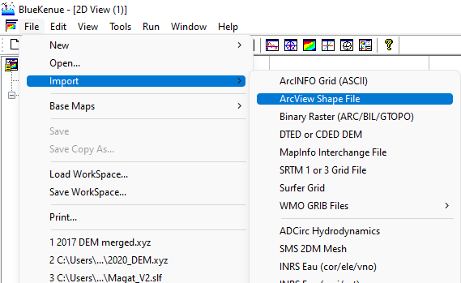

Figure 125. Importing a shapefile

1. Navigate into where your .shp is located and select and open it.

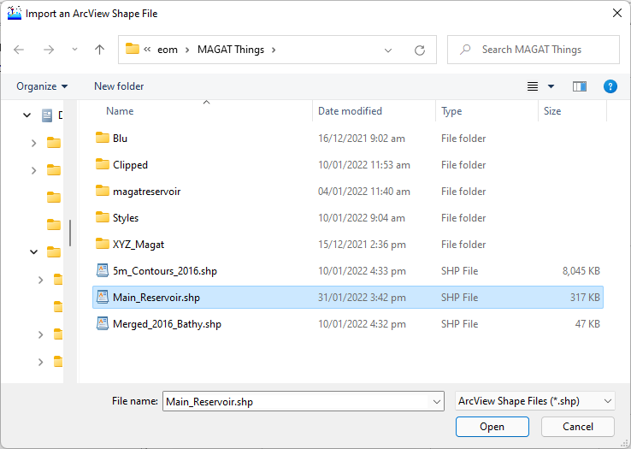

1. BlueKenue will try to read and load your file. If no errors were encountered, a “**DONE**” message shall appear. Click OK to close the message.

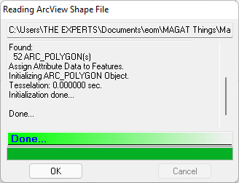

1. You can now drag and drop the loaded shp file into your 2D view to visualize it.

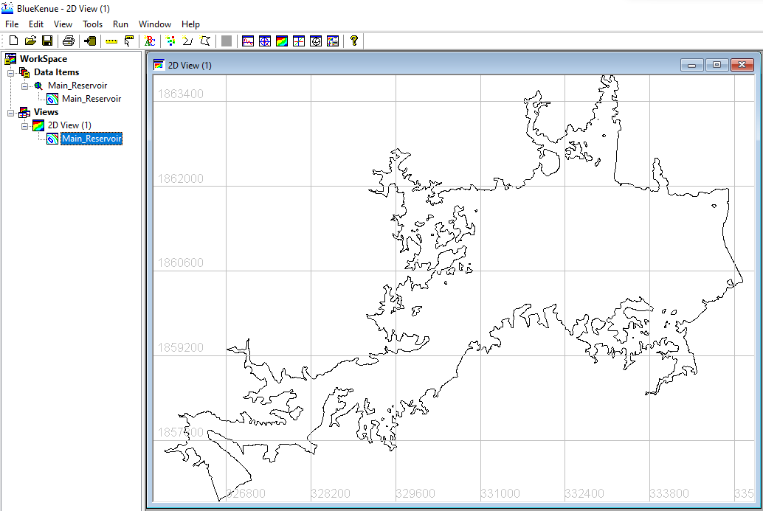

Figure 126. The Magat Reservoir outline loaded as a shapefile

# **References**

Canadian Hydraulics Center (CHC) - National Research Council (NRC). (2011, September ). Blue Kenue Reference Manual.

ELECTRICITE DE FRANCE (EDF). (2022, February). *Modules*. Retrieved from open TELEMAC-MASCARET: http://www.opentelemac.org/index.php/modules-list

Galland, J.-C., Goutal, N., & Hervouet, J.-M. (1991). TELEMAC: A new numerical model for solving shallow water equations. *Advances in Water Resources, 14*(3), 138-148.

Leon, A., & Gifford-Miears, C. (2013). Tutorial on the use of TELEMAC-2D Hydrodynamics model and Pre-/Post-processing with BlueKenue for flood-inundation mapping in Unsteady Flow Conditions. Oregon State University.

Schwindt, S. (2022). *TELEMAC.* Retrieved February 2022, from Hydro-Informatics: https://hydro-informatics.com/numerics/telemac.html